

**NEW ERA UNIVERSITY COLLEGE**

**FACULTY OF COMPUTER SCIENCE AND INFORMATION COMPUTING TECHNOLOGY**

**DEPARTMENT OF INFORMATION COMPUTING TECHNOLOGY**

**May Semester 2024**

**TCYS133 ALGORITHMS AND DATA STRUCTURES**

**FINAL REPORT**

**PREPARED BY:**

**LIM FENG YAO 2350102-DCS**

**YAP HUI JUN 2320020-DCS**

**WONG JIE YING 2350080-DCS**

**LECTURER: Ts. LAW TENG YI**

**DATE OF SUBMISSION: 20/08/2024**

**Table of Contents**

**1. Introduction** 1

**2. Flow of System (Flow Chart Diagram)** 3

**3. Data Structure System** 4

**3.1 Data Structure: Linked List** 4

**3.2 Database Table** 4

**3.3 Data Flow Diagram (DFD)** 5

**3.3.1 Level 0** 5

**3.3.2 Level 1** 5

**3.4 Data Table** 6

**3.4.1 User Table** 6

**3.4.2 Doctor Schedule Table** 7

**3.4.3 Type of service Table** 8

**3.4.4 Patient Appointment Table** 8

**3.4.5 Cancel Appointment Table** 9

**3.4.6 Medical Diagnosis Table** 9

**3.4.7 Patient Allergy Table** 10

**3.4.8 Vaccination Records Table** 10

**3.4.9 Patient Admission Transfer Table** 11

**3.4.10 Patient Follow Up Table** 11

**3.4.11 Feedback Table** 12

**3.4.12 Discount Table** 12

**3.4.13 Billint Table** 13

**3.4.14 Supplier Table** 13

**3.4.15 Purchase Table** 13

**3.4.16 Inventory Table** 14

**3.4.17 Medical Insurance Table** 14

**3.4.18 Notice Table** 15

**3.4.19 Emergency Tools Table** 15

**3.4.20 Project Table** 16

**3.5 Data Type** 17

**4. Hash Function** 17

**5. Pointers and References** 17

**6. Program Output** 18

**6.4 Patient Menu** 25

**6.4.1 Profile** 27

**6.4.1.1 Update Profile** 29

**6.4.1.2 Delete Profile** 31

**6.4.1.3 Exit** 32

**6.4.2 Doctor Info** 33

**6.4.3 Make Appointment** 33

**6.4.4 Cancel Appointment** 37

**6.4.4.1 Add New Cancel Appointment** 37

**6.4.4.2 Edit Cancelled Appointment** 39

**6.4.5 Appointment History** 41

**6.4.6 Medical Diagnosis** 42

**6.4.7 Allergy** 42

**6.4.7.1 Add New Patient Allergy** 42

**6.4.7.2 Edit Patient Allergy** 43

**6.4.7.3 Delete Patient Allergy** 43

**6.4.7.4 Exit** 45

**6.4.8 Notices** 46

**6.4.9 Give Feedback** 46

**6.4.9.1 Add New Feedback** 46

**6.4.9.2 Edit Feedback** 47

**6.4.9.3 Delete Feedback** 49

**6.4.9.4 Exit** 49

**6.4.10 Vaccination History** 50

**6.4.10.1 Add New Vaccination History** 50

**6.4.10.2 Edit Vaccination History** 51

**6.4.10.3 Delete Vaccination History** 51

**6.4.10.4 Exit** 53

**6.4.11 Billing** 53

**6.4.12 Medical Insurance** 54

**6.4.12.1 Add New Medical Insurance** 54

**6.4.12.2 Edit Medical Insurance** 55

**6.4.12.3 Exit** 56

**6.4.13 Emergency Tool** 56

**6.4.14 Project** 57

**6.5 Doctor Menu** 58

**6.5.1 Profile** 58

**6.5.2 Patient Appointment Schedule** 61

**6.5.3 Patient Medical Diagnosis** 64

**6.5.4.1 Patient Follow-up** 69

**6.5.4.2 Patient Admission Transfer** 73

**6.5.5 Vaccination Records** 75

**6.5.6 Doctor Schedule** 76

**6.5.7 Patient Allergies History** 76

**6.5.8 Notices** 76

**6.5.8.1 Emergency Tools** 76

**6.5.8.2 Project** 76

**6.5.8.3 Back to Doctor Menu** 76

**6.5.9 Exit** 77

**6.6 Admin Menu** 78

**6.6.1 All User** 80

**6.6.1.1 Filter User** 81

**6.6.1.2 Add User** 82

**6.6.1.3 Update User** 84

**6.6.1.4 Delete User** 85

**6.6.2 Medical Insurance** 87

**6.6.2.1 Add Medical Insurance** 88

**6.6.2.2 Update Medical Insurance** 89

**6.6.2.3 Delete Medical Insurance** 91

**6.6.3 Doctor Schedule** 93

**6.6.3.1 Add Doctor Schedule** 94

**6.6.3.2 Update Doctor Schedule** 95

**6.6.3.3 Delete Doctor Schedule** 97

**6.6.4 Patient Medical Diagnosis** 99

**6.6.5 Type of Service** 99

**6.6.5.1 Add Type of Service** 100

**6.6.5.2 Update Type of Service** 101

**6.6.5.3 Delete Type of Service** 102

**6.6.6 Patient Appointment** 104

**6.6.6.1 Add Patient Appointment** 105

**6.6.6.2 Update Patient Appointment** 107

**6.6.7 Patient Cancelled Appointment** 109

**6.6.7.1 Add Patient Cancelled Appointment** 110

**6.6.7.2 Update Patient Cancelled Appointment** 112

**6.6.8 Inventory Management** 113

**6.6.8.1 Inventory** 114

**6.6.8.1.1 Add Inventory** 115

**6.6.8.1.2 Update Inventory** 116

**6.6.8.1.3 Delete Inventory** 118

**6.6.8.2 Supplier** 120

**6.6.8.2.1 Add Supplier** 121

**6.6.8.2.2 Update Supplier** 122

**6.6.8.2.3 Delete Supplier** 124

**6.6.8.3 Purchase Order** 126

**6.6.8.3.1 Add Purchase Order** 127

**6.6.8.3.2 Update Purchase Order** 128

**6.6.8.3.3 Delete Purchase Order** 130

**6.6.9 View and Publish Notices** 132

**6.6.9.1 Add Notices** 132

**6.6.9.2 Update Notices** 133

**6.6.9.3 Delete Notices** 135

**6.6.10 View and Publish Project** 137

**6.6.10.1 Add Project** 137

**6.6.10.2 Update Project** 138

**6.6.10.3 Delete Project** 140

**6.6.11 Discount** 141

**6.6.11.1 Add Discount** 142

**6.6.11.2 Update Discount** 143

**6.6.11.3 Delete Discount** 145

**6.6.12 Patient Admission Transfer** 147

**6.6.13 View Feedback** 148

**6.6.14 Patient Vaccination Records** 148

**6.6.15 History of Patient Allergies** 149

**6.6.16 Latest Patient Status** 149

**6.6.17 Emergency Tools** 150

**6.6.17.1 Add Emergency Tools** 150

**6.6.17.2 Update Emergency Tools** 151

**6.6.17.3 Delete Emergency Tools** 153

**6.6.18 Billing** 155

**6.6.18.1 Add Billing** 156

**6.6.18.2 Update Billing** 158

**6.6.18.3 Delete Billing** 160

**6.6.19 Exit** 162

**7. Example Coding** 163

**7.1 Patient Menu** 163

**7.1.1 Make appointments** 163

**7.1.1.1 Structure** 163

**7.1.1.2 Print** 164

**7.1.1.3 Push back** 165

**7.1.1.4 Create** 166

**7.1.1.5 Read** 169

**7.1.2 Cancel Appointment** 169

**7.1.2.1 Structure** 169

**7.1.2.2 Print** 170

**7.1.2.3 Push back** 171

**7.1.2.4 Create** 172

**7.1.2.5 Read** 174

**7.1.2.6 Update** 175

**7.2 Doctor Menu** 177

**7.2.1 Structure** 177

**7.2.2 Node** 177

**7.2.3 Push Back** 177

**7.2.4 Generates Unique ID** 178

**7.2.5 Create Medical Diagnosis** 178

**7.2.6 Read Medical Diagnosis** 181

**7.2.7 Update Medical Diagnosis** 182

**7.2.8 Delete Medical Diagnosis** 186

**7.3 Admin Menu** 189

**7.3.1 Inventory Structure** 189

**7.3.2 Inventory Node** 190

**7.3.3 Inventory Push Back** 191

**7.3.4 Generates Unique Inventory ID** 192

**7.3.5 Read Inventory** 192

**7.3.6 Create Inventory** 193

**7.3.7 Update Inventory** 195

**7.3.8 Delete Inventory** 198

**8. Database Sqlite3** 199

**8.1 Billing Table** 199

**8.2 Cancel Appointment Table** 199

**8.3 Discount Table** 199

**8.4 Doctor Schedule Table** 199

**8.5 Emergency Table** 200

**8.6 Feedback Table** 200

**8.7 Inventory Table** 200

**8.8 medical Diagnosis Table** 200

**8.9 Medical Insurance Table** 201

**8.10 Notice Table** 201

**8.11 Patient Admission Transfer Table** 201

**8.12 Patient Allergy Table** 201

**8.13 Patient Follow Up Table** 202

**8.14 Patient Appointment Table** 202

**8.15 Project Table** 202

**8.16 Purchase Table** 202

**8.18 Type of Service Table** 203

**8.19 User Table** 203

**8.20 Vaccination Records Table** 203

**9.0 Conclusion** 203

**10.0 Distribution** 206

# **1. Introduction**

The Best Clinic Appointment Management System is a comprehensive platform designed to streamline and enhance the efficiency of scheduling and managing clinic appointments. The system is structured to accommodate three primary user roles: patients, doctors, and administrators, each with tailored functionalities to meet their specific needs.

Patients are provided with a user-friendly menu featuring fourteen key functions that facilitate their interaction with the clinic. The primary functions include the ability to make and cancel appointments, view medical diagnoses, and manage payments. Patients can easily schedule appointments by selecting the desired service, date, time, and doctor. Additionally, they can view and settle their bills securely through the system. Other important features include the ability to update personal information, access clinic notices and doctor information, review medical reports, check allergy details, review follow-up appointments, and admission statuses. The system also offers a direct communication channel for patients to contact clinic support if needed.

Doctors have access to an eight-function menu that supports their clinical responsibilities and patient management tasks. Their primary functions include viewing patient appointments and conducting medical diagnoses. The system allows doctors to select a patient, update medical history, record diagnoses, and document medications. It also supports the management of follow-up care, including recording dates and descriptions of follow-up actions. For patients requiring admission, doctors can record check-in and check-out times and update the patient’s current status. Additionally, doctors can view clinic information, patient allergy details, and their own medical records. A support contact feature is also available for doctors to communicate with the administrative team when needed.

Administrators enjoy the highest level of access, with eighteen functions at their disposal, allowing them to manage various aspects of clinic operations. Administrators can perform CRUD operations on user accounts, ensuring that patient, doctor, and admin information is kept up to date. They are also responsible for managing clinic information, including updating services, and posting notices. The system enables admins to oversee payment records, review doctors’ medical diagnoses and patient follow-ups.

Overall, the Best Clinic Appointment Management System is designed to provide a secure, user-friendly, and efficient platform for managing clinic appointments, patient care, and administrative tasks, ensuring that all users can interact with the clinic seamlessly and effectively.

# 

# **2. Flow of System (Flow Chart Diagram)**

The Flow of System (Flow Chart Diagram) shows how the Best Clinic Appointment Management System works. It maps out the steps users take from logging in to performing tasks like making appointments, updating information, and so on. This diagram helps to understand how different parts of the system interact and function together.

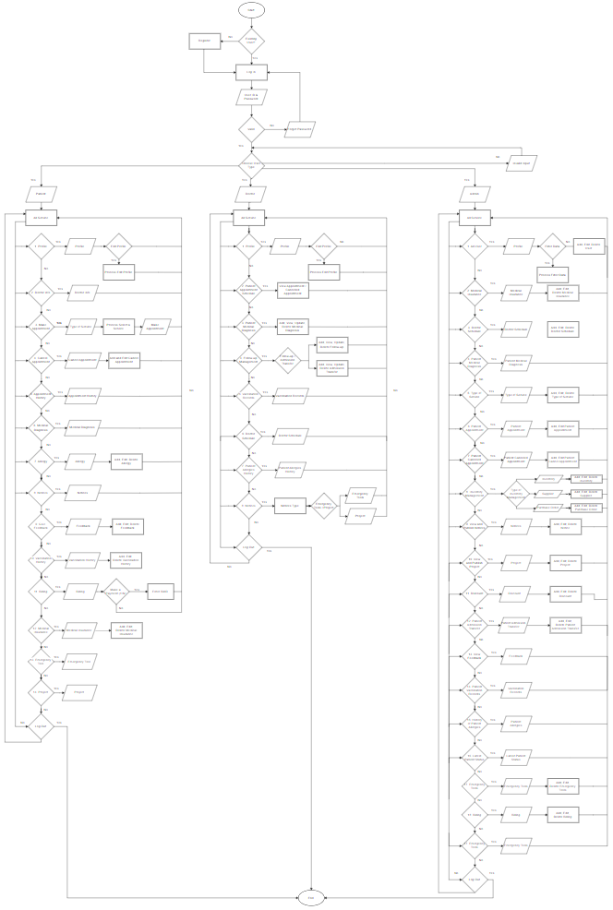

# **3. Data Structure System**

## **3.1 Data Structure: Linked List**

In the Best Clinic Appointment Management System, a linked list data structure is used to efficiently manage patient records, appointments, and other clinic data. Linked lists allow for easy insertion, deletion, and updating of information, which is essential in a healthcare setting where details often change. By representing each piece of data as nodes within linked lists, the system can handle dynamic information smoothly and keep operations flexible and responsive to the clinic’s needs.

## **3.2 Database Table**

The Best Clinic Appointment Management System is supported by a database that organizes essential clinic data across various tables. These tables manage user information, appointment scheduling, medical records, billing, and inventory. This structure ensures that all clinic operations run smoothly, with data being easily accessible and well-organized.

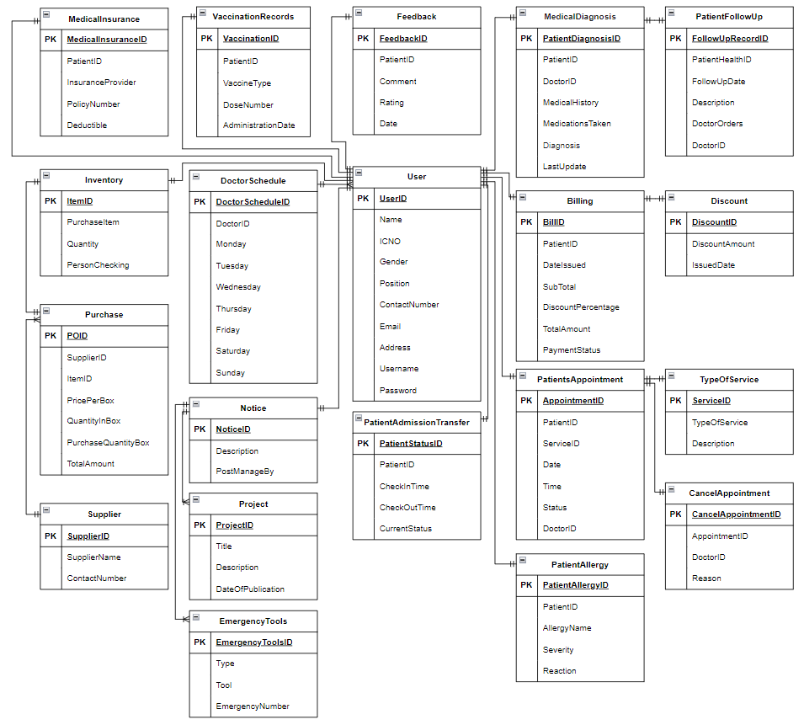

## **3.3 Data Flow Diagram (DFD)**

### **3.3.1 Level 0**

In our project, the Level 1 Data Flow Diagram (DFD) highlights essential functions such as managing patient diagnoses, handling patient lists and statuses, updating patient and doctor information, and processing billing details. It also covers appointment scheduling and information management, ensuring that all critical aspects of patient care and administrative tasks are efficiently handled.

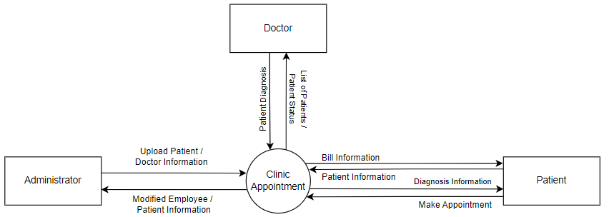

### **3.3.2 Level 1**

This Data Flow Diagram (DFD) outlines how information flows within a clinic management system. It shows interactions between Patients, Administrators, Doctors, Suppliers, and various databases. Key processes include managing patient appointments and billing, scheduling and updating appointments, ordering from suppliers, updating employee records, and posting notices. The diagram illustrates how data moves between these components to ensure smooth clinic operations.

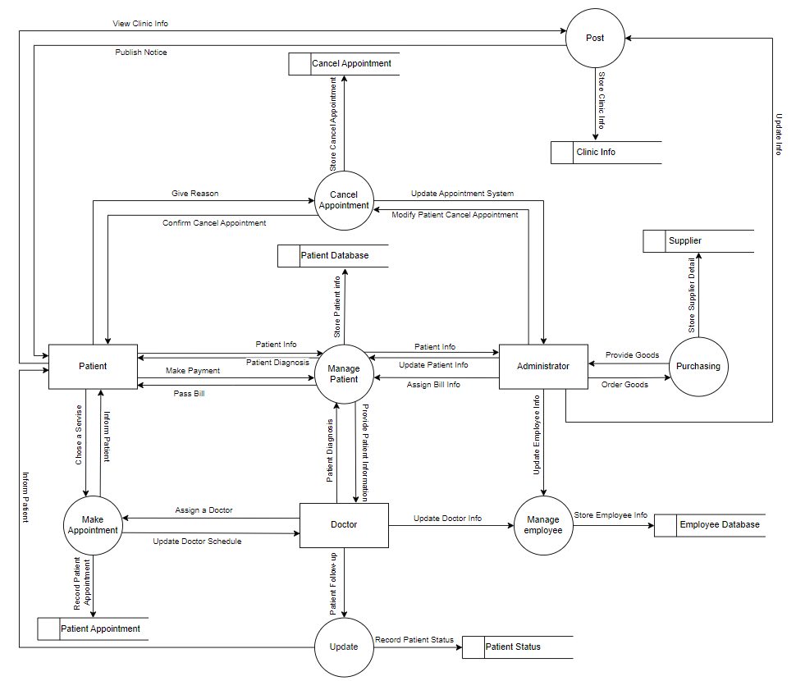

## **3.4 Data Table**

### **3.4.1 User Table**

|  |  |  |  |  |  |  |  |  |  |
| --- | --- | --- | --- | --- | --- | --- | --- | --- | --- |
| **User** | | | | | | | | | |
| **UserID** | **Name** | **IC NO** | **Gender** | **Position** | **Contact Number** | **Email** | **Address** | **Username** | **Password** |
| P1 | Johnathan Alexander Doe | 800101141239 | Male | Patient | 60119876543 | johndoe@example.com | Majestic Maxim Jalan 9/142, Taman Len Seng, Batu 9, Cheras, Kuala Lumpur | John Doe | ab7kl |
| P2 | Jane Elizabeth Smith | 850202105678 | Female | Patient | 60145678901 | janesmith@example.com | 7 Jalan Dataran Cheras 6, Balakong, Kajang, Selangor | Jane Smith | x9mn124 |
| P3 | Alice Victoria Brown | 880303089102 | Female | Patient | 60171234567 | alicebrown@example.com | Jalan Tasik Utama, Sungai Besi, Wilayah Persekutuan Kuala Lumpur | Alice Brown | 1uz9x |
| E1 | Johnathan Maxwell Smith | 750123105671 | Male | Doctor | 60154489651 | john@example.com | Jalan Setia Tropika U13/20, Setia Eco Park, Setia Eco Park, Shah Alam, Selangor | John Smith | 156cd |
| E2 | Matthew Harrison Wilson | 820305891723 | Male | Doctor | 60166546545 | matthew@example.com | Lebuhraya Sungai Besi BESRAYA, Sungai Besi, Kuala Lumpur | Matthew Wilson | casca62 |
| E3 | Michael Christopher Brown | 910405141122 | Female | Admin | 60141486554 | michael@example.com | 1A Tingkat 1 Jalan S 10, 1, Jalan Bukit Kajang, 43000 Kajang, Selangor | Michael Brown | dsCg530 |

### **3.4.2 Doctor Schedule Table**

|  |  |  |  |  |  |  |  |  |
| --- | --- | --- | --- | --- | --- | --- | --- | --- |
| **Doctor Schedule ID** | | | | | | | | |
| **Doctor Schedule ID** | **Doctor ID** | **Monday** | **Tuesday** | **Wednesday** | **Thursday** | **Friday** | **Saturday** | **Sunday** |
| D1 | E1 | Working | Working | Working | Off | Off | Off | Off |
| D2 | E2 | Off | Off | Off | Working | Working | Working | Off |

### **3.4.3 Type of service Table**

|  |  |  |
| --- | --- | --- |
| **Type of service** | | |
| **ServiceID** | **Type of Service** | **Description** |
| S1 | Laboratory Services | Diagnostic Services include blood and urine tests |
| S2 | Vaccination | Immunizations cover all ages |
| S3 | Family Medicine | Primary Care focuses on health, prevention, and chronic conditions |

### **3.4.4 Patient Appointment Table**

|  |  |  |  |  |  |  |
| --- | --- | --- | --- | --- | --- | --- |
| **Patient's Appointment** | | | | | | |
| **Appointment ID** | **Patient ID** | **ServiceID** | **Date** | **Time** | **Status** | **Doctor ID** |
| A1 | P1 | S3 | 05/01/2024 | 09:00 | Accessed | E1 |
| A2 | P2 | S1 | 08/02/2024 | 10:00 | Cancelled | E2 |
| A3 | P2 | S1 | 10/02/2024 | 10:00 | Accessed | E2 |
| A4 | P3 | S2 | 15/03/2024 | 12:00 | Accessed | E1 |

### **3.4.5 Cancel Appointment Table**

|  |  |  |  |
| --- | --- | --- | --- |
| **Cancel Appointment by Patient** | | | |
| **Cancel Appointment ID** | **Appointment ID** | **Doctor ID** | **Reason** |
| CA1 | A2 | E2 | Scheduling conflicts |

### **3.4.6 Medical Diagnosis Table**

|  |  |  |  |  |  |  |
| --- | --- | --- | --- | --- | --- | --- |
| **Medical Diagnosis** | | | | | | |
| **Patient Diagnosis ID** | **Patient ID** | **Doctor ID** | **Medical History** | **Medications Taken** | **Diagnosis** | **Last Update** |
| PH1 | P1 | E1 | Hypertension | Lisinopril, Amlodipine, Losartan, Metoprolol | Dengue fever | 08/01/2024 |
| PH2 | P2 | E2 | Diabetes | Metformin, Insulin, DPP-4 inhibitors | Iron deficiency anaemia | 17/02/2024 |
| PH3 | P3 | E1 | Asthma | Albuterol (short-acting), Fluticasone | Get HPV vaccine | 15/03/2024 |
| PH4 | P3 | E1 | Diabetes | Metformin, Insulin | Type 2 Diabetes | 2024-03-17 |

### **3.4.7 Patient Allergy Table**

|  |  |  |  |  |
| --- | --- | --- | --- | --- |
| **Patient Allergy** | | | | |
| **Patient Allergy ID** | **Patient ID** | **Allergy Name** | **Severity** | **Reaction** |
| AI1 | P2 | Peanut | Severe | Anaphylaxis (life-threatening allergic reaction) |

### **3.4.8 Vaccination Records Table**

|  |  |  |  |  |
| --- | --- | --- | --- | --- |
| **Vaccination Records** | | | | |
| **Vaccination ID** | **Patient ID** | **Vaccine Type** | **Dose Number** | **Administration Date** |
| V1 | P1 | AZ | First dose | 16/09/2021 |
| V2 | P3 | Pfizer | First dose | 01/10/2021 |

### **3.4.9 Patient Admission Transfer Table**

|  |  |  |  |  |
| --- | --- | --- | --- | --- |
| **Patient Admission Transfer** | | | | |
| **Patient Status ID** | **Patient ID** | **Check-in Time** | **Check-out Time** | **Current Status** |
| PS1 | P1 | 06/01/2024 10.30 | 08/01/2024 12.00 | Discharged |
| PS2 | P2 | 10/02/2024 13.00 | 17/02/2024 16.00 | Transferred |
| PS3 | P3 | 15/03/2024 13.00 | 15/03/2024 15.30 | Discharged |

### **3.4.10 Patient Follow Up Table**

|  |  |  |  |  |  |
| --- | --- | --- | --- | --- | --- |
| **Patient Follow-up** | | | | | |
| **Follow-up Record ID** | **Patient Diagnosis ID** | **Follow-up Date** | **Description** | **Doctor OrdersDescription** | **Doctor ID** |
| FU1 | PH1 | 07/01/2024 | Mild fever, joint pain; no rash | Monitor platelets, rest. Follow-up in 1 week | E1 |
| FU2 | PH2 | 13/02/2024 | Reduced fatigue, better energy | Continue treatment, add Vitamin C. Test in 1 month | E2 |

### **3.4.11 Feedback Table**

|  |  |  |  |  |
| --- | --- | --- | --- | --- |
| **Feedback** | | | | |
| **Feedback ID** | **Patient ID** | **Comment** | **Rating** | **Date** |
| F1 | P1 | Excellent care, very satisfied with service. | 5 | 08/01/2024 |
| F2 | P2 | Good service, but waiting time was too long. | 3 | 14/02/2024 |

### **3.4.12 Discount Table**

|  |  |  |
| --- | --- | --- |
| **Discount** | | |
| **Discount ID** | **Discount Amount** | **Issued Date** |
| V1 | 5% | 05/01/2024 |
| V2 | 10% | 16/02/2024 |

### **3.4.13 Billint Table**

|  |  |  |  |  |  |  |
| --- | --- | --- | --- | --- | --- | --- |
| **Billing** | | | | | | |
| **Bill ID** | **Patient ID** | **Date Issued** | **SubTotal** | **Discount Percentage** | **Total Amount** | **Payment Status** |
| B1 | P1 | 07/01/2024 | RM 542.00 | - | RM 542.00 | Unpaid |
| B2 | P2 | 16/02/2024 | RM 873.33 | 10% | RM 786.00 | Unpaid |
| B3 | P3 | 18/03/2024 | RM 206.00 | - | RM 206.00 | Unpaid |

### **3.4.14 Supplier Table**

|  |  |  |
| --- | --- | --- |
| **Supplier** | | |
| **Supplier ID** | **Supplier Name** | **Contact Number** |
| SU1 | ABC Medical | 60167456215 |
| SU2 | XYZ Supplies | 60145951716 |

### **3.4.15 Purchase Table**

|  |  |  |  |  |  |  |
| --- | --- | --- | --- | --- | --- | --- |
| **Purchase** | | | | | | |
| **PO ID** | **Supplier ID** | **Item ID** | **Price/Box (RM)** | **Quantity in a Box** | **Purchase Quantity (Box)** | **Total Amount (RM)** |
| PO1 | SU1 | I1 | 60 | 100 | 8 | 480 |
| PO2 | SU2 | I1 | 20 | 50 | 4 | 80 |

### **3.4.16 Inventory Table**

|  |  |  |  |
| --- | --- | --- | --- |
| **Inventory** | | | |
| **Item ID** | **Purchase Item** | **Quantity** | **Person Checking** |
| I1 | Syringes | 500 | E2 |
| I2 | Bandages | 100 | E2 |

### **3.4.17 Medical Insurance Table**

|  |  |  |  |  |
| --- | --- | --- | --- | --- |
| **Medical Insurance** | | | | |
| **Medical Insurance ID** | **Patient ID** | **Insurance Provider** | **Policy Number** | **Deductible** |
| INS1 | P1 | Allianz | A12392 | 400000 |
| INS2 | P2 | AIA | AIA193842 | 600000 |

### **3.4.18 Notice Table**

|  |  |  |
| --- | --- | --- |
| **Notice (link employee)** | | |
| **Notice ID** | **Description** | **Post Manage By** |
| N1 | Update emergency tools | E3 |
| N2 | Vaccination Information | E3 |
| N3 | Know more about your health | E3 |

### **3.4.19 Emergency Tools Table**

|  |  |  |  |
| --- | --- | --- | --- |
| **Emergency Tools** | | | |
| **Emergency Tools ID (PK)** | **Type** | **Tool** | **Emergency Number** |
| ET1 | Contact Information | Emergency Number | 03-86457894 |
| ET2 | Transportation | Ambulance Department Service | 999 |

### **3.4.20 Project Table**

|  |  |  |  |
| --- | --- | --- | --- |
| **Project** | | | |
| **Project ID (PK)** | **Title** | **Description** | **Date of Publication** |
| PRO1 | New Vaccination Guidelines | Release of updated guidelines for vaccination protocols | 18/01/2024 |
| PRO3 | Mental Health Awareness | Campaign to promote mental health awareness | 08/03/2024 |

## **3.5 Data Type**

In the Best Clinic Appointment Management System, various data types are utilized to effectively manage and store information. **TEXT** is used for string data such as names, addresses, and descriptions, while **INTEGER** is employed for whole numbers like quantities and ID numbers. **DOUBLE** handles decimal values, which are essential for monetary amounts and measurements. **DATE** is used to record dates such as appointment and issuance dates, while **TIME** is used for specific times like appointment schedules. **DATETIME** combines both date and time, useful for tracking events like check-ins and check-outs. These data types ensure the system can accurately manage and process all necessary information for smooth clinic operations.

# **4. Hash Function**

In the Best Clinic Appointment Management System, hash functions are used to efficiently manage and secure various types of data. A hash function converts input data, such as user information or system records, into a fixed-size value known as a hash code. This hash code is used for quick data retrieval, ensuring that similar data is stored and accessed efficiently. For instance, when organizing and indexing records in the system, hash functions help in distributing data uniformly, which reduces the likelihood of data collisions and speeds up search operations. Additionally, hash functions support data integrity by providing a way to verify that data has not been altered or corrupted.

# **5. Pointers and References**

In our project, we use references and pointers to efficiently manage and manipulate data. **Pointers** allow us to directly access and modify memory locations, which is crucial for handling dynamic data structures and optimizing performance. **References**, on the other hand, provide a simpler way to work with variables without dealing with memory addresses explicitly, making the code cleaner and easier to understand. Together, these tools enhance the flexibility and efficiency of our project's data management and functionality.

# 

# **6. Program Output**

**6.1 Main Menu**

Show the logo and ask if the user has an account or not.

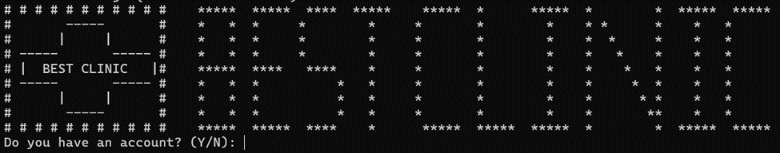**6.1 Register**

If you select ‘n’ or ‘N’, it will show a Register Account to allow users to enter the username and password they want. If no error will show “Account registered successfully!”.

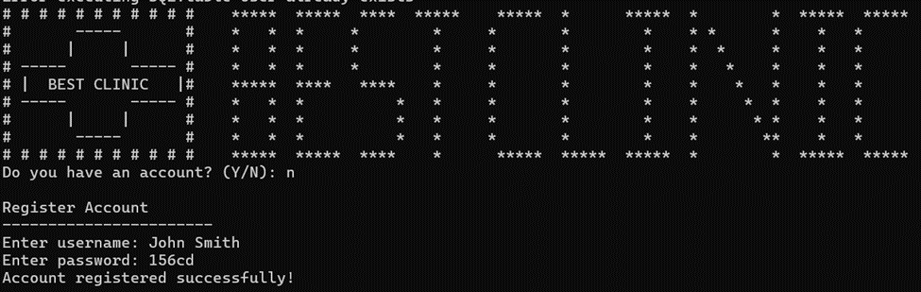

Ask the user to complete their profile.

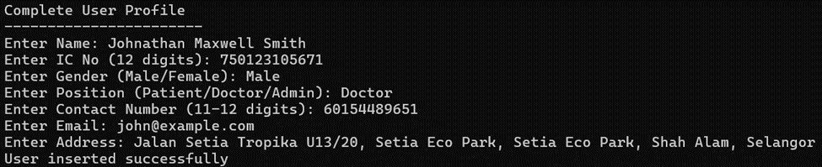

Based on the user position show the following menu.

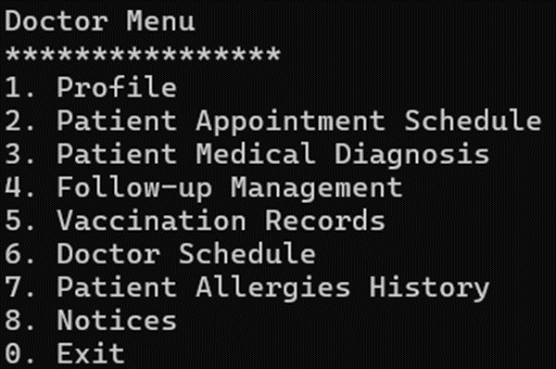

If the user puts it blank or invalid input will show a reminder and ask to enter again.

Here the IC number should be 12 digits.

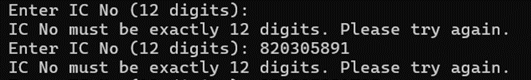

Set the gender only and can enter ‘male’, ‘female’, ‘Male’, or ‘Female’.

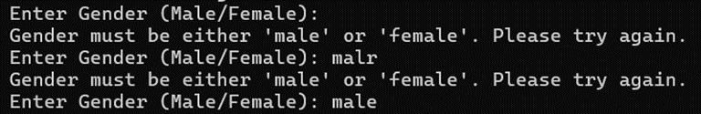

Set the position only can enter ‘patient’, ‘doctor’, ‘admin’, ‘Patient’, ‘Doctor’, or ‘Admin’.

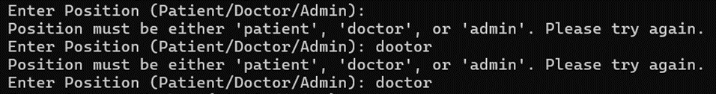

Set contact number should be entered between 11 – 12 digits.

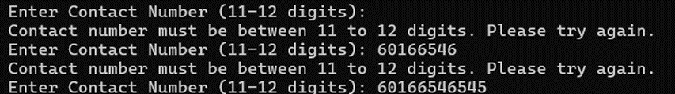

Set email must include ‘@’.

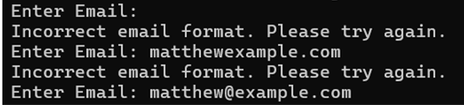

Address disallows put blank.



If the username already exists, disallow using the username to register.

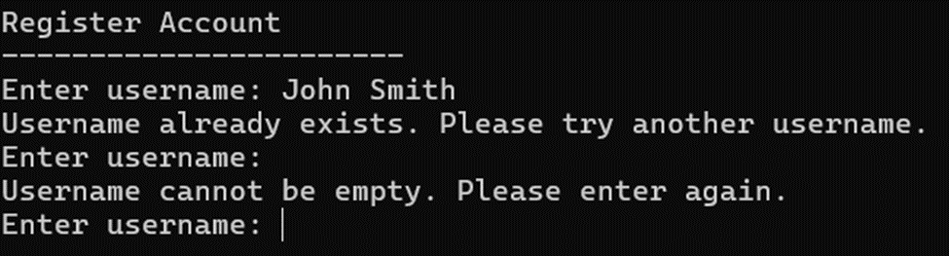

Using a different username and the same password is allowed to register an account.  
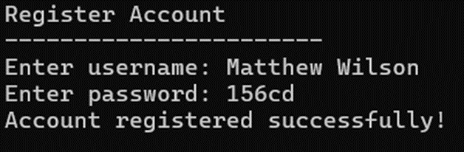

**6.2 Login**

Login account with the user that is already registered.

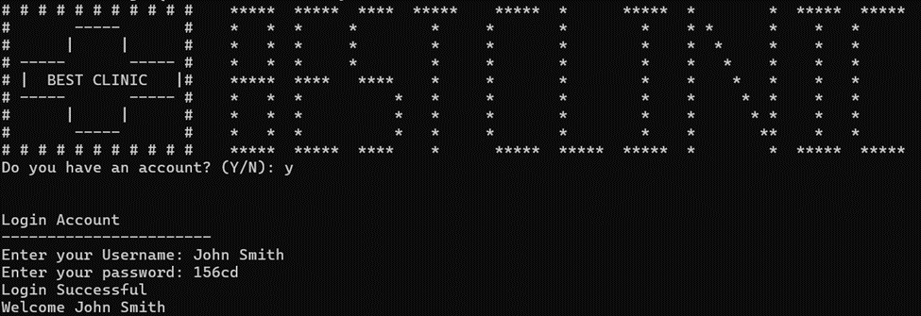

The username and password are disallowed and put blank.

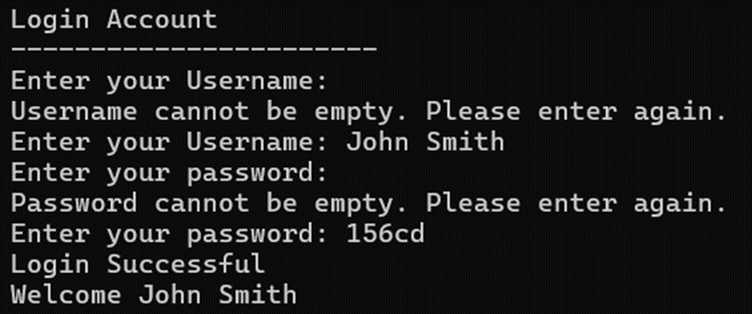

Invalid three times will ask if the user wants to register an account or not.

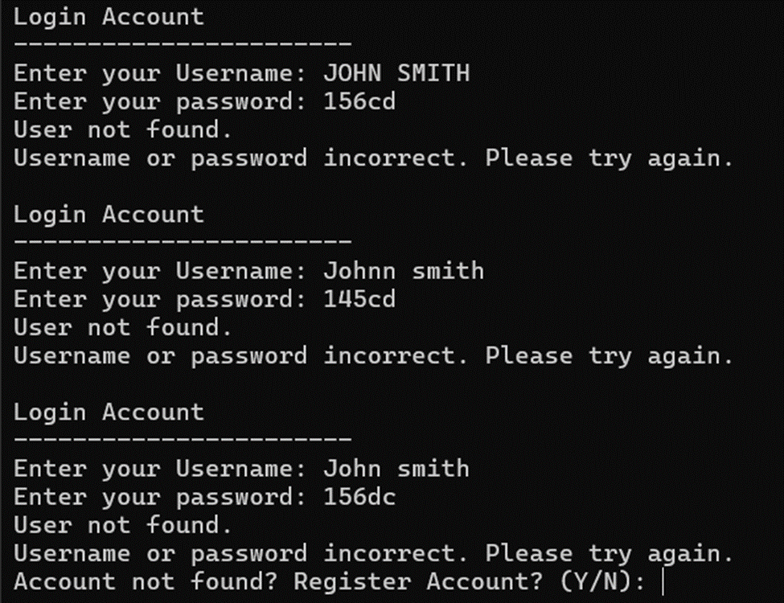

If ‘y’ or ‘Y’ shows the register menu for the user to register a new account.

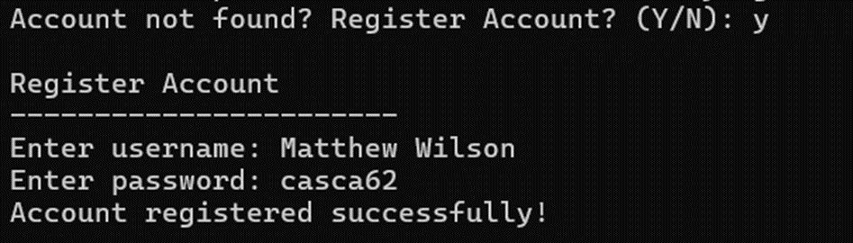

If ‘n’ or ‘N’ shows forgot password option for the user to select, if they forgot and would like to reset the password? If the user selects ‘y’ or ‘Y’, enter can perform a reset password action.

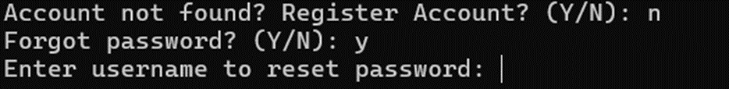

If you select ‘n’ or ‘N’ will exit the program.

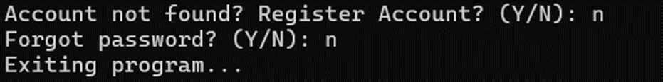**6.3 Forgot Password**

Users need to enter their username to reset the old password. They are required to enter two times to verify the new password is the same.

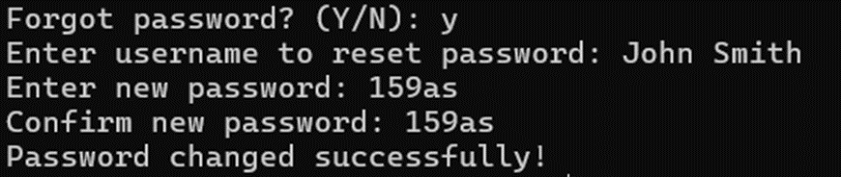

When the new password and confirm new password do not match, the user needs to enter it again.

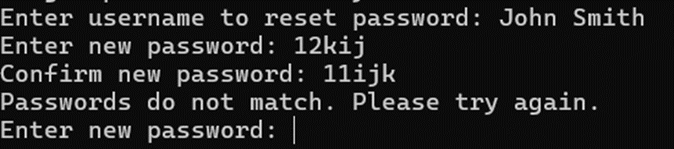

When a user enters a username that is not found in the system, ask the user to register a new account. If the user enters ‘y’ or ‘Y’, return to the register menu.

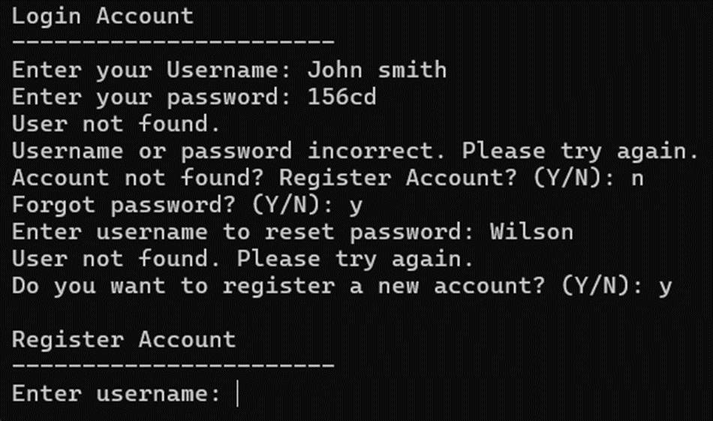

For the option “Do you want to register a new account? (Y/N)”, the user enters ‘n’ or ‘N’ and returns to the login menu.

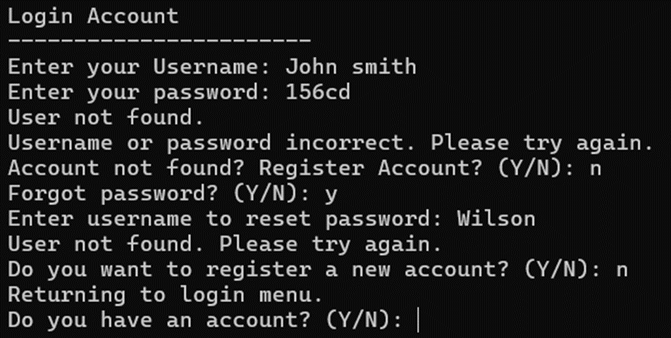

## 

## 

## **6.4 Patient Menu**

The patient menu provides a user-friendly interface for patients to manage their appointments, view medical information, and access various services within the system.

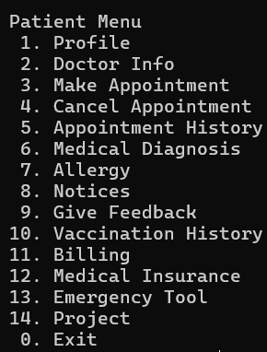

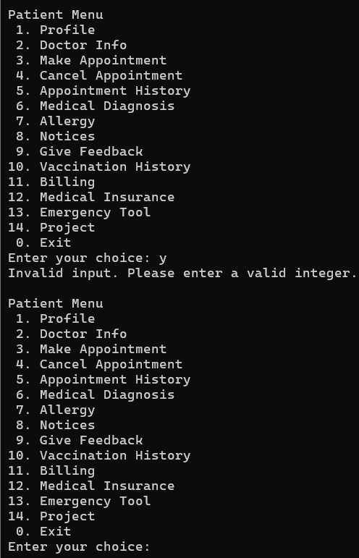

If the user types something that isn't an integer, display 'Invalid input. Please enter a valid integer.' and then show the patient menu again.

Type '0' to exit the patient menu.

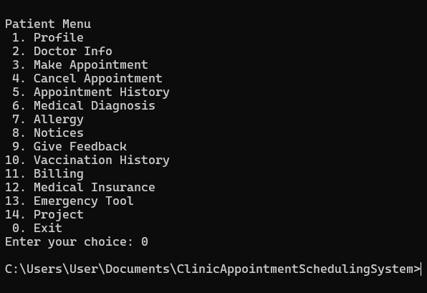

### **6.4.1 Profile**

This profile belongs to Johnathan Alexander Doe. It will display the user's information.

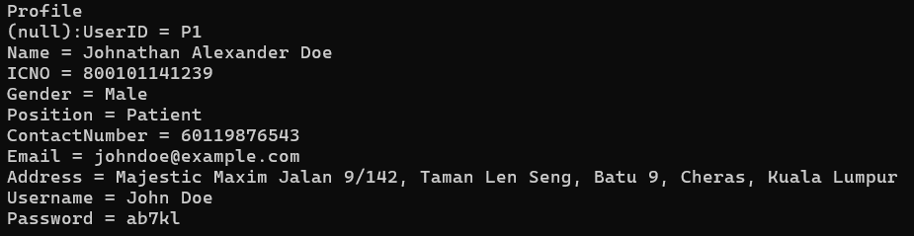

This profile belongs to Jane Elizabeth Smith. It will display the user's information.

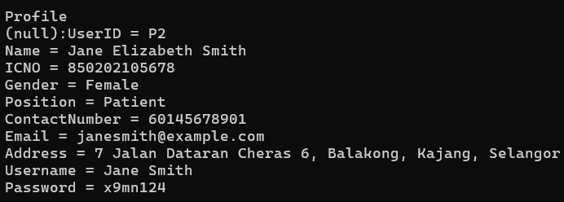

This profile belongs to Alice Victoria Brown. It will display the user's information.

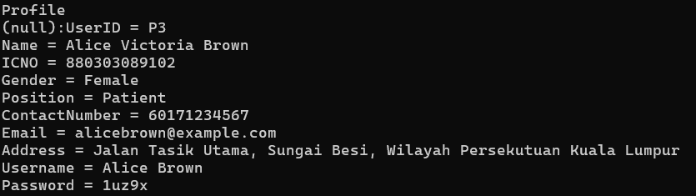

#### **6.4.1.1 Update Profile**

This is the user SQLite.

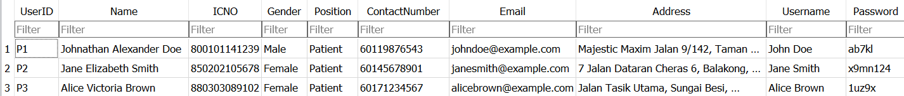

If the patient wants to edit the profile, prompt them with 'Do you want to take action on your Profile? (Y/N):'. If they type 'Y', proceed to the update process. If they type 'N', return to the patient menu. Then, display the available actions and prompt them to choose '1' to update the profile.

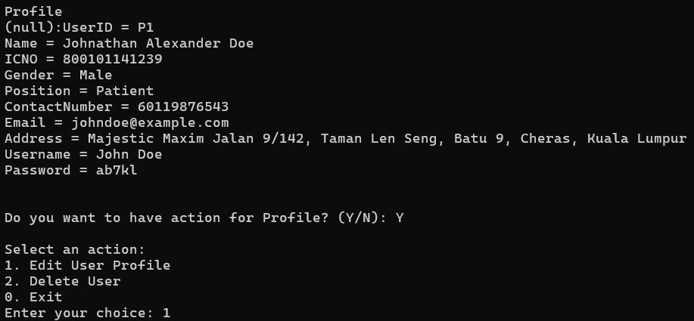

Then update the contact number.

Before



After

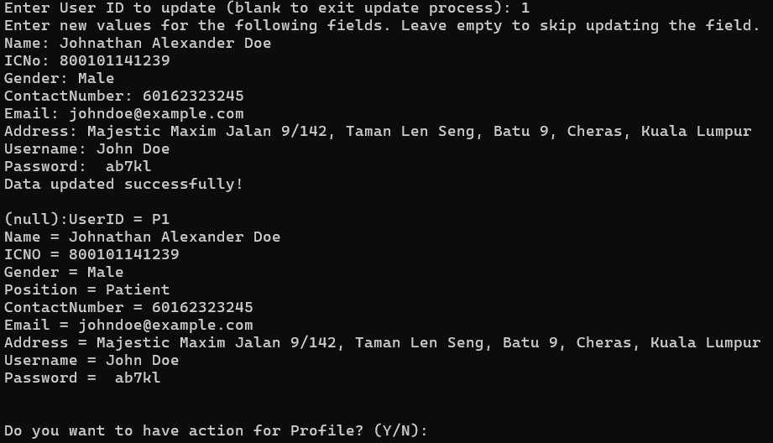



In SQLite, the contact number will be updated.

Before



After

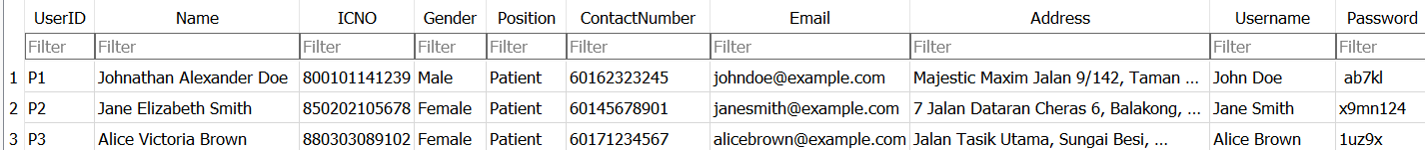

If the user does not type anything, it will show 'No fields were updated.

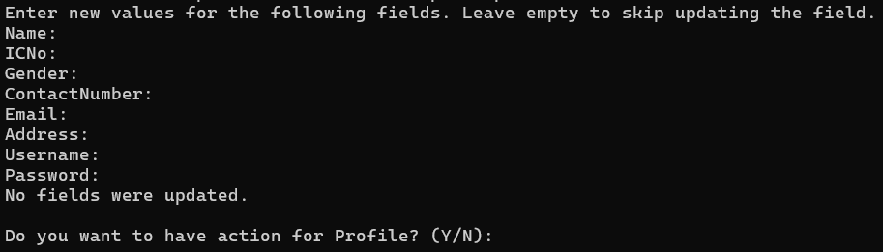

If the IC number does not have exactly 12 digits, it will show 'Invalid IC Number. It must be exactly 12 digits.' Please try again.

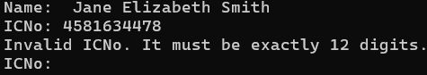

If the user types a word that is not 'Male' or 'Female', it will show 'Invalid Gender. Please enter 'Male', 'Female', or any lowercase variation.'



If the contact number does not have 11 or 12 digits, it will show 'Invalid Contact Number. It must be 11 or 12 digits.

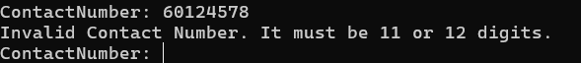

If the user types an email without the '@' symbol, it will show 'Invalid Email. It must contain an '@' symbol.'

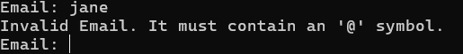

#### **6.4.1.2 Delete Profile**

Select option 2. Then, you will be asked, 'Do you want to delete your account (press Enter to exit the delete process)? (Y/N):'. Type 'Y', and after that, a message will appear saying 'Data deleted successfully.

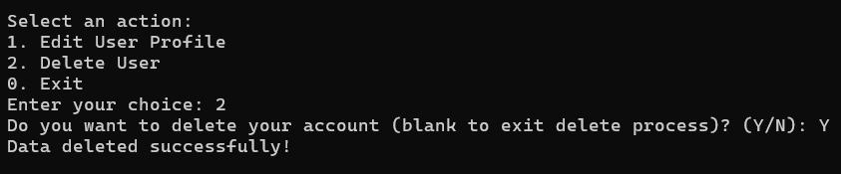

In SQLite, John Doe will not be shown because the record has already been deleted.



After deleting the profile, go to option 1. The user profile will not be shown.

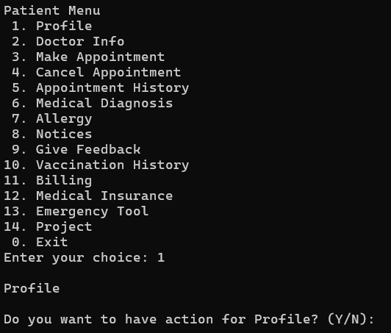

#### **6.4.1.3 Exit**

When the user types '0', they will be redirected to the patient menu.

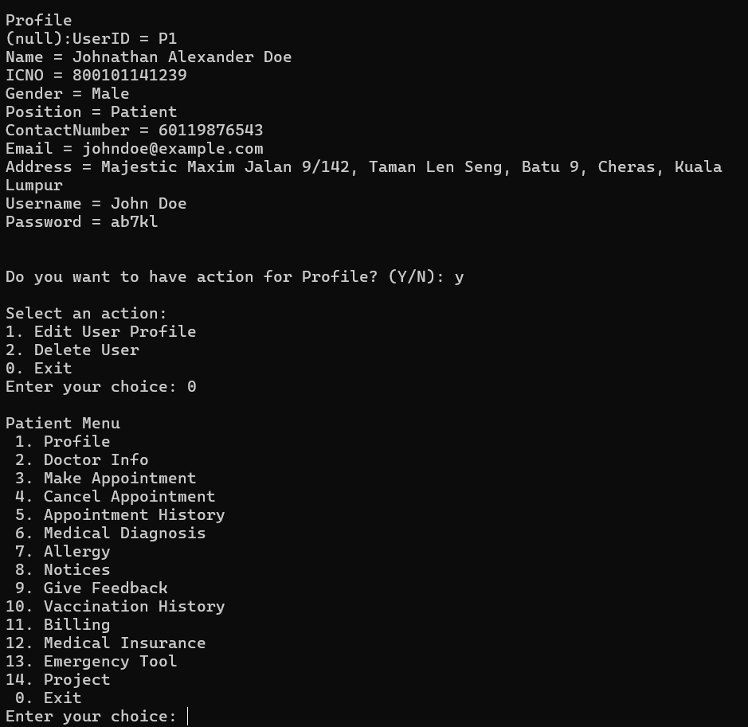

### **6.4.2 Doctor Info**

Choosing option 2 will show the doctor’s information.

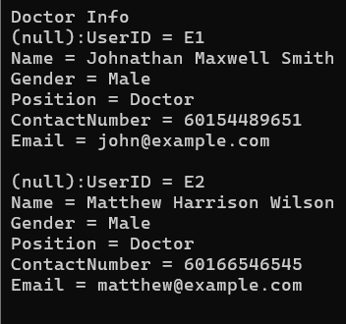

### **6.4.3 Make Appointment**

Choose 'S2' for the Vaccination, then enter the date and time.

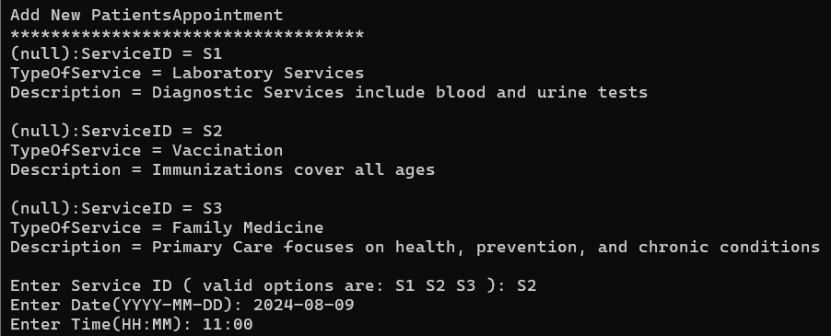

Choose the doctor you want. The system will then confirm the action as successful. After that, you will be asked if you want to make another appointment. If you choose 'Y', you can continue making appointments. If you choose 'N', you will return to the patient menu.

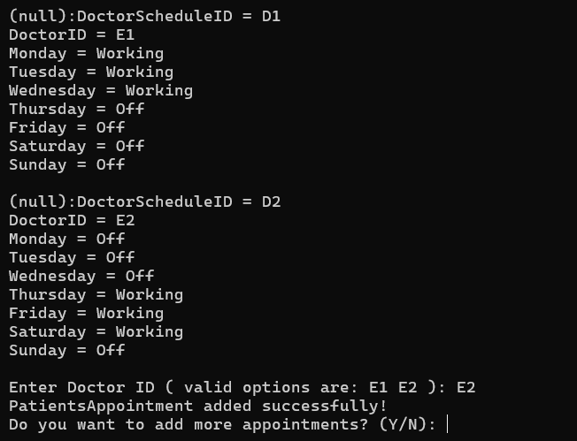

If you choose 'Y', you can continue to make another appointment.

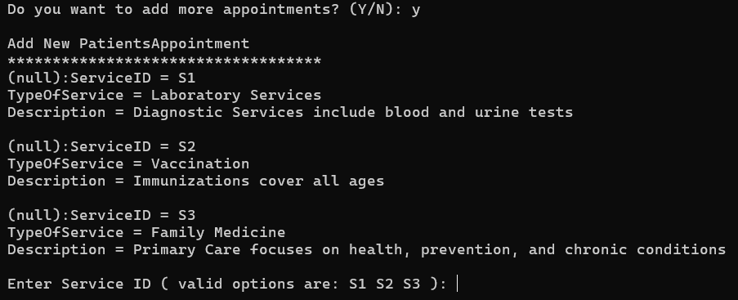

If you choose 'N', you will return to the patient menu.

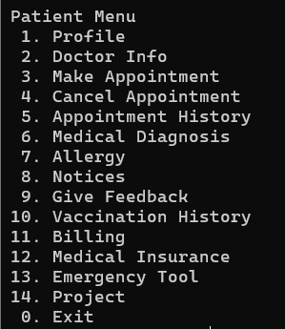

This is the make appointment SQLite

Before

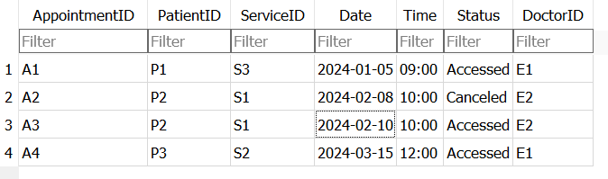

After

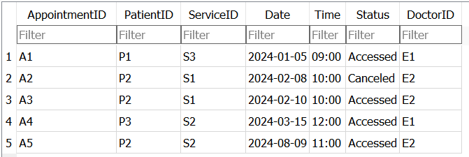

If the user chooses '4', it will show 'Invalid Service ID. Please enter a valid Service ID from the list.

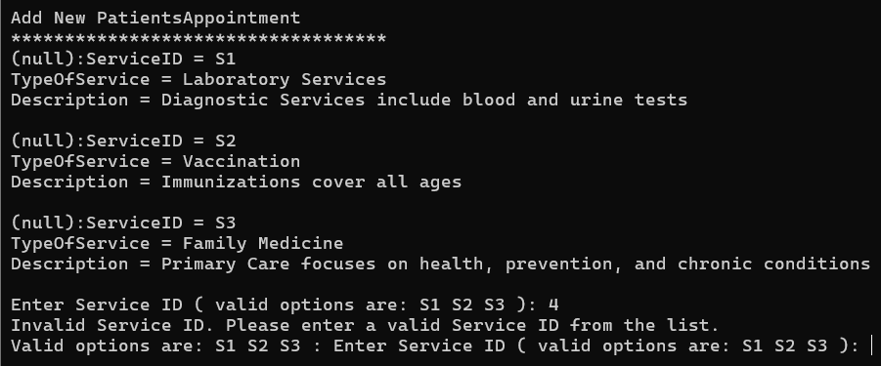

If the user does not enter the date in the correct format, it will show 'Invalid date format. Please enter a valid date (YYYY-MM-DD).

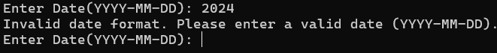

If the user does not enter the time in the correct format, it will show 'Invalid time format. Please enter a valid time (HH).

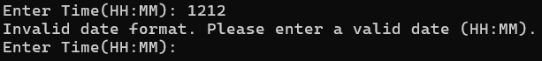

If the user types 'E4', it will show 'Invalid Doctor ID. Please enter a valid Doctor ID from the list.'



### **6.4.4 Cancel Appointment**

### **6.4.4.1 Add New Cancel Appointment**

Choose option 1, then enter the appointment ID you want to cancel. After that, you'll be prompted to write the reason for the cancellation. Once the reason is entered, it will show 'CancelAppointment added successfully!

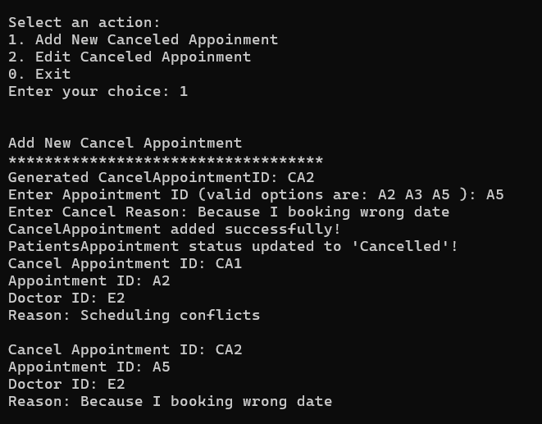

This is the SQLite for cancelling appointments.

Before

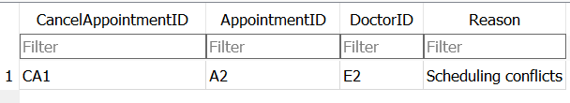

After

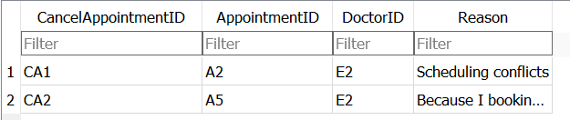

After that, the system will show the cancellation appointment history. If you choose 'Y', you can continue to make a cancellation appointment. If you choose 'N', you will return to the patient menu.

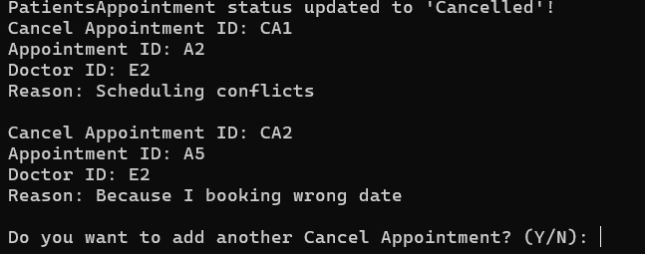

If you choose 'Y', you can continue to cancel another appointment.

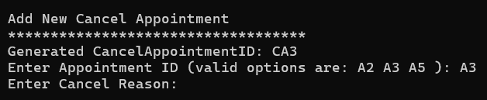

If you choose 'N', you will return to the patient menu.



If the appointment has already been cancelled and the user tries to enter it again, it will show 'This Appointment ID has already been cancelled. Update process exited.'

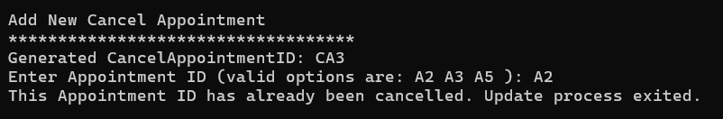

### **6.4.4.2 Edit Cancelled Appointment**

Choose '2' to edit an appointment. You will need to provide the appointment ID, and the edited reason for the change.

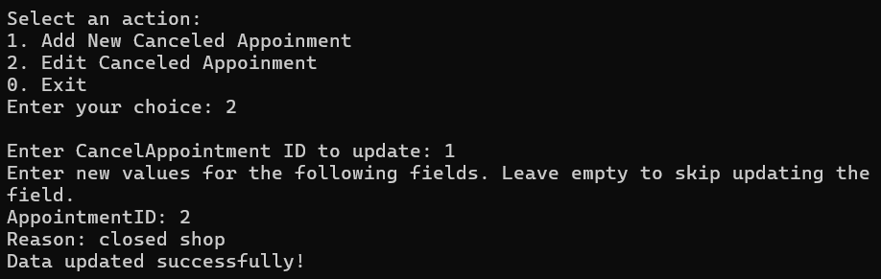

This is the SQLite of cancel appointment.

Before

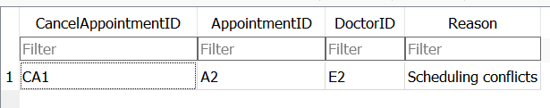

After

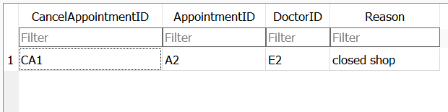

If the ID entered is not correct, it will show 'No relevant search results found.

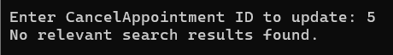

If the user does not type anything, it will show 'No fields were updated.

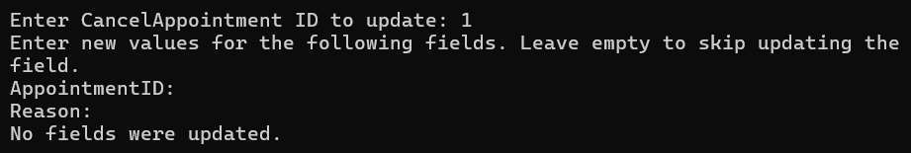

If the user enters a non-relevant cancellation appointment ID, it will show 'No relevant search results found.

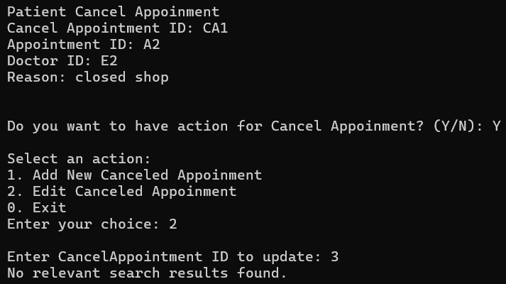

If the user enters a non-relevant appointment ID, it will show 'Invalid Appointment ID. Please enter a valid Appointment ID.'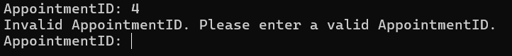

### **6.4.5 Appointment History**

Choose '5' user can view the appointment history prior to the current appointment.

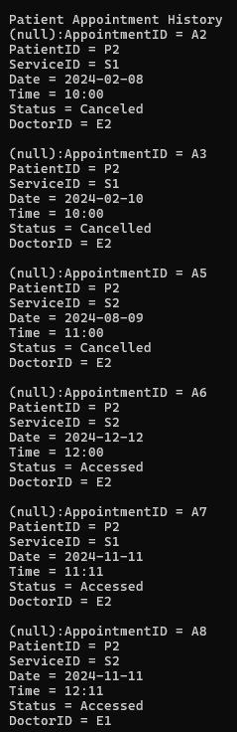

### **6.4.6 Medical Diagnosis**

Choose '6' user can view the patient's medical diagnosis information.

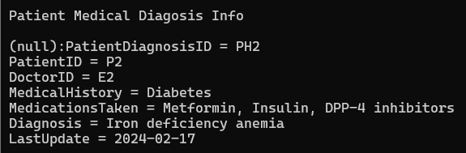

### **6.4.7 Allergy**

### **6.4.7.1 Add New Patient Allergy**

Choose '1', then enter the allergy name, severity, and reaction. After doing so, it will show 'Patient Allergy added successfully!

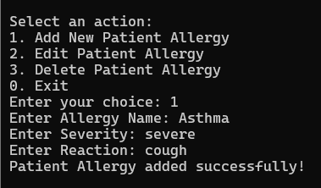

This is the SQLite of allergy.

Before

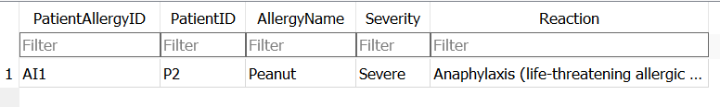

After

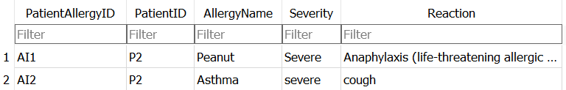

### **6.4.7.2 Edit Patient Allergy**

Choose '2', then enter the allergy name, severity, and update the reaction. After doing so, it will show 'Data updated successfully!

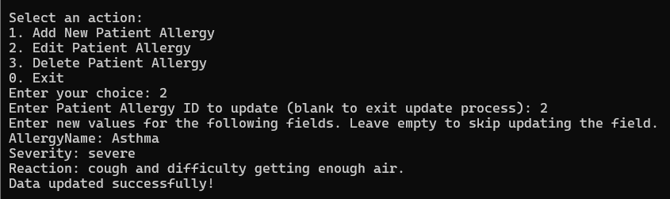

This is the SQLite of allergy.



After

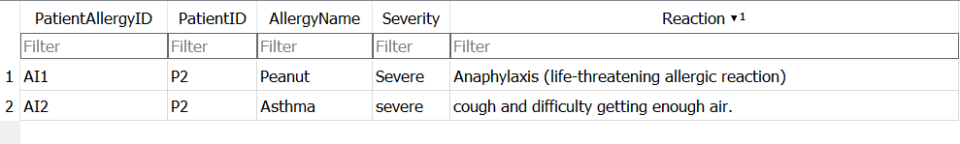

### **6.4.7.3 Delete Patient Allergy**

Choose '2' to delete an allergy. After doing so, it will show 'Data deleted successfully!

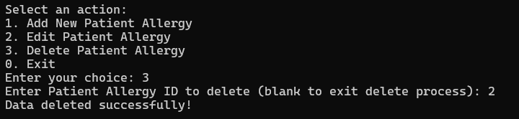

Before



After

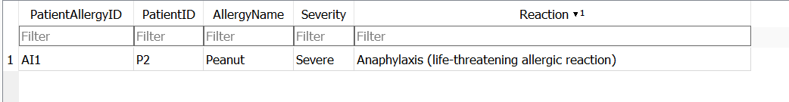

### **6.4.7.4 Exit**

When the user types '0', they will be redirected to the patient menu.

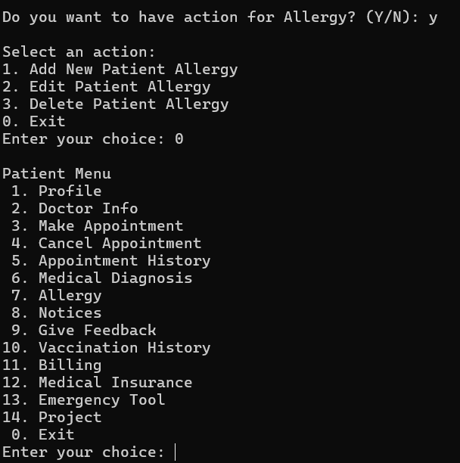

### **6.4.8 Notices**

Choose '8' to view the notice.

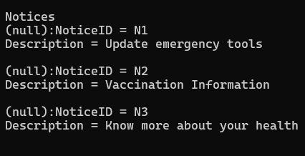

### **6.4.9 Give Feedback**

### **6.4.9.1 Add New Feedback**

Select '1' to add new feedback.

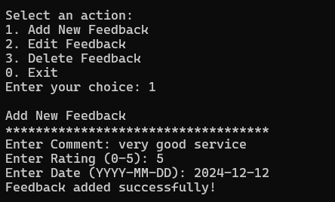

This is SQLite of feedback.

Before

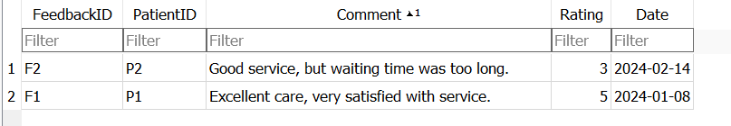

After 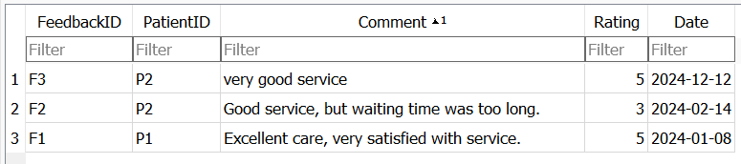

### **6.4.9.2 Edit Feedback**

Select '2' to edit the feedback.

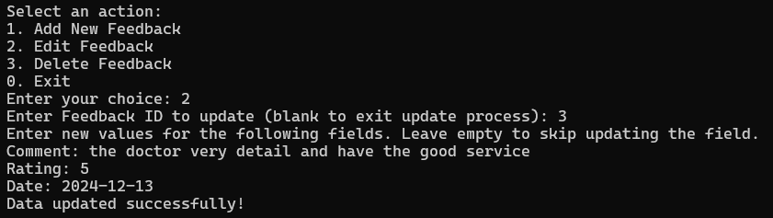

Before



After

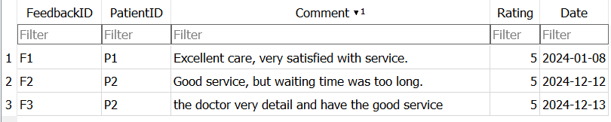

If the feedback ID is not relevant, it will show 'No relevant search results found.

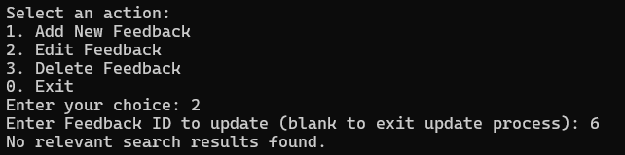

Rating wrong

If the user enters a rating that is not between 0 and 5, it will show 'Invalid rating value. Please enter a value between 0 and 5.

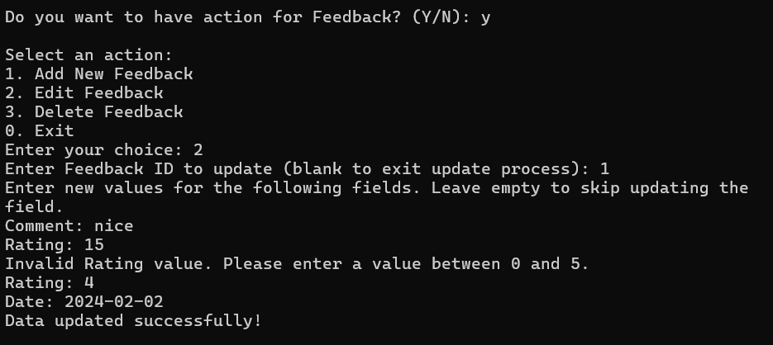

If the date is incorrect due to an invalid month, it will show 'Invalid Date. Please enter a valid date in the format YYYY-MM-DD.'

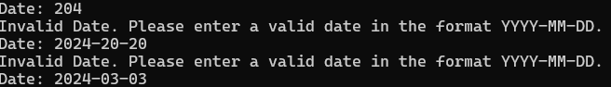

### **6.4.9.3 Delete Feedback**

Select '3' to delete the feedback.

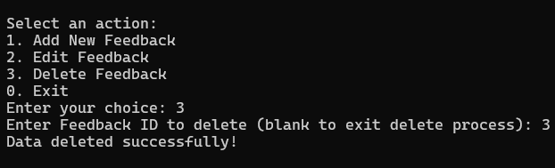

### **6.4.9.4 Exit**

When the user types '0', they will be redirected to the patient menu.

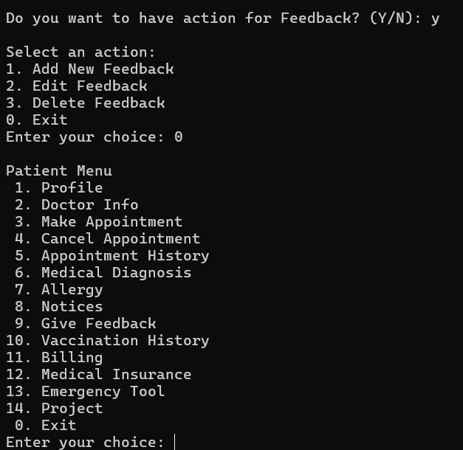

### **6.4.10 Vaccination History**

### **6.4.10.1 Add New Vaccination History**

Select '1' to add new vaccination records.

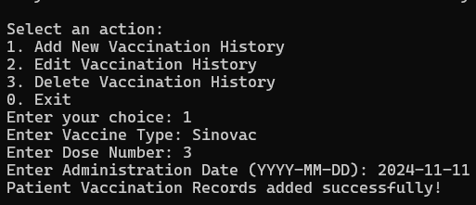

This is the SQLite of vaccination records.

Before

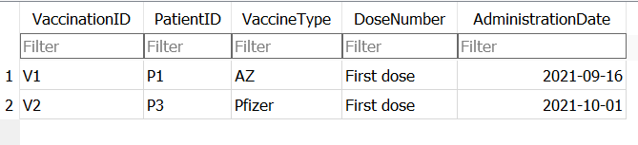

After

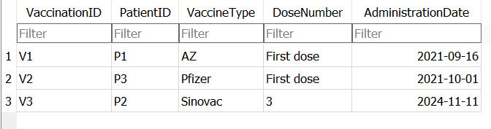

### **6.4.10.2 Edit Vaccination History**

Select '2' to update the vaccination details.

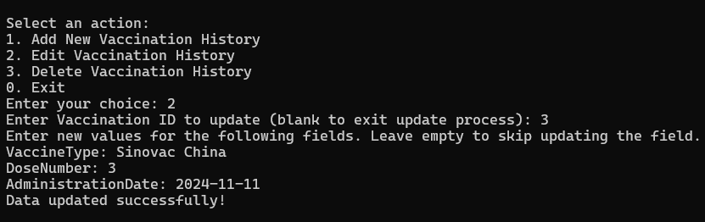

Before



After

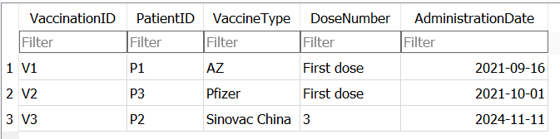

### **6.4.10.3 Delete Vaccination History**

Select '3' to delete the vaccination history.

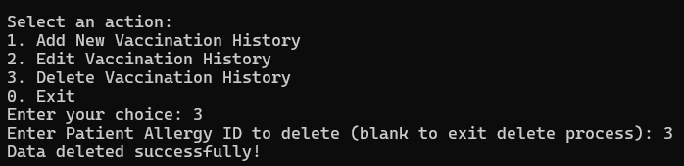

Before



After

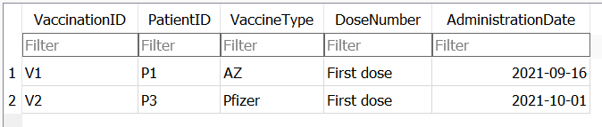

### **6.4.10.4 Exit**

When the user types '0', they will be redirected to the patient menu.

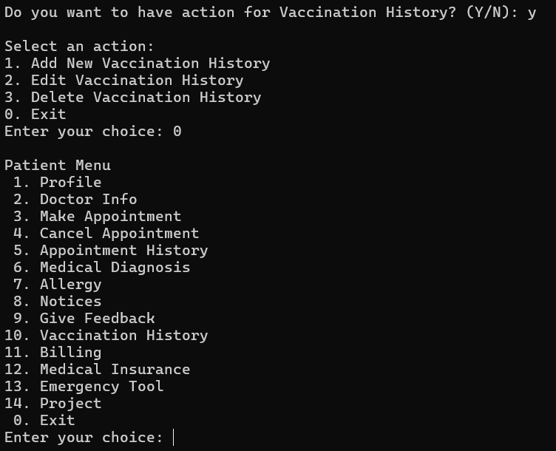

### **6.4.11 Billing**

Choose '11' to view the billing details. To confirm payment, type the bill ID. After doing so, it will show 'Payment successful.

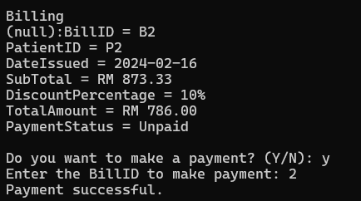

Before

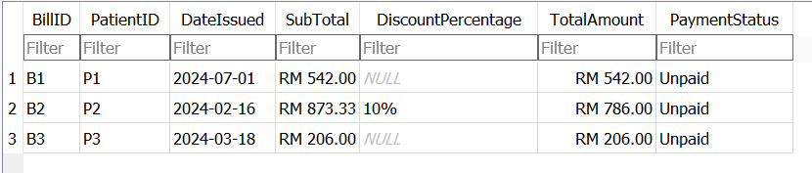

After

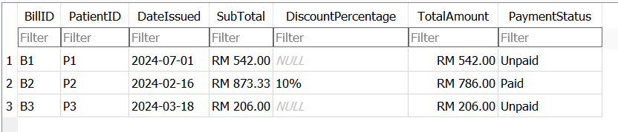

If the billing ID has already been paid and is typed again, it will show 'Payment successful.

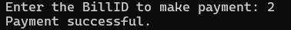

If the billing ID is not relevant, it will show 'Bill ID not found.

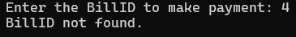

### **6.4.12 Medical Insurance**

### **6.4.12.1 Add New Medical Insurance**

Choose '1' to add new medical insurance.

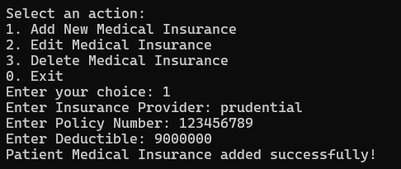

This is SQLite of medical insurance

Before

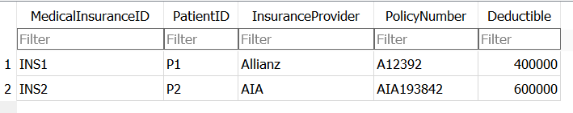

After

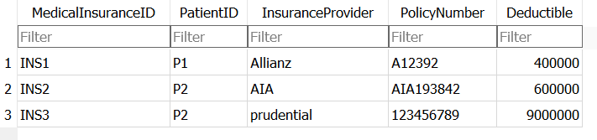

### **6.4.12.2 Edit Medical Insurance**

Choose '2' to edit the medical insurance.

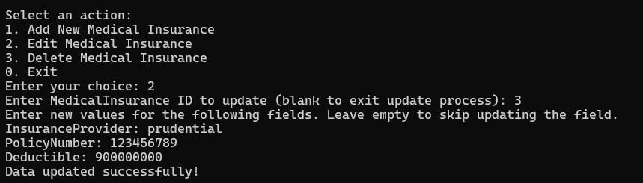

Before



After 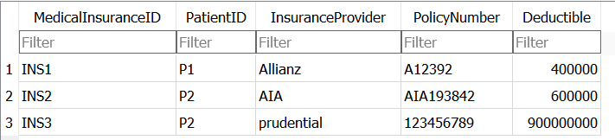

If the ID typed is not relevant, it will show 'No relevant search results found.



If nothing is typed, it will show 'No fields were updated.

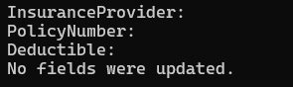

### **6.4.12.3 Exit**

### **6.4.13 Emergency Tool**

Choose '13' to view the emergency tool information.

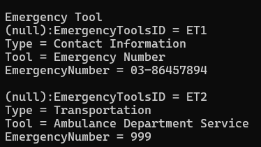

### **6.4.14 Project**

Choose '14' to view the project.

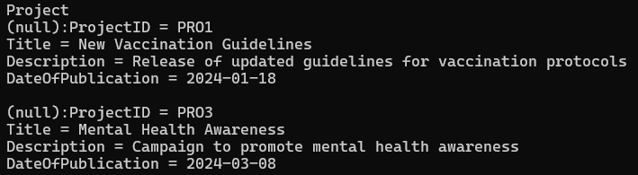

## 

## **6.5 Doctor Menu**

### **6.5.1 Profile**

Select 1 for profile

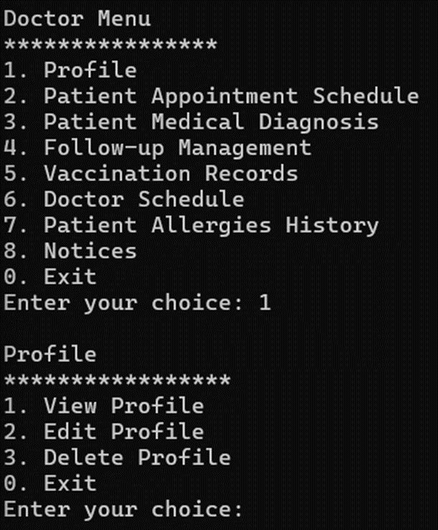

Select 1 to view the doctor profile. The profile includes the user ID, name, IC number, gender, position, contact number, email, address, username, and password.

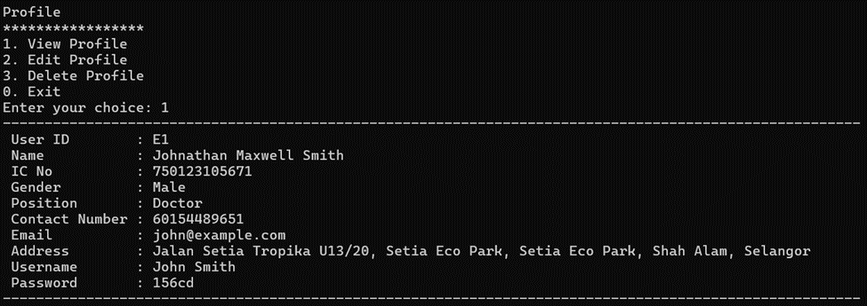

Select 2 to edit the doctor profile. All the information of the doctor can be edited except the position where the user doesn't have the privileges to modify. Here I edit the contract number from 60154489651 to 60101574826.

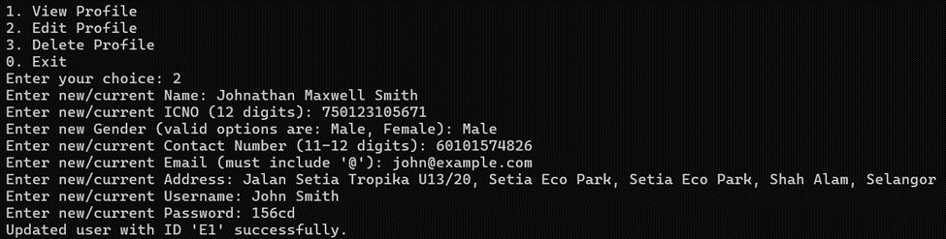

Result

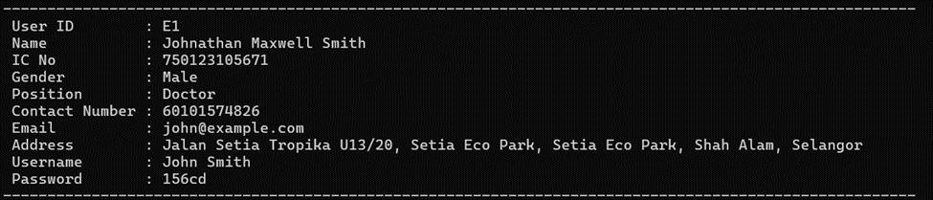

The data stored on database Sqlite3 also will update when user edit their profile.



Invalid Input



The Name can’t be blank.



The IC number needs to enter 12 digits.



The gender only can enter ‘male’, ‘female’, ‘Male’ , or ‘Female’.



The contact number should be entered 11-12 digits.



The email must include ‘@’.



The Address can’t be blank.



The Username can’t be blank.



The Password can’t be blank.



Select 3 for delete profile. Delete profile means delete the account. After deletion, the user can't login with the current username, and password.

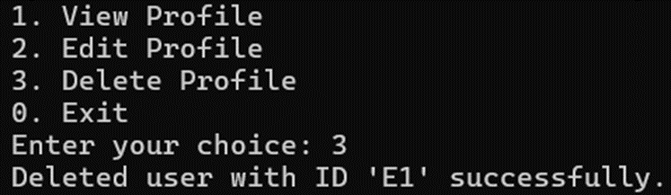

Select 0 for exit.

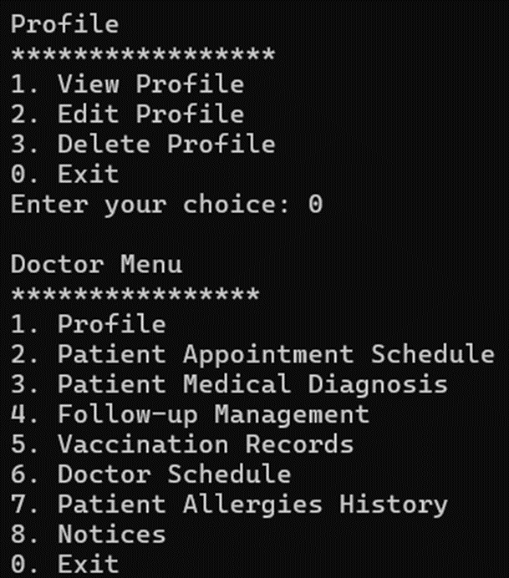

### **6.5.2 Patient Appointment Schedule**

Select 1 for viewing patient appointments. Here the doctor only can view own patient appointments. Now I login to the doctor account and the doctor ID is “E1”. So, here only will show the patient appointment that selected this doctor.

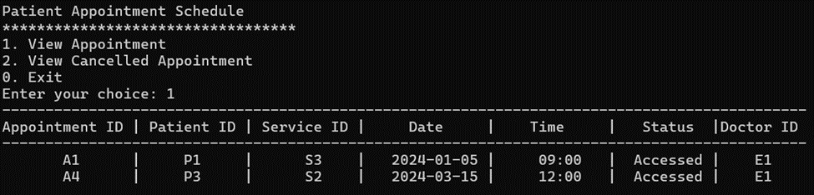

All the patient appointment records on database Sqlite3.

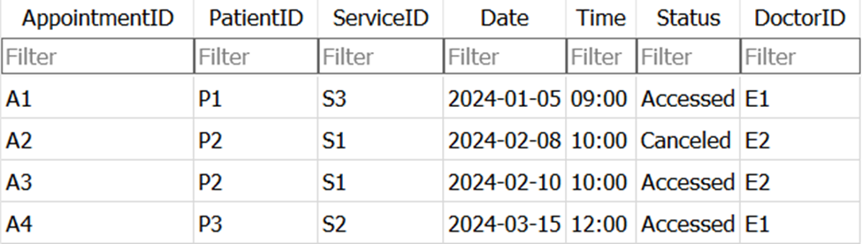

Select 2 for view cancelled appointment. Due to the patient which selected this doctor didn’t have to cancel any appointment, so here will not show anything.

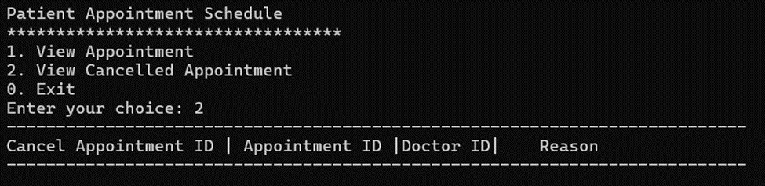

The other doctor with doctor ID “E2”, which can view the cancelled appointment by his patient.

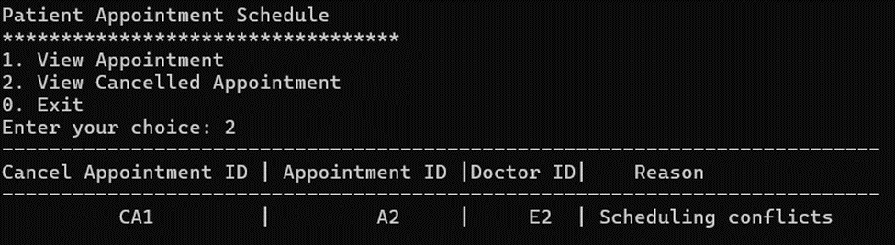

All the patients cancelled appointment records on database Sqlite3.

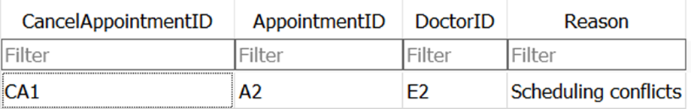

Select 0 for exit.

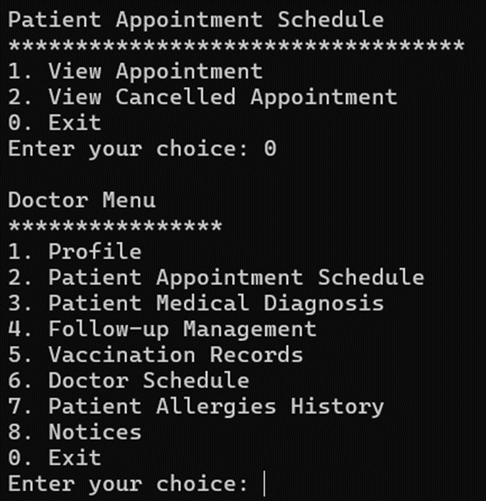

### **6.5.3 Patient Medical Diagnosis**

Select 1 to add a patient medical diagnosis. For the patient ID doctor only needs to enter the integer, it will auto generate the ‘P’ at front.

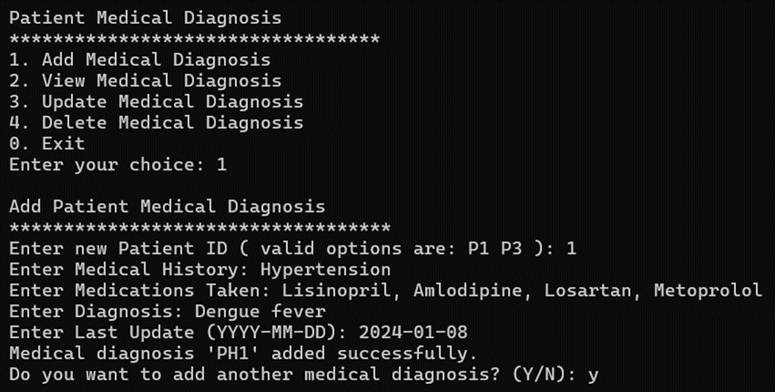

For the asking “Do you want to add another medical diagnosis? (Y/N)”, if a user enters ‘y’ or ‘Y’, the user can add another more patient medical diagnosis.

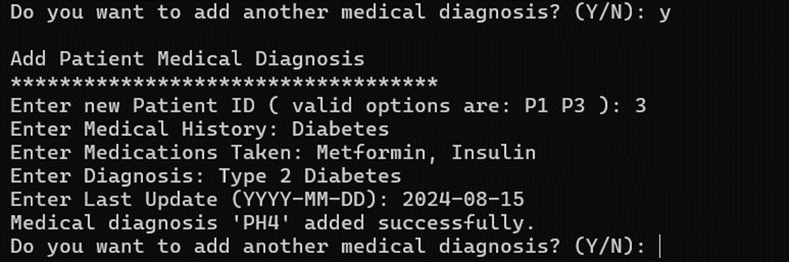

Instead, the doctor selects ‘n’ or ‘N’, and returns the patient to the medical diagnosis menu.

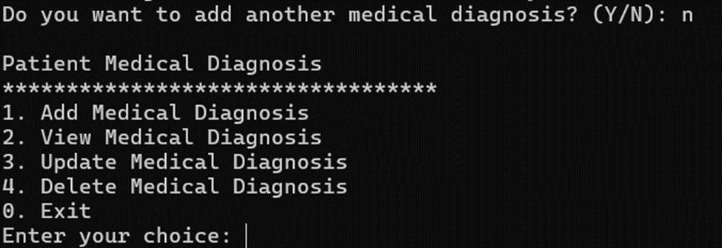

Invalid Input

Disallow to enter other patient IDs and only can enter integers.

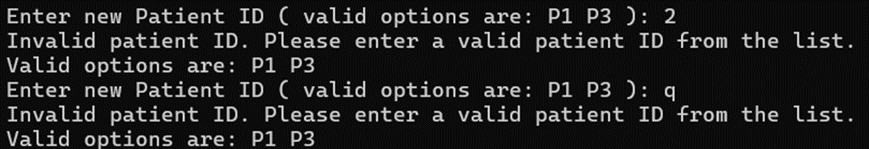

Date must enter in (YYYY-MM-DD) format.

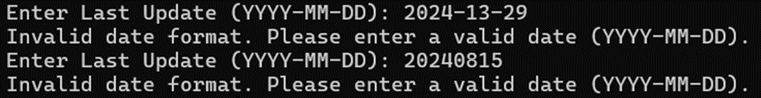

Select 2 to view the patient's medical diagnosis. Doctors are only allowed to view their own patient medical diagnosis.

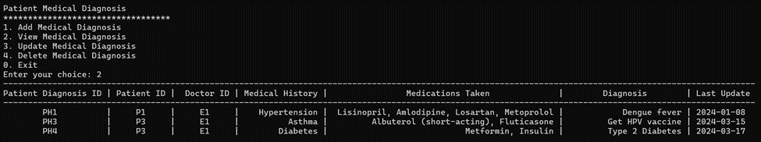

Put blank can exit the delete process.

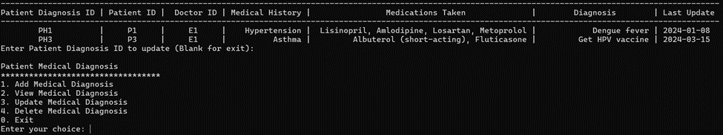

Select 3 for updating patient medical diagnosis. Here has updated the PH4’s date from 2024-03-17 to 2024-03-28.

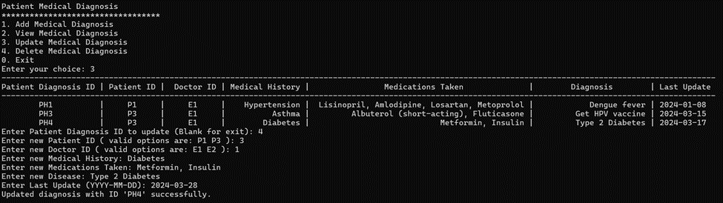

Result on database Sqlite3.

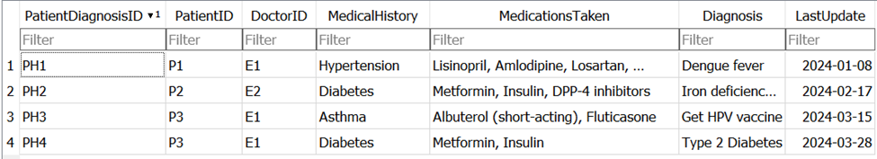

If a doctor tries to enter the patient diagnosis ID not in the list will show he is not authorized to perform an update.

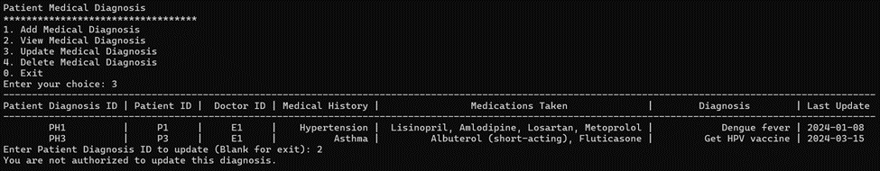

When the patient diagnosis ID is updated as “E2” which is another doctor ID, the current doctor can’t view the patient diagnosis information any more.

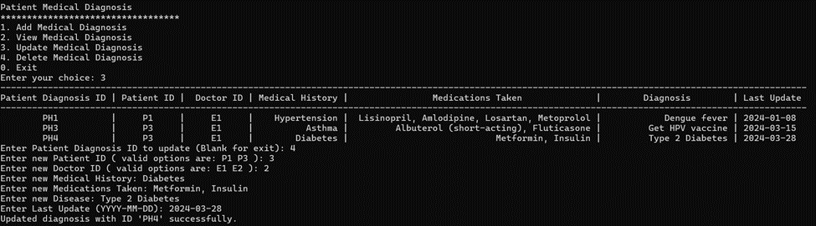

Here are the results.



Put blank can exit the delete process.

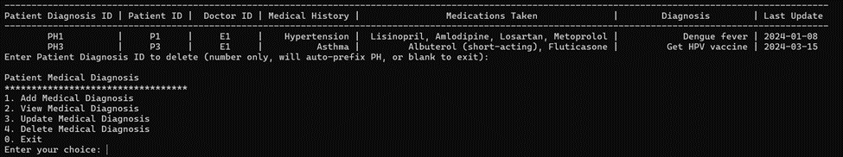

Invalid Input

Doctor ID only allows entering valid ID which is “E1” and “E2”.



Select 0 for exit.

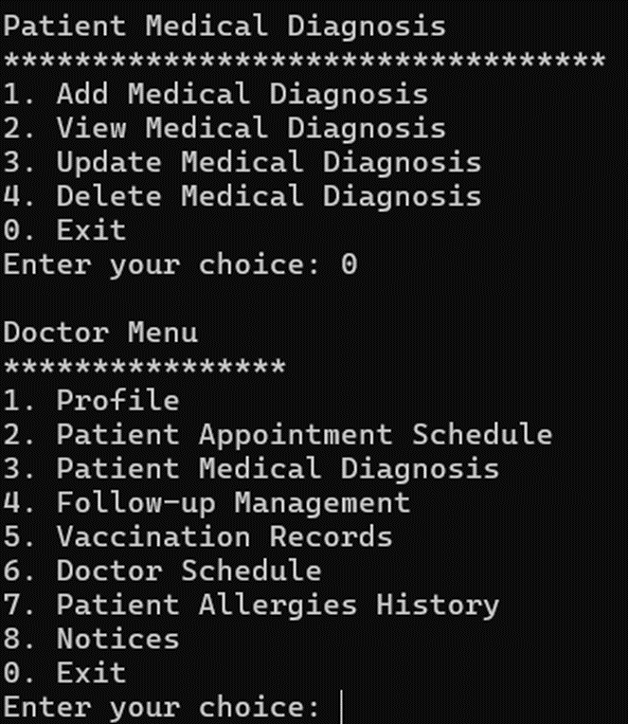

#### **6.5.4.1 Patient Follow-up**

Select 4 for follow-up management. After this will show the follow-up management menu for doctor to select patient follow-up.

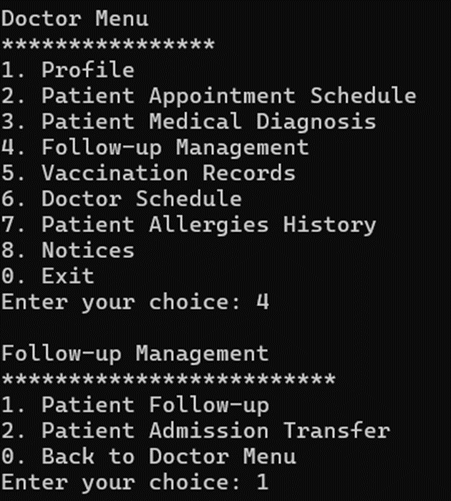

Select 1 for add patient follow-up. Doctors only allow to add own patient’s diagnosis ID.

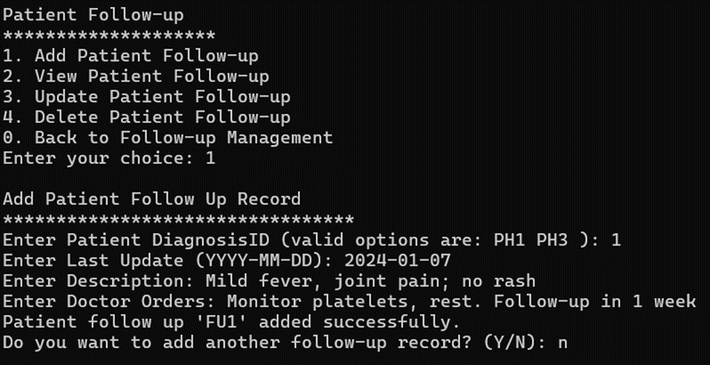

Invalid input

Patient diagnosis ID only can enter valid ID which are “PH1” and “PH3”.



The date must enter in (YYYY-MM-DD) format.



Select 2 for view patient follow-up. Doctors only will vie own patient follow-up information.

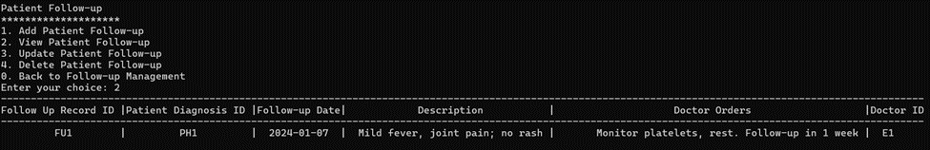

Select 3 for update patient follow-up. Before performing an update, they will show the doctor the following record he added before. Update last update from “2024-01-15” to “2024-01-20” and “Respiratory pain; ongoing meds” to “Respiratory pain”.

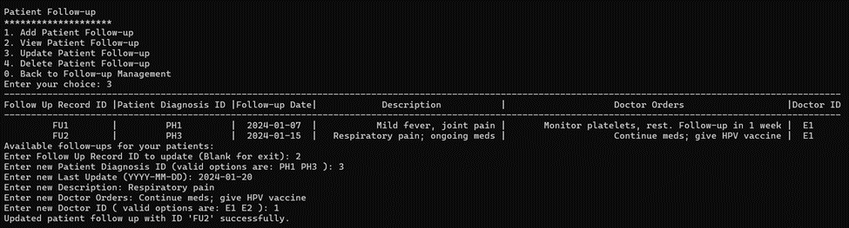

Result after updating successfully.



data on database Sqlite3

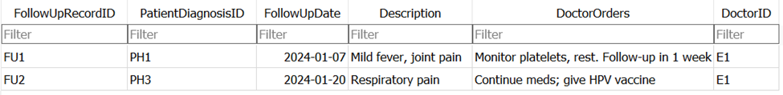

Invalid input

Enter the follow up record ID didn’t in the list will return not found.



Date needs to be entered in (YYYY-MM-DD) format.



Can’t enter the invalid doctor ID.



Put blank can exit



Select 4 for delete patient follow-up.

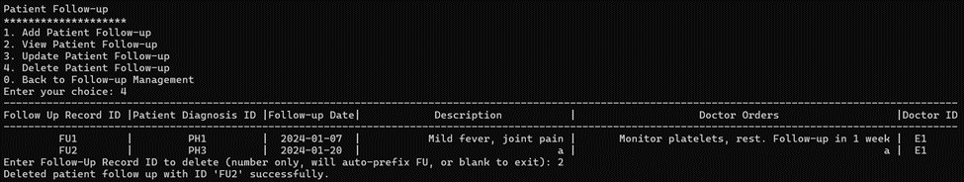

Enter the follow up record ID didn’t in the list will return not found.



Put blank can exit

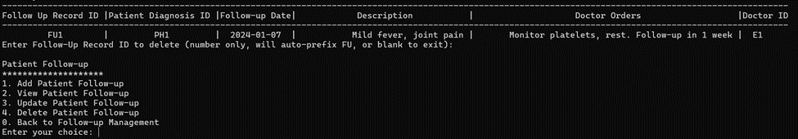

Select 0 for exit

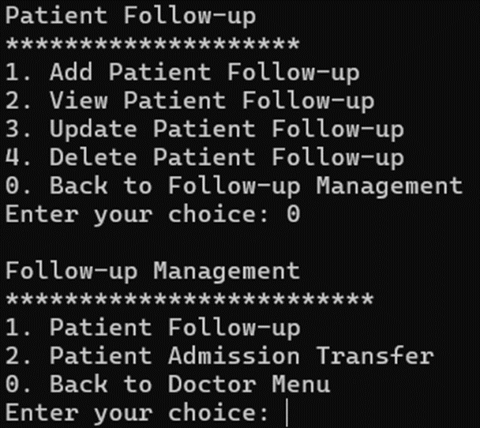

#### **6.5.4.2 Patient Admission Transfer**

Select 1 for add patient admission transfer.

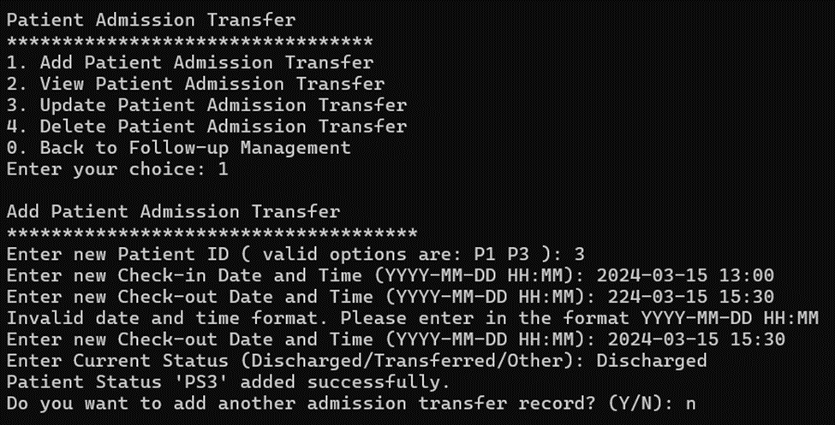

Select 2 for view patient admission transfer.



Select 3 for update patient admission transfer. Doctors can select the patient status ID they want to perform an update. Update check-in time from 2024-03-15 13:00 to 2024-03-15 14:00.

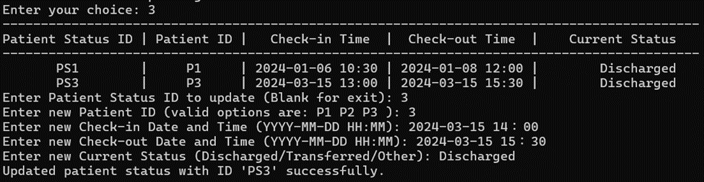

Invalid input

The check-in date and time must enter in (YYYY-MM-DD HH:MM) format.



The check-out date and time must enter in (YYYY-MM-DD HH:MM) format.



If the doctor entered the patient status ID didn’t in the list return not found.

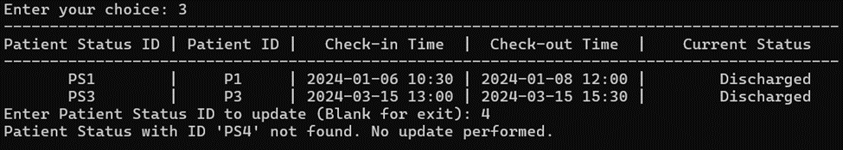

Put blank for exit

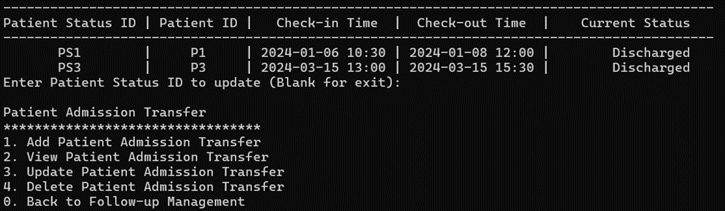

Select 4 for delete patient admission transfer. Enter patient status ID to perform deletion.

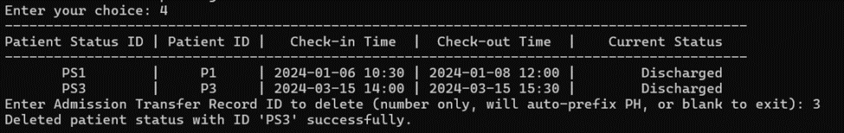

If a doctor entered the patient status ID didn’t in the list return not found.

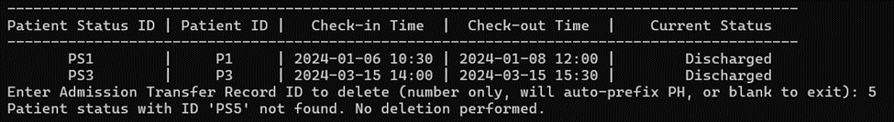

Put blank for exit

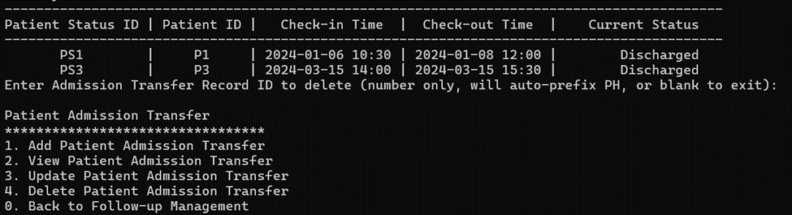

Select 0 for exit

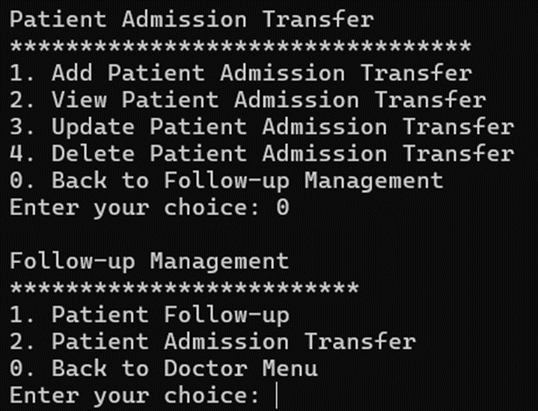

### **6.5.5 Vaccination Records**

Choose '5' to view the vaccination records.

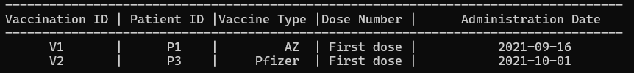

### **6.5.6 Doctor Schedule**

Choose '6' to view the doctor schedule.

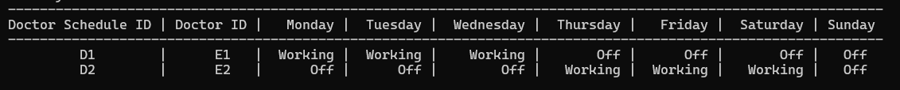

### **6.5.7 Patient Allergies History**

Choose '7' to view the patient's allergies history.



### **6.5.8 Notices**

#### **6.5.8.1 Emergency Tools**

Choose '1' to view the emergency tools.



#### **6.5.8.2 Project**

Choose '2' to view the project.



#### **6.5.8.3 Back to Doctor Menu**

Choose '0' to return to the doctor menu.

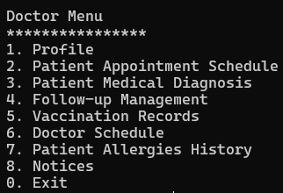

If the ID chosen is not the relevant id, it will show 'Invalid choice. Please try again.'

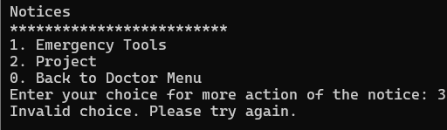

If the ID chosen is not relevant, it will show 'Invalid choice. Please try again.

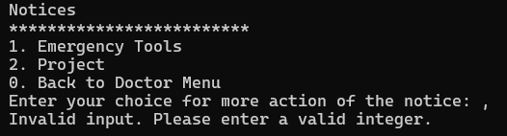

### **6.5.9 Exit**

Choose '0' to exit the doctor menu.

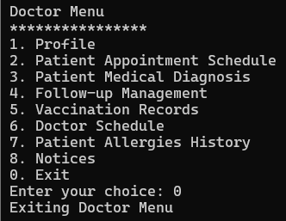

## 

## **6.6 Admin Menu**

The admin menu provides a simple interface for admin managing different functions within the system.

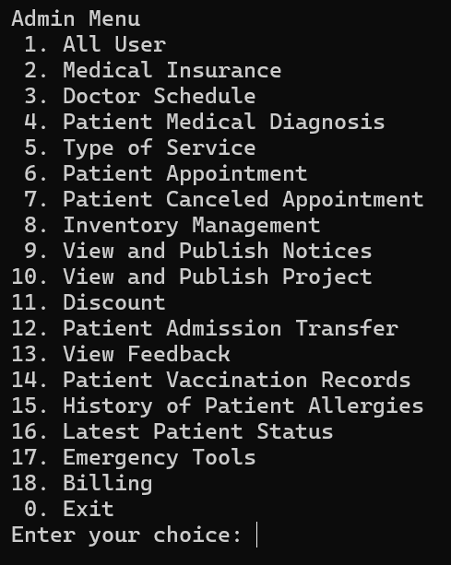

If an invalid input is entered, the system prompts the user with an "Invalid input" message and asks them to enter a valid integer. The menu then reappears for the user to select a valid option.

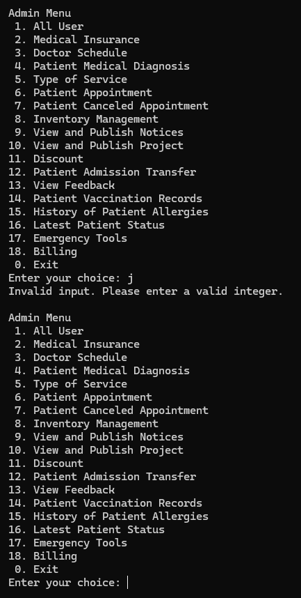

### **6.6.1 All User**

All User is a list of all users within the hospital management system displayed, including their details such as UserID, Name, ICNO, Gender, Position, Contact Number, Email, and Address.

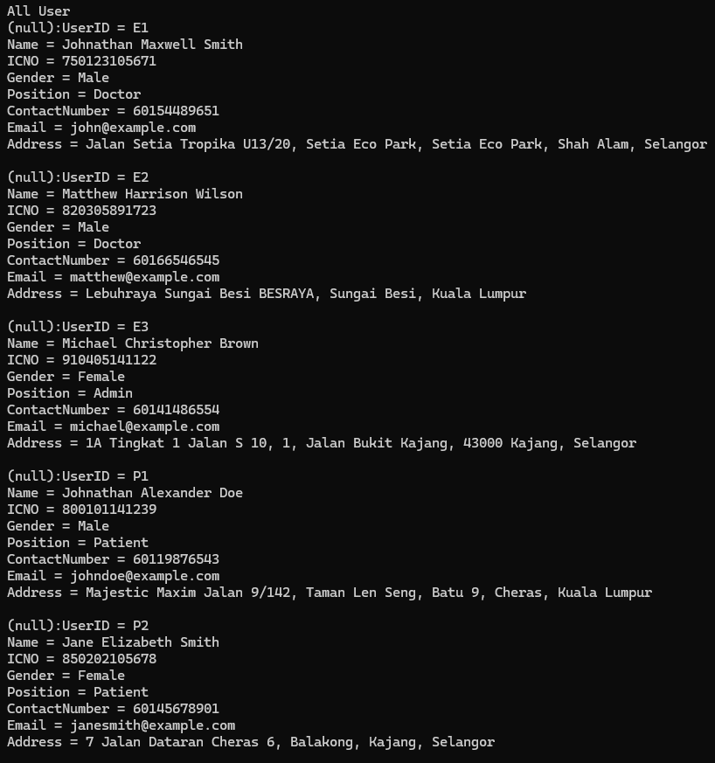

#### **6.6.1.1 Filter User**

Admin can retrieve specific user data based on chosen criteria. The system prompts the admin to filter data by various attributes.

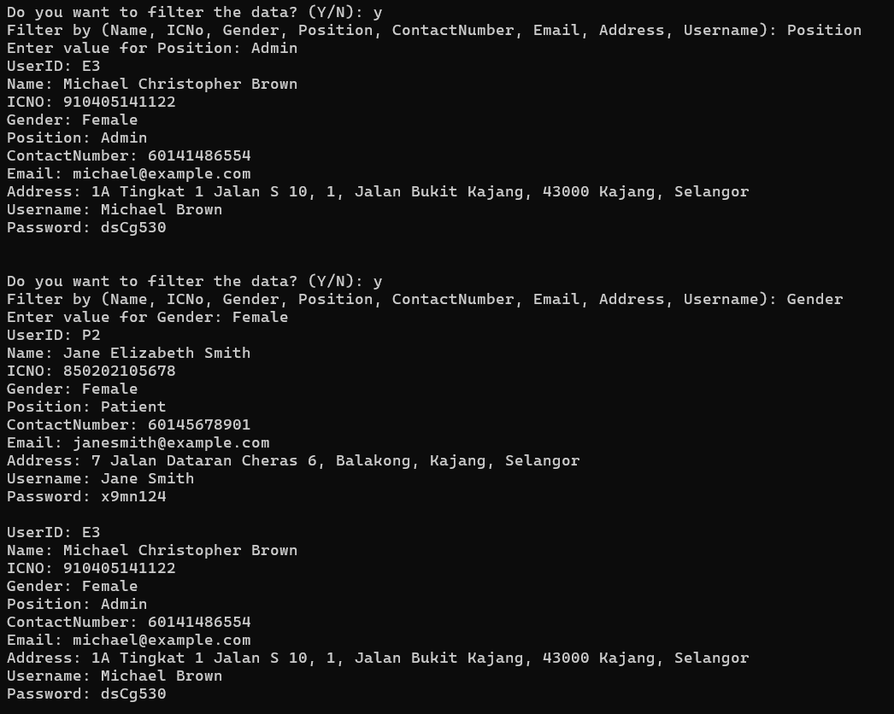

If an invalid field is entered, the system notifies the admin and requests a valid field.

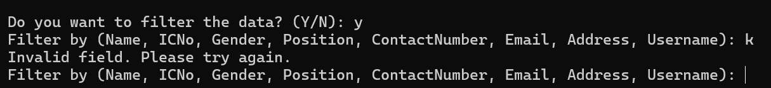

If it finds no matching results, it will show **No relevant search results found**.

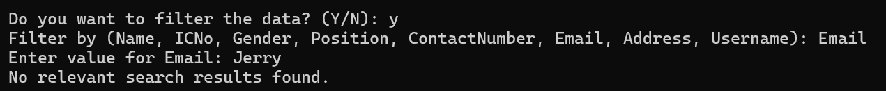

#### **6.6.1.2 Add User**

The input is validated at each step, ensuring correct formats (e.g., IC number must be 12 digits, contact number at least 10 digits, etc.). After successful validation and data entry, the user is created with a unique UserID based on their position (e.g., 'P' for patients, 'E' for doctors/admins). The system displays all existing users after creation and asks if another user should be added.

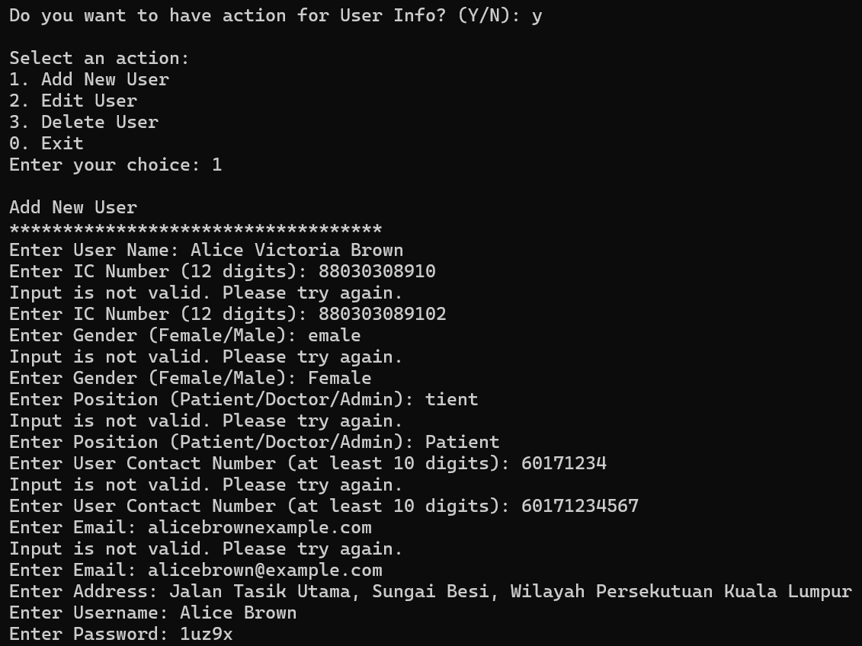

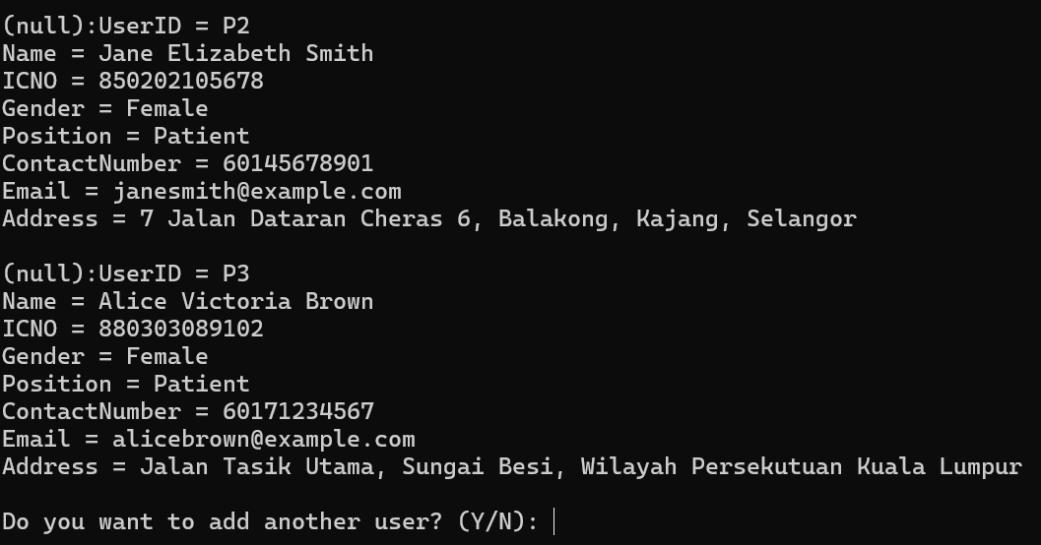

SQLite shows add the new user data successfully.

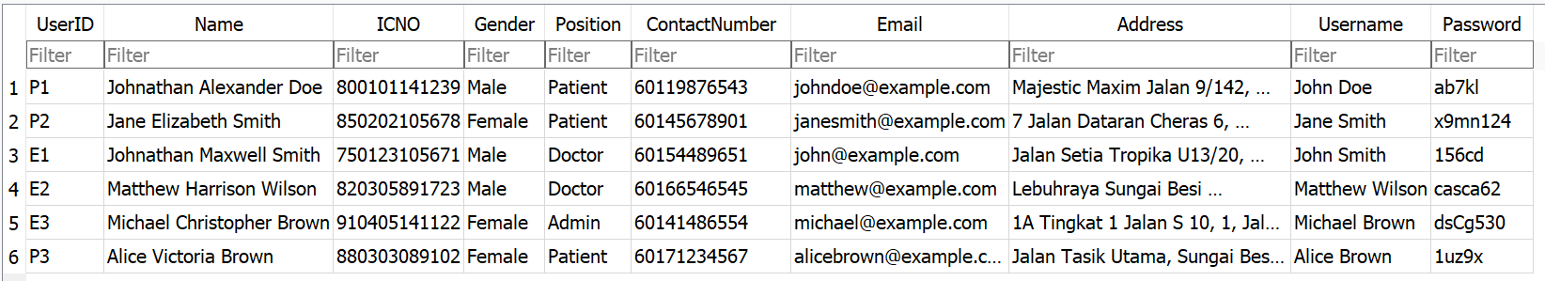

#### **6.6.1.3 Update User**

The system prompts for the **User ID**. If blank, the update process exits. If it doesn't match any records, a **no relevant search results found** message is shown, and the update process exits.

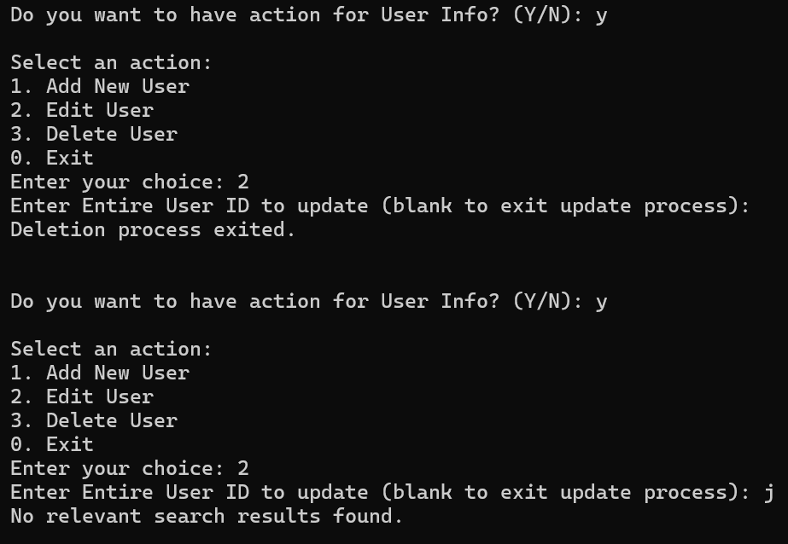

After entering a valid **User ID**, the system lets you update fields, leaving blanks unchanged. It confirms successful updates and shows the updated information.

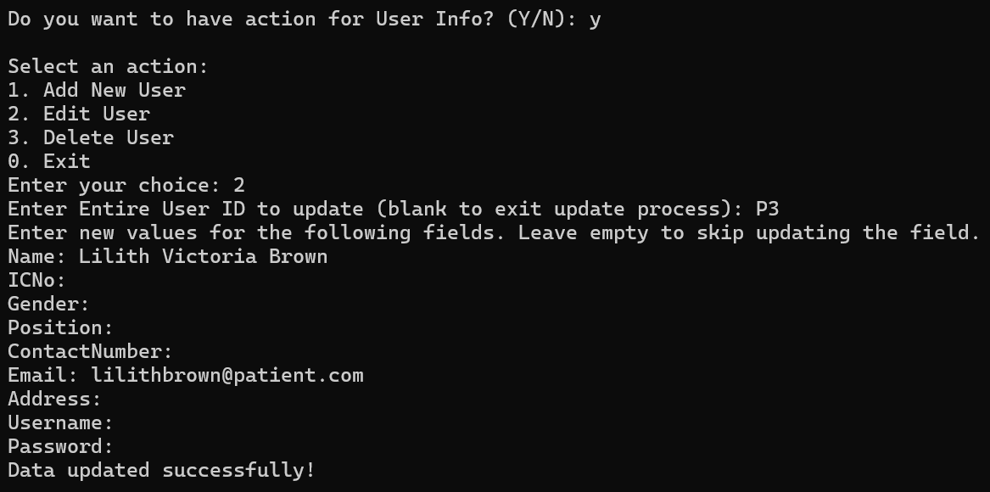

SQLite is showing the updated user information.

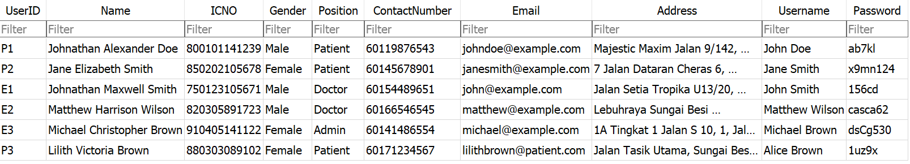

#### **6.6.1.4 Delete User**

The system prompts for the **User ID**. If blank, the deletion process exits. If it doesn't match any records, a **no relevant search results found** message is shown, and the deletion process exits.

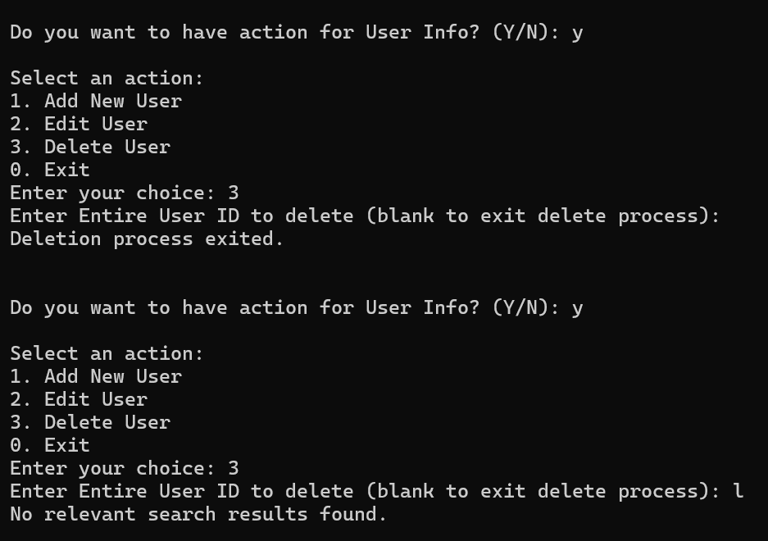

After entering a valid **User ID**, the system successfully deletes the user and confirms the deletion. Then it displays the remaining users and asks if you want to perform another action.

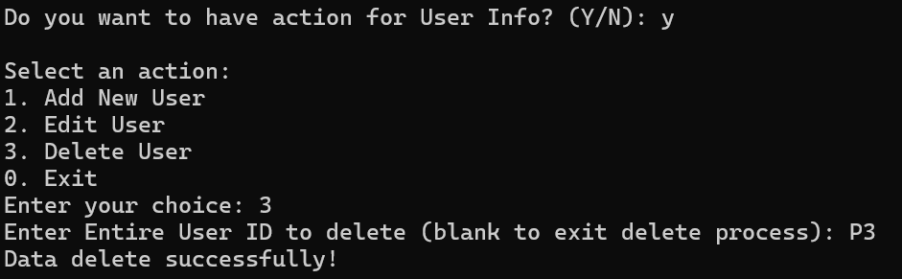

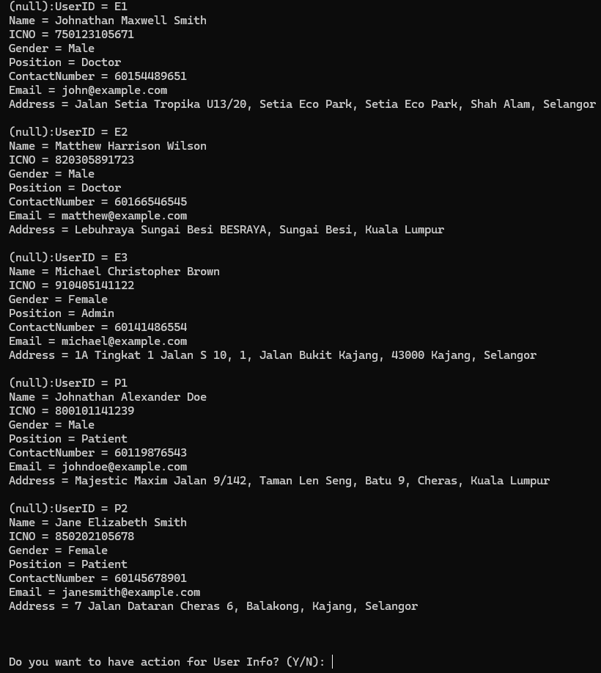

SQLite shows the user data is deleted.

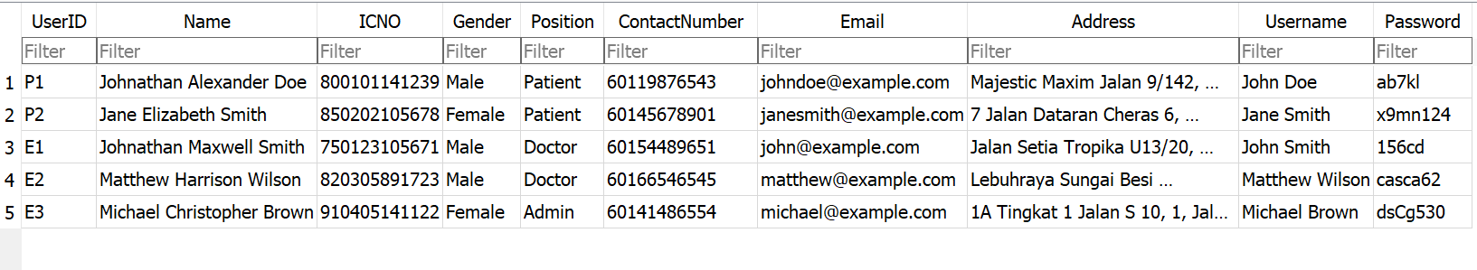

### **6.6.2 Medical Insurance**

The system displays details of the medical insurance record. After showing this information, it prompts whether you want to perform another action related to medical insurance.

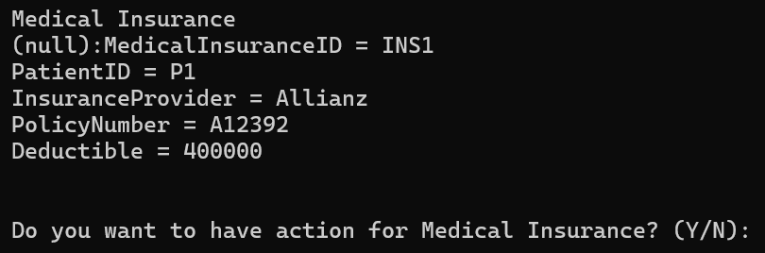

#### **6.6.2.1 Add Medical Insurance**

If an invalid **Patient ID** or non-integer value for **Deductible** is entered, the system requests correct input. Upon successful addition, the system displays the updated list of medical insurance records and asks if you want to add another.

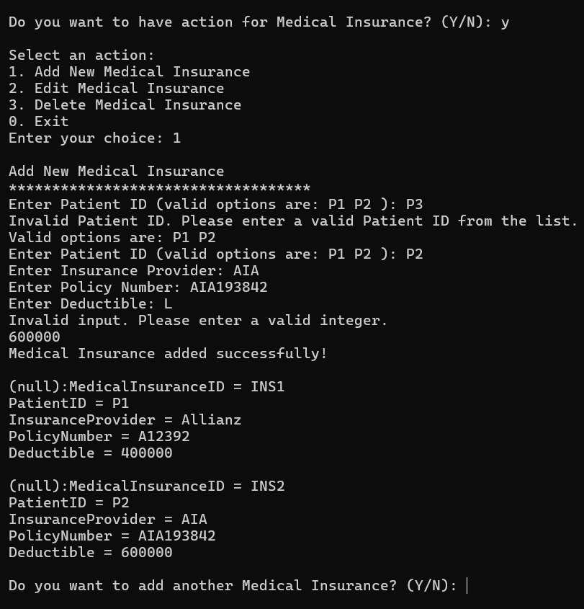

SQLite shows the new medical insurance data successfully.

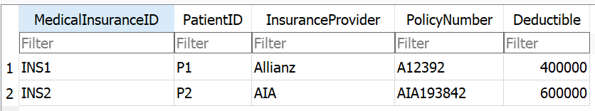

#### **6.6.2.2 Update Medical Insurance**

The system prompts for the **Medical Insurance ID**. If blank, the update process exits. If it doesn't match any records, a **no relevant search results found** message is shown, and the update process exits.

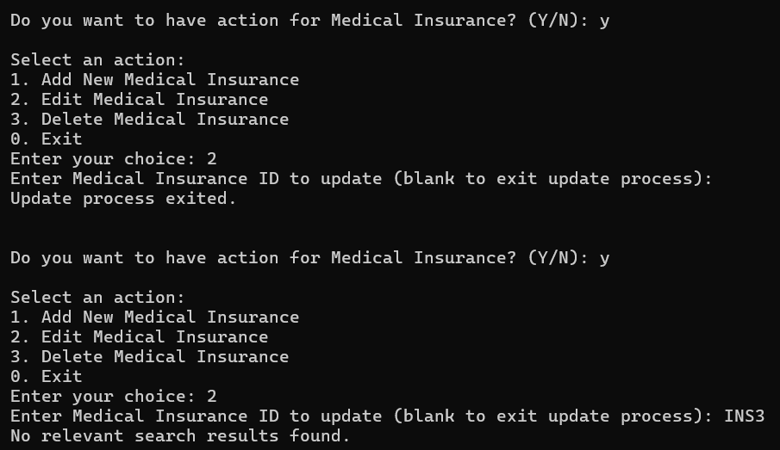

After entering a valid **Medical Insurance ID**, the system lets you update fields, leaving blanks unchanged. It confirms successful updates and shows the updated information.

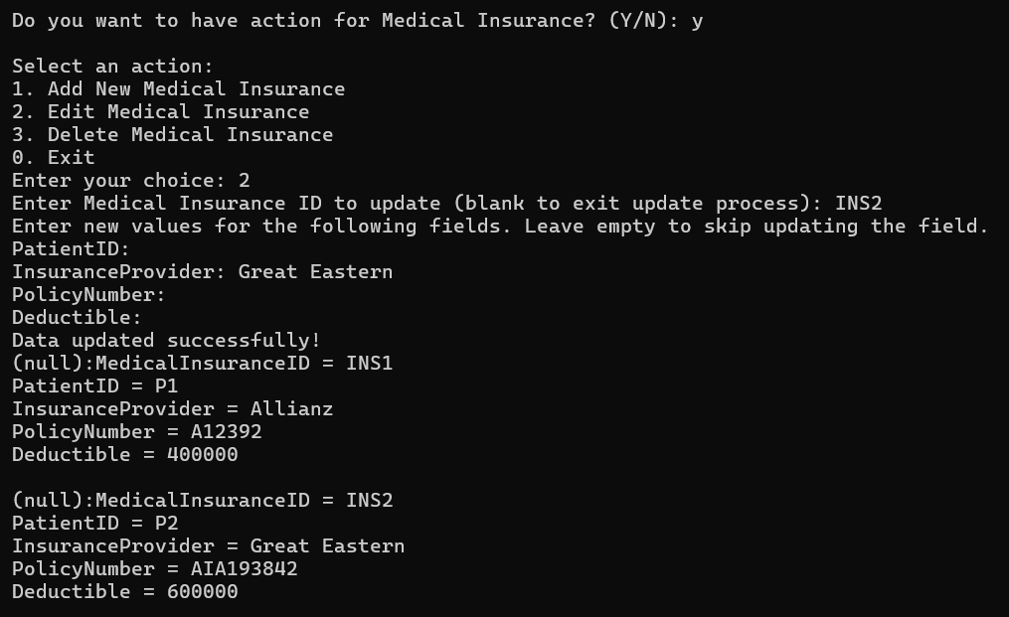

SQLite is showing the updated medical insurance information.

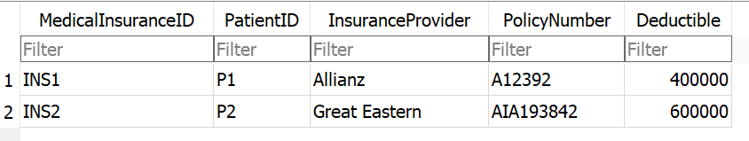

#### **6.6.2.3 Delete Medical Insurance**

The system prompts for the **Medical Insurance ID**. If blank, the deletion process exits. If it doesn't match any records, a **no relevant search results found** message is shown, and the deletion process exits.

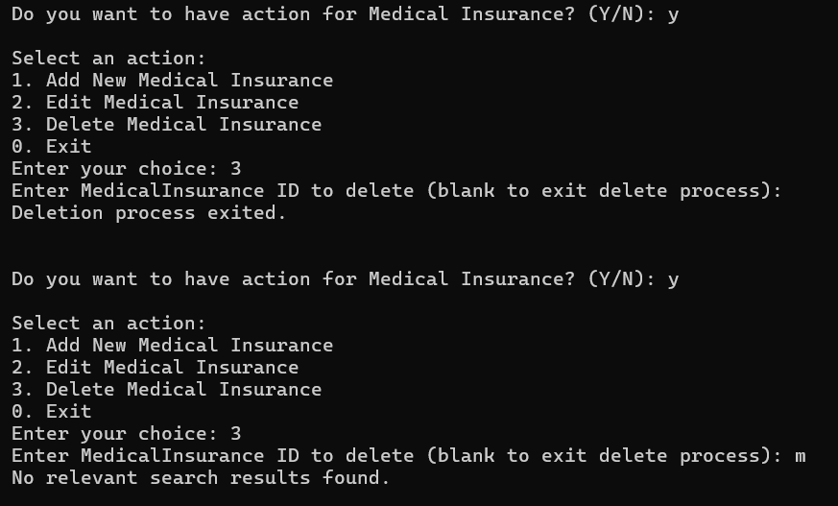

After entering a valid **Medical Insurance ID**, the system successfully deletes the user and confirms the deletion. Then it displays the remaining users and asks if you want to perform another action.

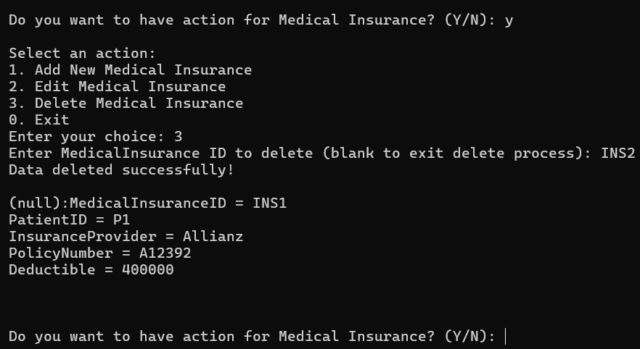

SQLite shows the medical insurance data is deleted.

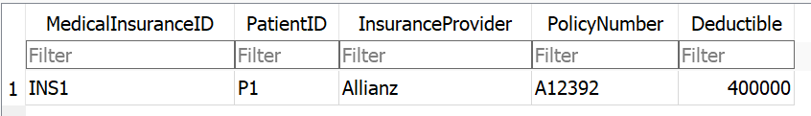

### **6.6.3 Doctor Schedule**

The system displays details of the doctor's schedule. After showing this information, it prompts whether you want to perform another action related to the doctor schedule.

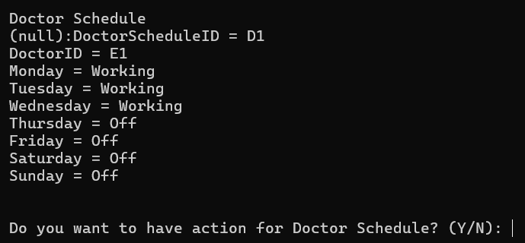

#### **6.6.3.1 Add Doctor Schedule**

The system prompts for a valid **Doctor ID**. If the **Doctor ID** is invalid, the system asks for a valid input. After entering valid details, the system confirms successful addition and displays the updated schedule. Then it asks if you want to add another schedule.

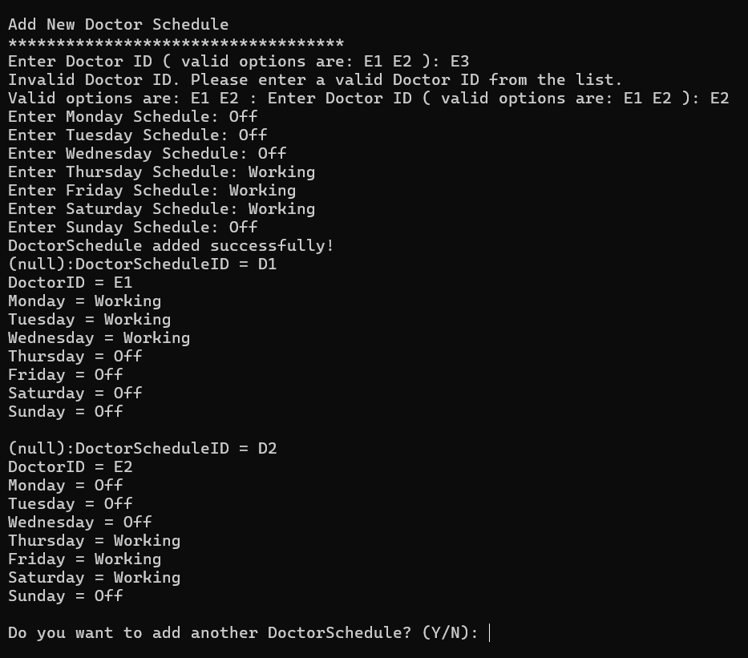

SQLite shows add the new doctor schedule data successfully.

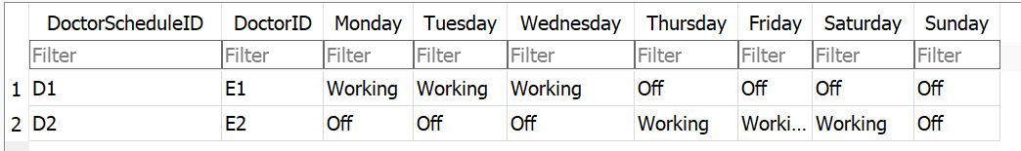

#### **6.6.3.2 Update Doctor Schedule**

The system prompts for the **Doctor Schedule ID**. If blank, the update process exits. If it doesn’t match any records, a **no relevant search results found** message is shown, and the update process exits.

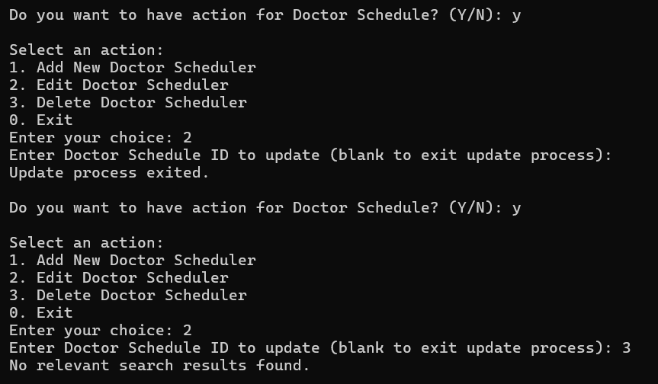

After entering a valid **Doctor Schedule ID**, the system lets you update fields, leaving blanks unchanged. It confirms successful updates and shows the updated information.

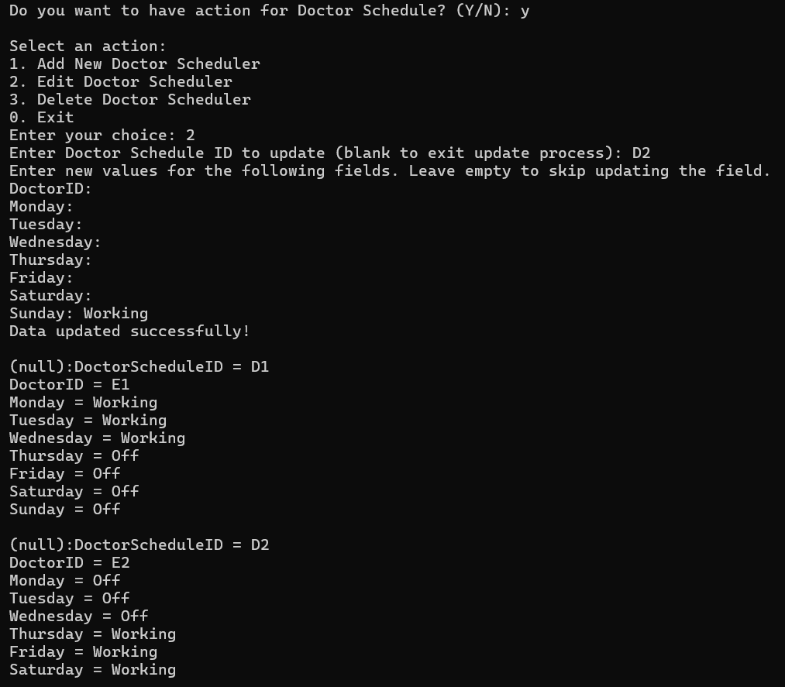

SQLite is showing the updated doctor schedule information.

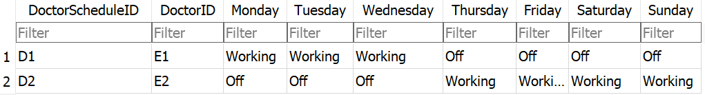

#### **6.6.3.3 Delete Doctor Schedule**

The system prompts for the **Doctor Schedule ID**. If blank, the deletion process exits. If it doesn't match any records, a **no relevant search results found** message is shown, and the deletion process exits.

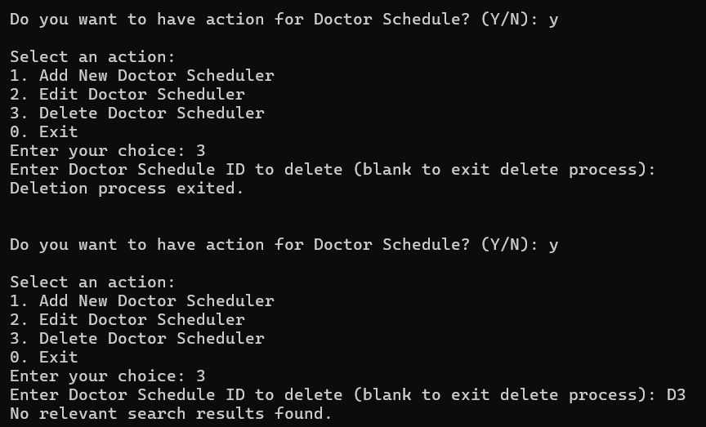

After entering a valid **Doctor Schedule ID**, the system successfully deletes the user and confirms the deletion. Then it displays the remaining users and asks if you want to perform another action.

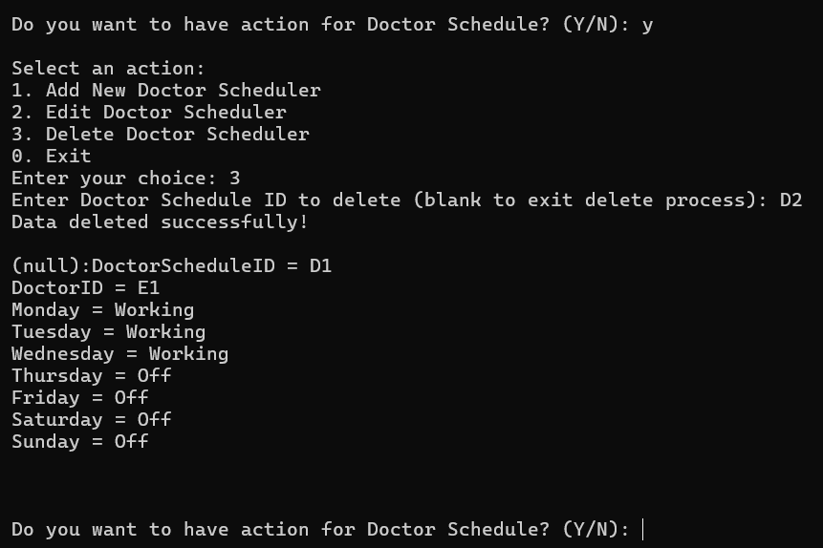

SQLite shows the user doctor schedule data is deleted.

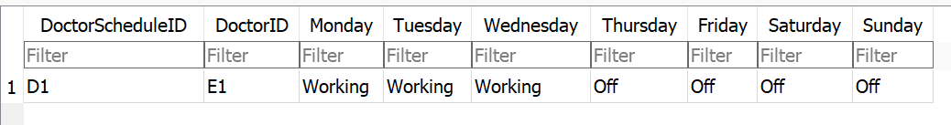

### **6.6.4 Patient Medical Diagnosis**

The system displays details of the patient’s medical diagnosis. Admin only has read rights.

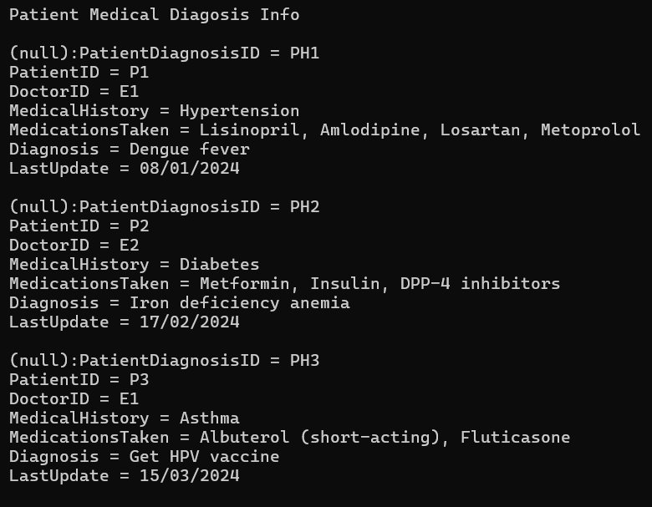

### **6.6.5 Type of Service**

The system displays details of the type of service for the clinic. After showing this information, it prompts whether you want to perform another action related to the type of service.

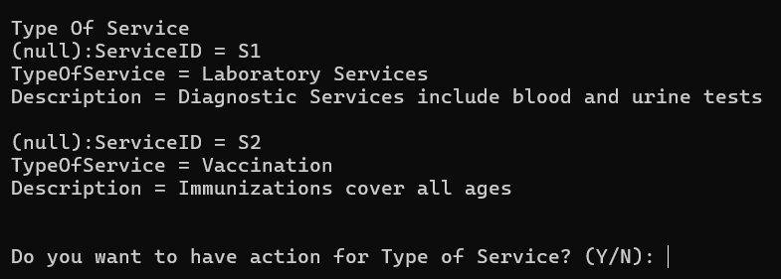

#### **6.6.5.1 Add Type of Service**

The system prompts for the service type and description. Once entered, it confirms the addition and displays the updated list of services. Then it asks if you want to add another service.

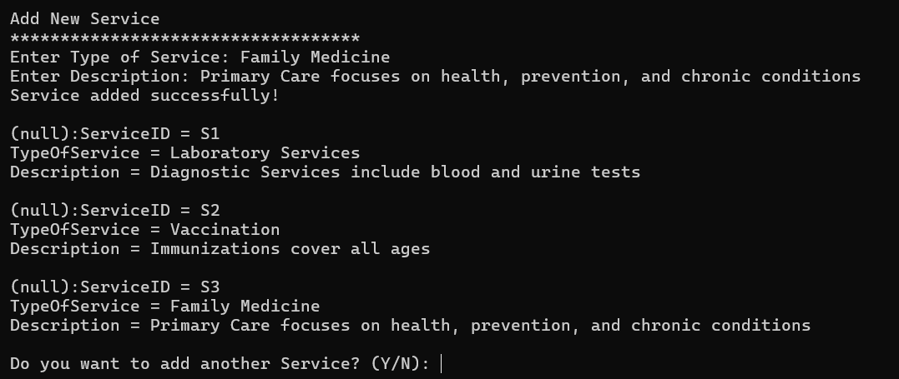

SQLite shows the new type of service data successfully.

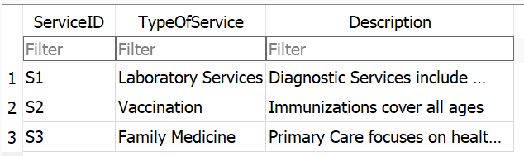

#### **6.6.5.2 Update Type of Service**

The system prompts for the **Service ID**. If blank, the update process exits. If it doesn’t match any records, a **no relevant search results found** message is shown, and the update process exits.

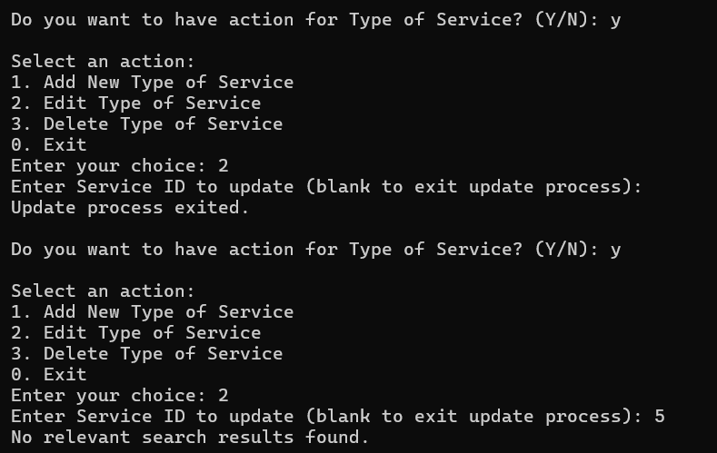

After entering a valid **Service ID**, the system lets you update fields, leaving blanks unchanged. It confirms successful updates and shows the updated information.

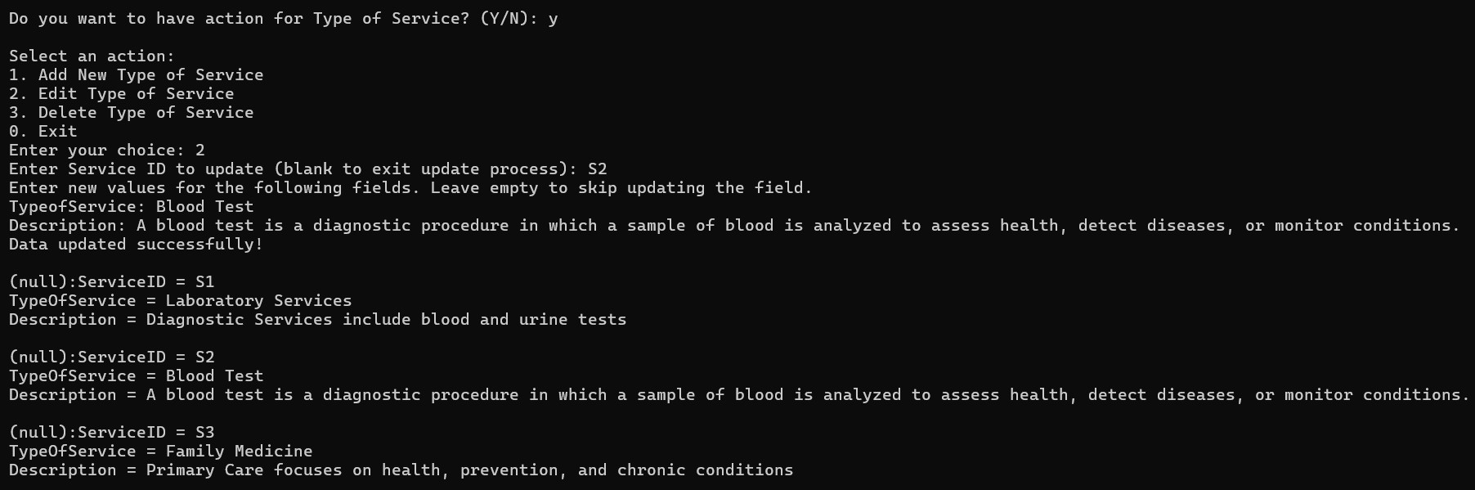

SQLite is showing the updated service information.

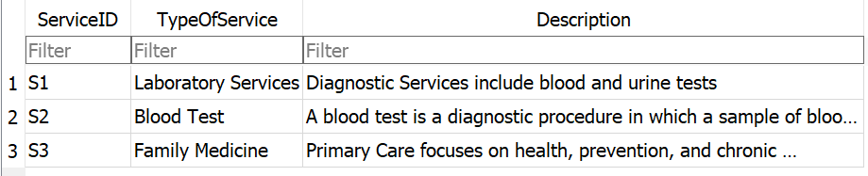

#### **6.6.5.3 Delete Type of Service**

The system prompts for the **Service ID**. If blank, the deletion process exits. If it doesn't match any records, a **no relevant search results found** message is shown, and the deletion process exits.

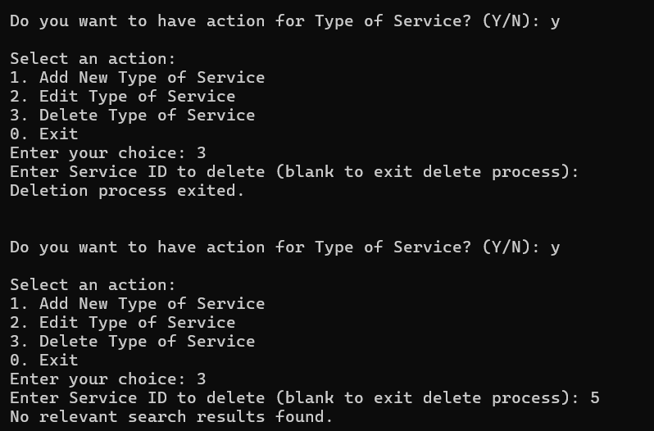

After entering a valid **Service ID**, the system successfully deletes the user and confirms the deletion. Then it displays the remaining users and asks if you want to perform another action.

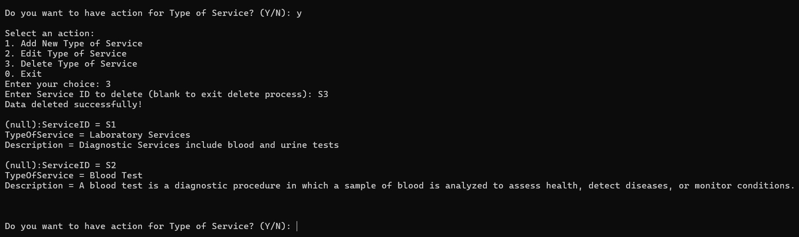

SQLite shows the service data is deleted.

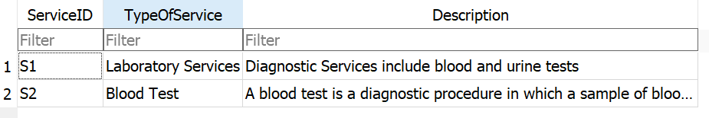

### **6.6.6 Patient Appointment**

The system displays details of the patient’s appointment, also history. After showing this information, it prompts whether you want to perform another action related to patient appointment.

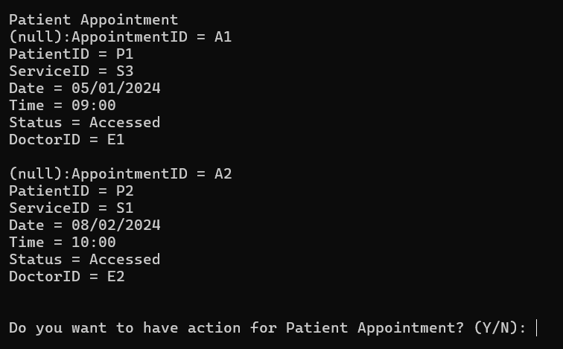

#### **6.6.6.1 Add Patient Appointment**

The system allows the admin to help patients to make appointments for them. When adding a new patient appointment, the system prompts for the Patient ID, Service ID, date, time, and Doctor ID. If invalid inputs are provided (e.g., non-existent ID or incorrect date formats), the system requests correct values. Once valid inputs are given, the system confirms the appointment and shows the updated list. It then asks if you want to add more appointments.

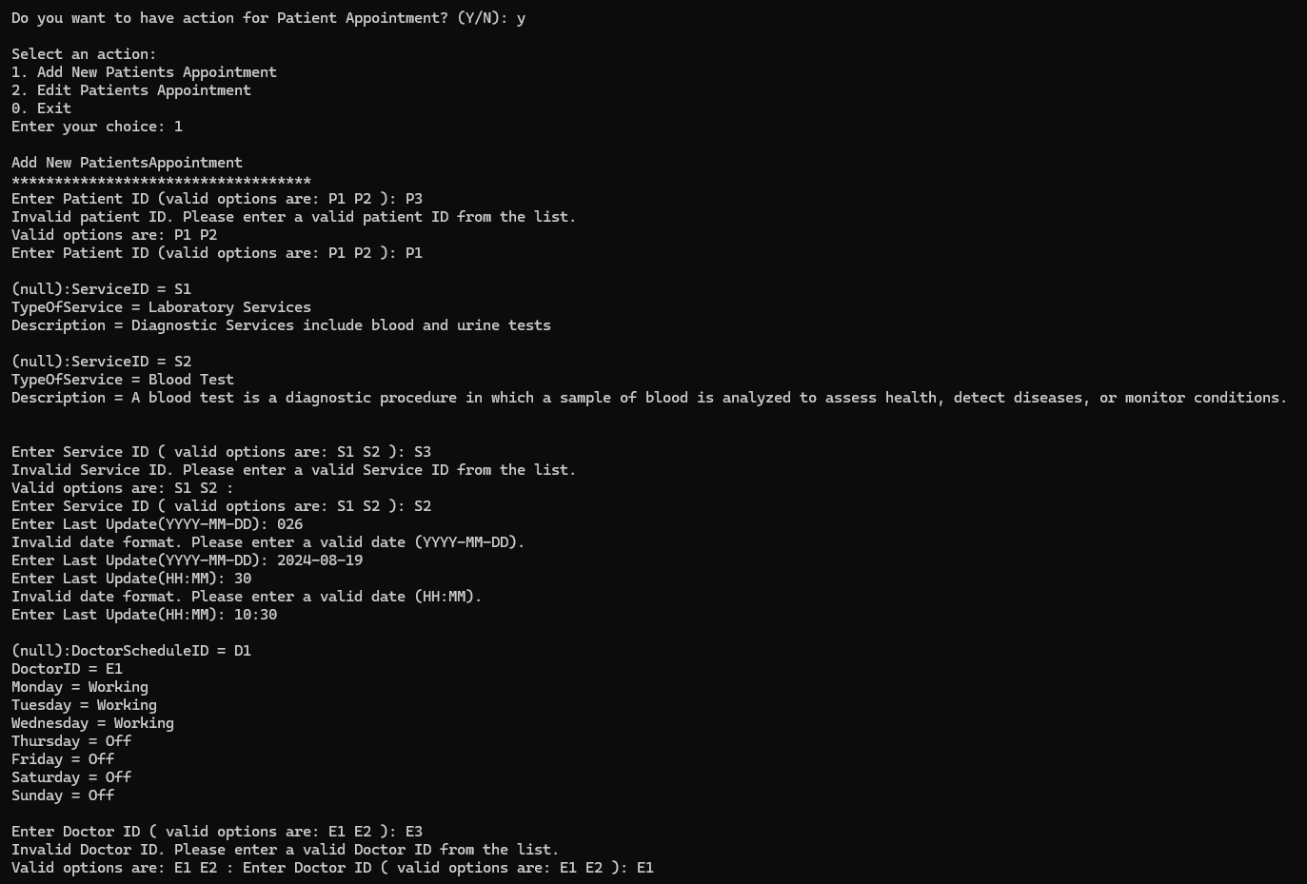

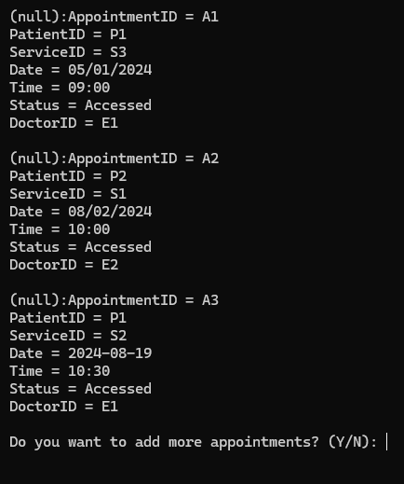

SQLite shows the new patient’s appointment data successfully.

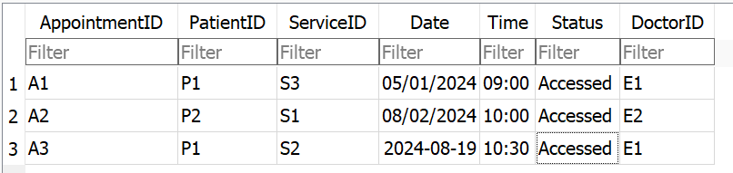

#### **6.6.6.2 Update Patient Appointment**

The system prompts for the **Patient’s Appointment ID**. If blank, the update process exits. If it doesn’t match any records, a **no relevant search results found** message is shown, and the update process exits.

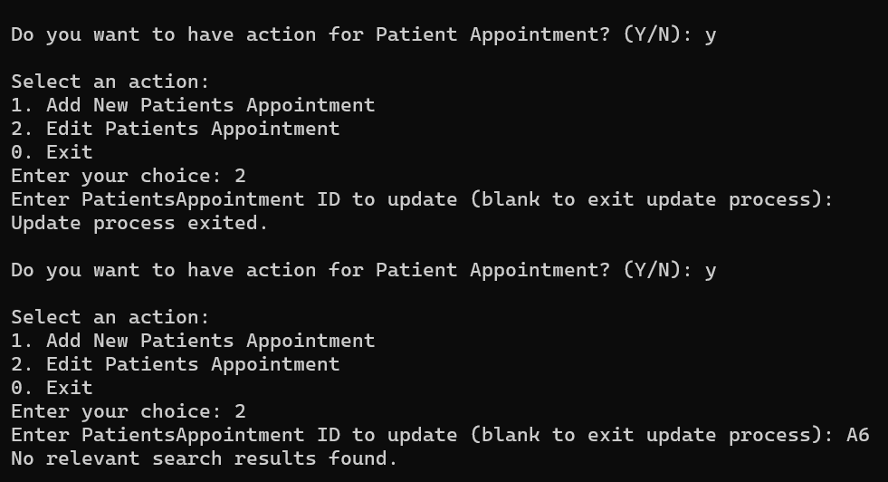

After entering a valid **Patient’s Appointment ID**, the system lets you update fields, leaving blanks unchanged. It confirms successful updates and shows the updated information.

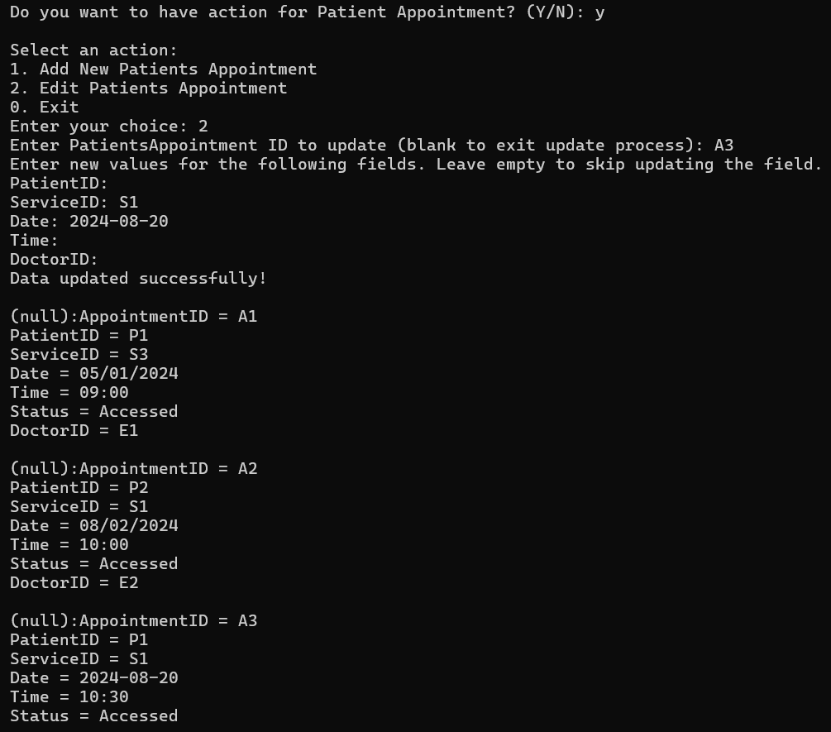

SQLite is showing the updated patient’s appointment information.

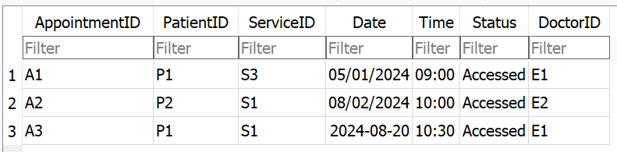

### **6.6.7 Patient Cancelled Appointment**

The system will display details of the patient’s cancelled appointment. Now it shows nothing because the record is empty. After showing this information, it prompts whether you want to perform another action related to patient’s cancelled appointment.

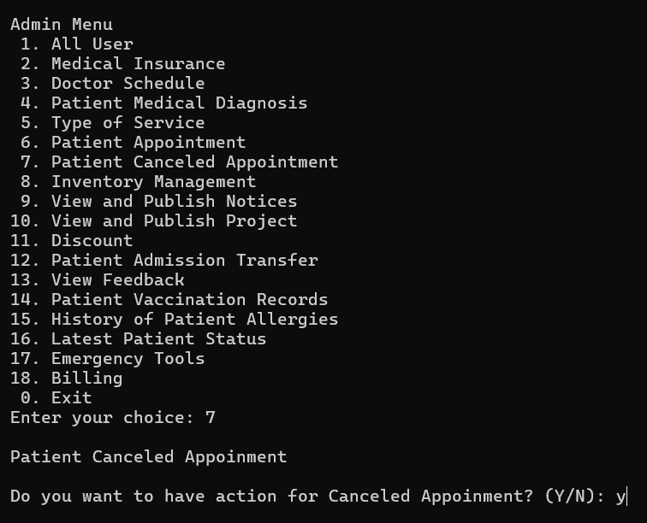

#### **6.6.7.1 Add Patient Cancelled Appointment**

The system allows the admin to help patients to cancel appointments. It first verifies the validity of the Appointment ID and Doctor ID. If an invalid IDs is entered, it asks again. After providing valid inputs, the system updates the appointment status to 'Cancelled' and confirms that the cancellation was successful.

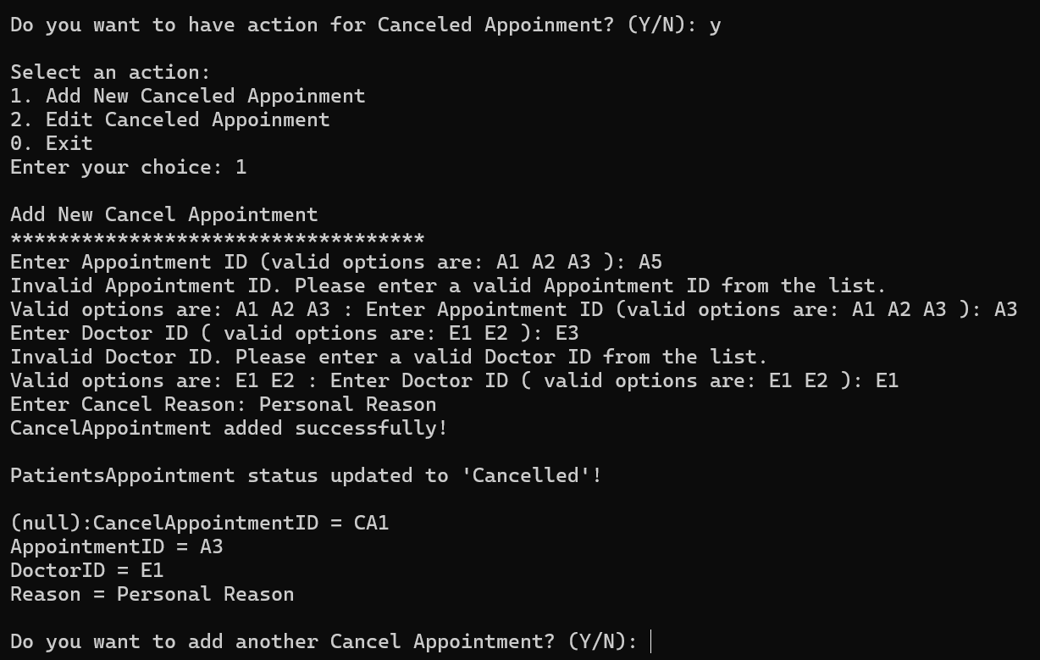

SQLite shows add the new cancel appointment data successfully.

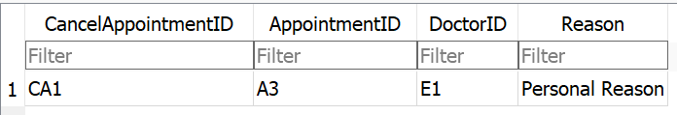

Patient’s Appointment shows the A3’s status is Cancelled.

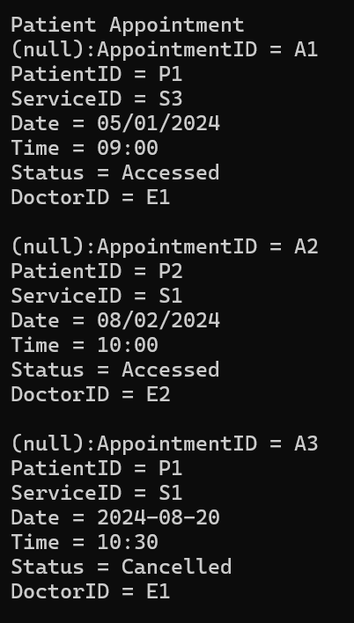

SQLite Patient’s Appointment also shows the A3’s status is Cancelled.

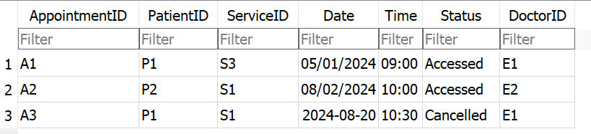

#### **6.6.7.2 Update Patient Cancelled Appointment**

The system prompts for the **Cancel Appointment ID**. If blank, the update process exits. If it doesn’t match any records, a **no relevant search results found** message is shown, and the update process exits.

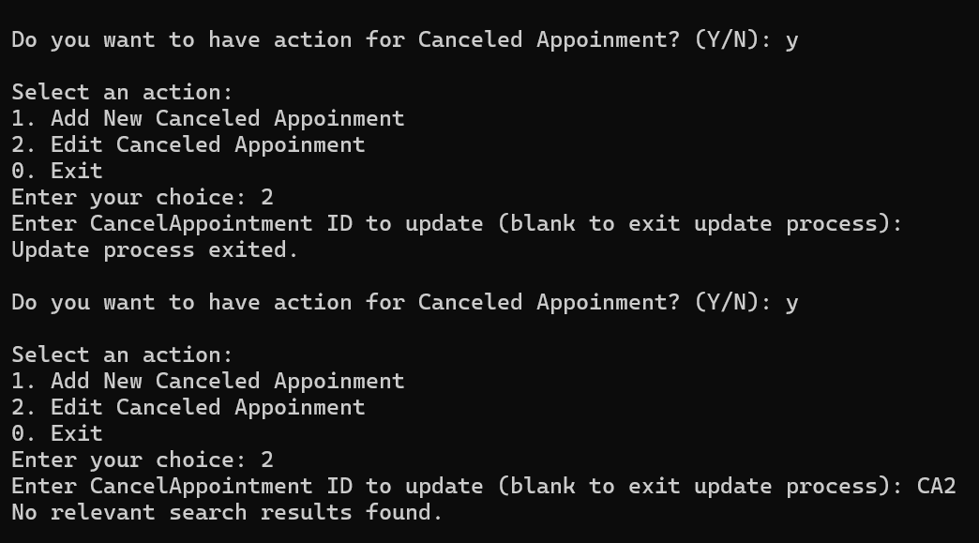

After entering a valid **Cancel Appointment ID**, the system lets you update fields, leaving blanks unchanged. It confirms successful updates and shows the updated information.

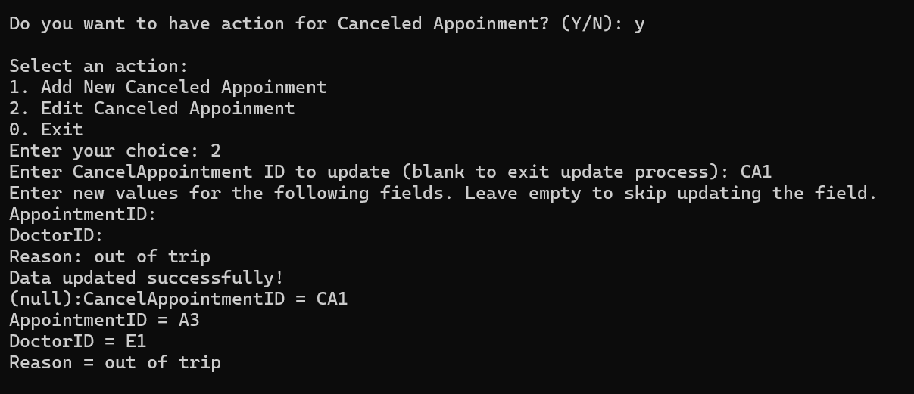

SQLite is showing the updated cancel appointment information.

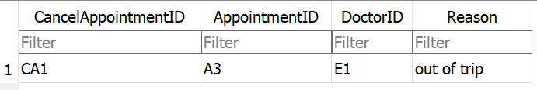

**Note:** The Patient Appointment and Patient Cancelled Appointment tables do not allow data deletion. When a patient cancels an appointment, it is recorded in the Cancelled Appointment table, and the corresponding appointment in the Patient Appointment table is updated with a status of "Cancelled." This approach maintains the integrity of appointment records and preserves a complete history of all appointments.

### **6.6.8 Inventory Management**

The Inventory Management presents choices for managing inventory, suppliers, and purchase orders. Select Exit will go back to the admin menu.

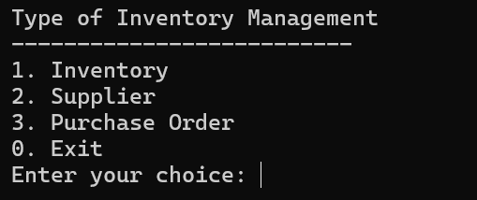

#### **6.6.8.1 Inventory**

The system displays details of the status of inventory. After showing this information, it prompts whether you want to perform another action related to inventory.

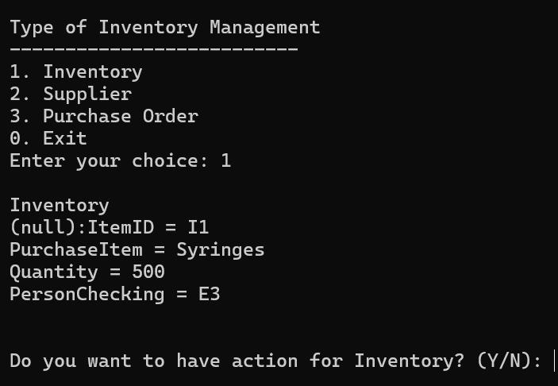

##### **6.6.8.1.1 Add Inventory**

The system requests details such as the purchase item, quantity, and user ID. After successfully adding the new inventory, the updated list is displayed. The user is then asked if they want to add more inventory.

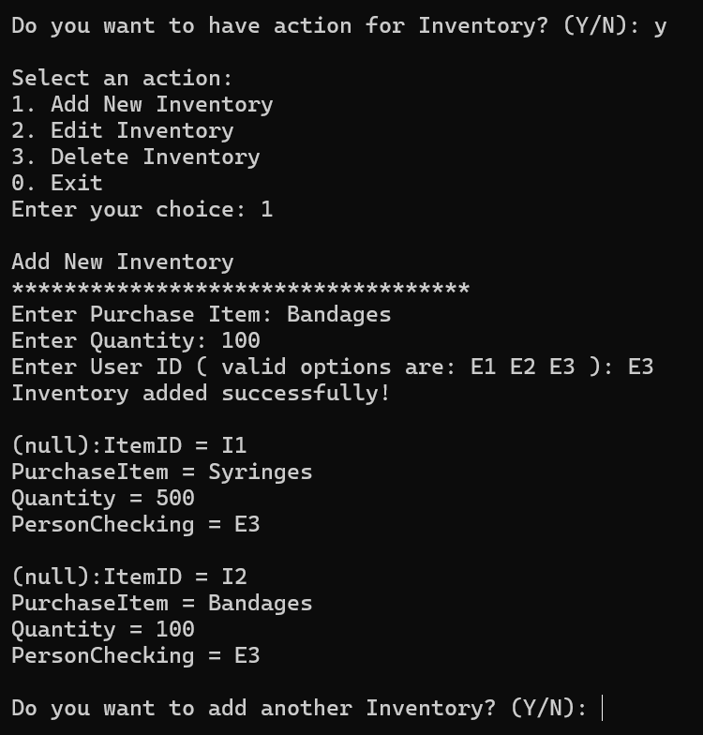

SQLite shows the new inventory data successfully.

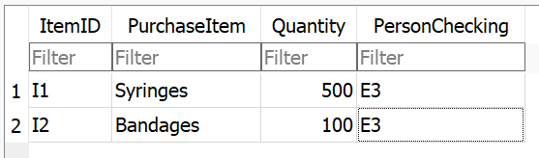

##### **6.6.8.1.2 Update Inventory**

The system prompts for the **Inventory ID**. If blank, the update process exits. If it doesn’t match any records, a **no relevant search results found** message is shown, and the update process exits.

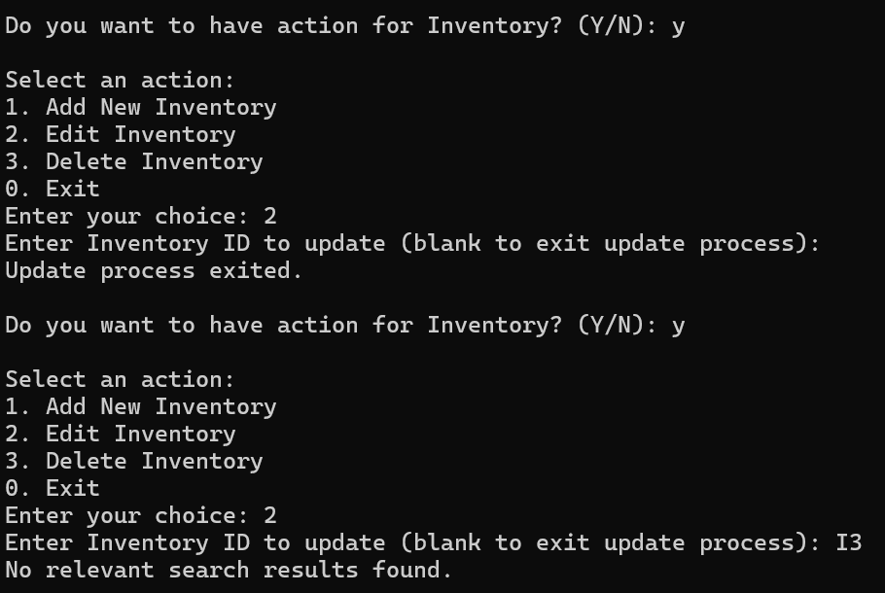

After entering a valid **Inventory ID**, the system lets you update fields, leaving blanks unchanged. It confirms successful updates and shows the updated information.

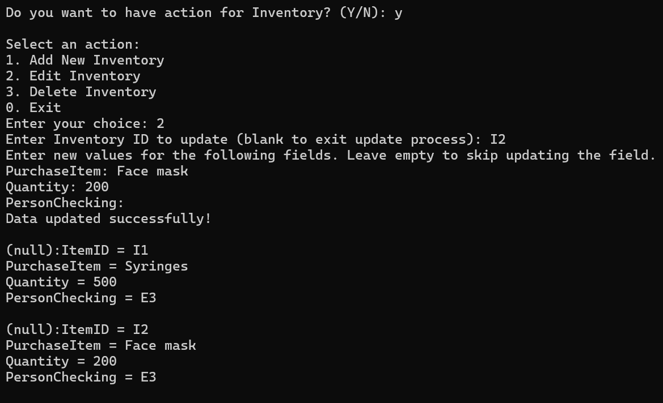

SQLite is showing the updated inventory information.

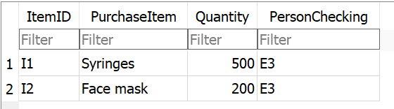

##### **6.6.8.1.3 Delete Inventory**

The system prompts for the **Inventory ID**. If blank, the deletion process exits. If it doesn't match any records, a **no relevant search results found** message is shown, and the deletion process exits.

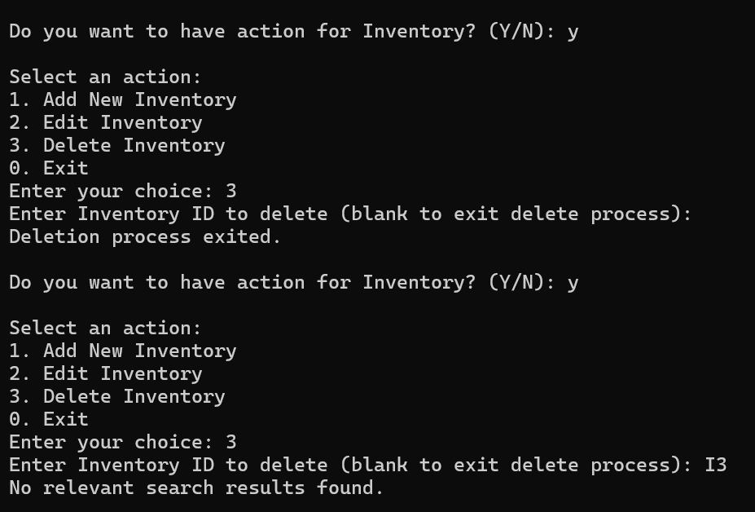

After entering a valid **Inventory ID**, the system successfully deletes the user and confirms the deletion. Then it displays the remaining users and asks if you want to perform another action.

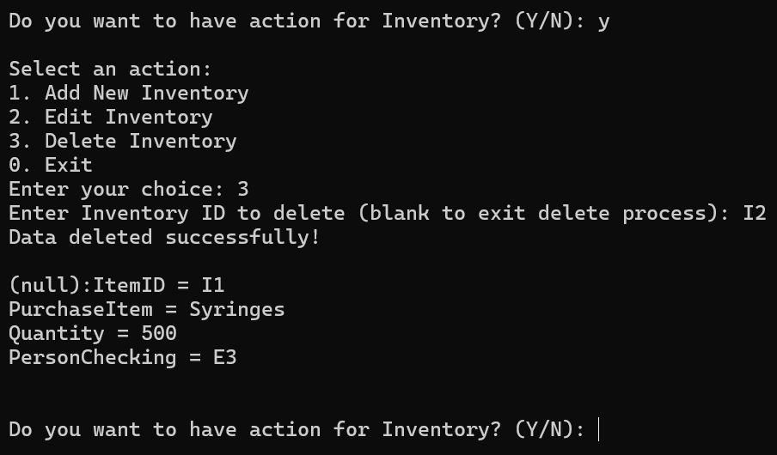

SQLite shows the inventory data is deleted.

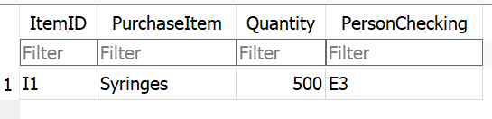

#### **6.6.8.2 Supplier**

The system displays details of the suppliers. After showing this information, it prompts whether you want to perform another action related to supplier.

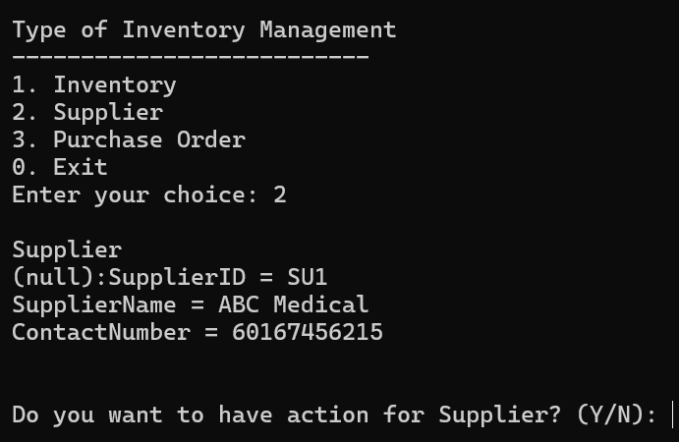

##### **6.6.8.2.1 Add Supplier**

When adding a new supplier, the user is asked to enter the supplier name and contact number. If an invalid contact number (less than 10 digits) is entered, an error message is shown. Once valid information is provided, the supplier is added successfully, and the updated list is displayed. The user is then asked if they wish to add another supplier.

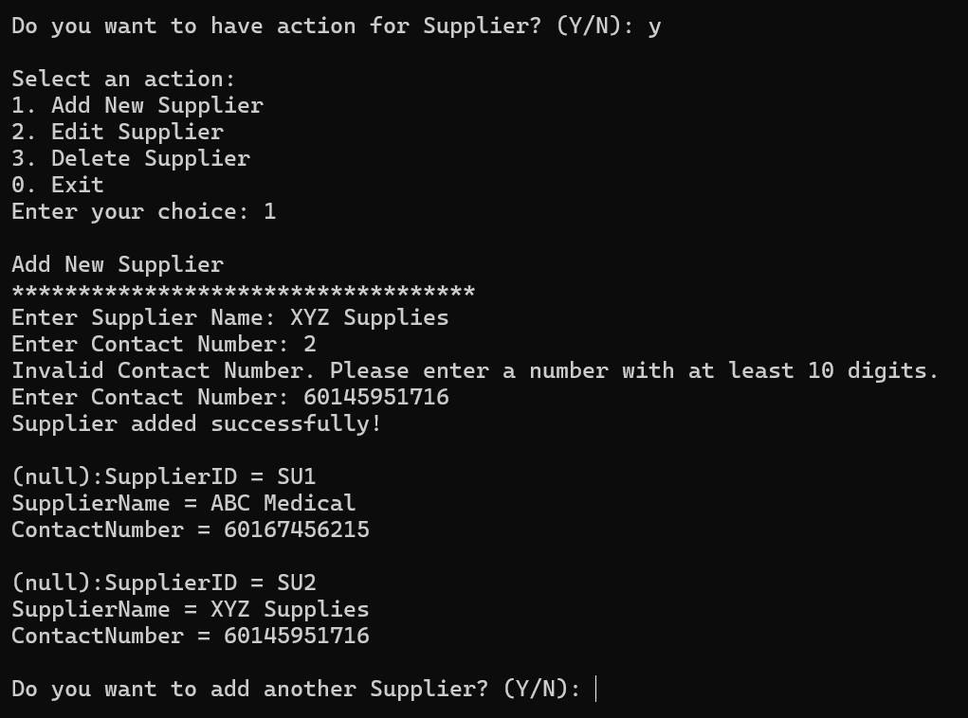

SQLite shows add the new supplier data successfully.

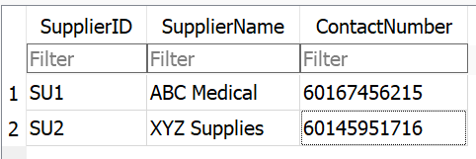

##### **6.6.8.2.2 Update Supplier**

The system prompts for the **Supplier ID**. If blank, the update process exits. If it doesn’t match any records, a **no relevant search results found** message is shown, and the update process exits.

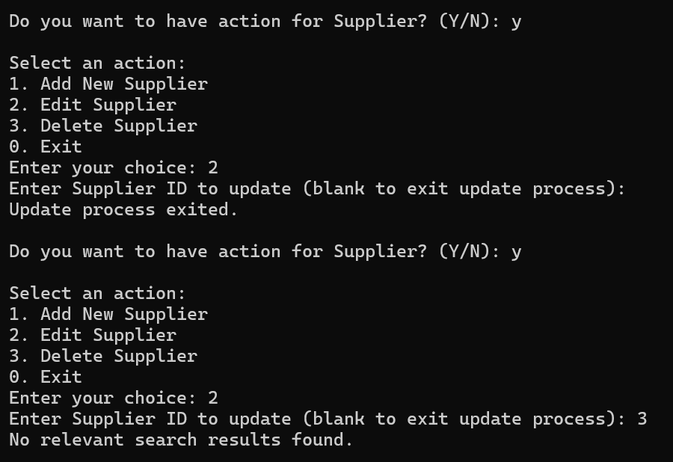

After entering a valid **Supplier ID**, the system lets you update fields, leaving blanks unchanged. It confirms successful updates and shows the updated information.

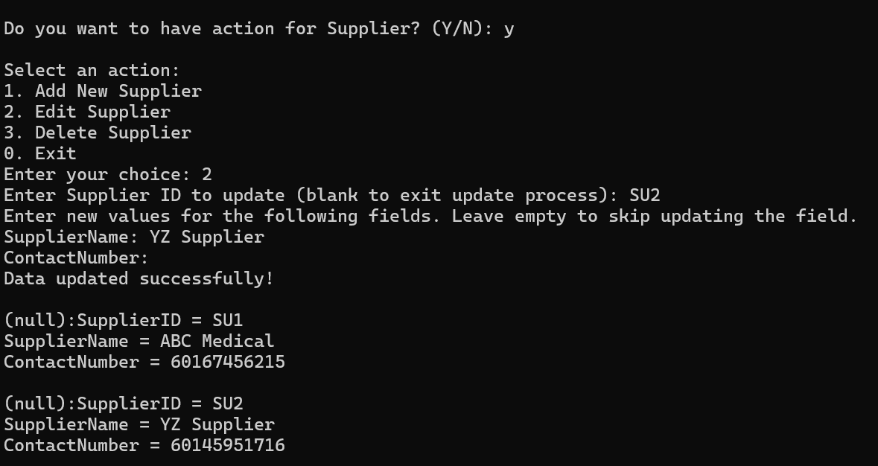

SQLite is showing the updated supplier information.

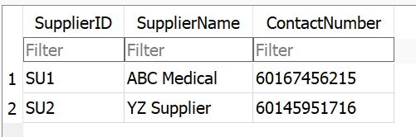

##### **6.6.8.2.3 Delete Supplier**

The system prompts for the **Supplier ID**. If blank, the deletion process exits. If it doesn't match any records, a **no relevant search results found** message is shown, and the deletion process exits.

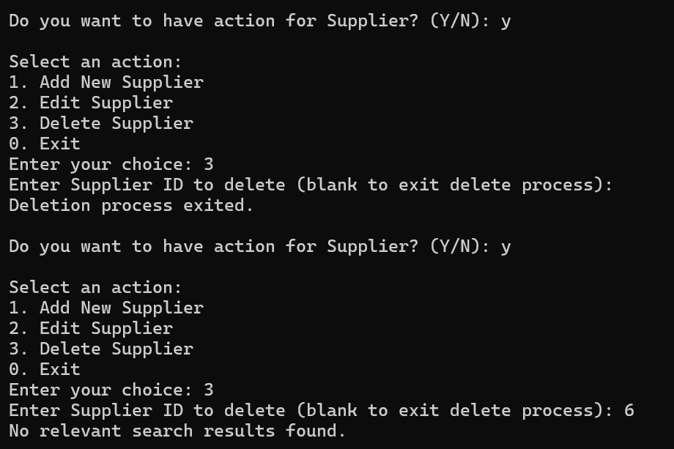

After entering a valid **Supplier ID**, the system successfully deletes the user and confirms the deletion. Then it displays the remaining users and asks if you want to perform another action.

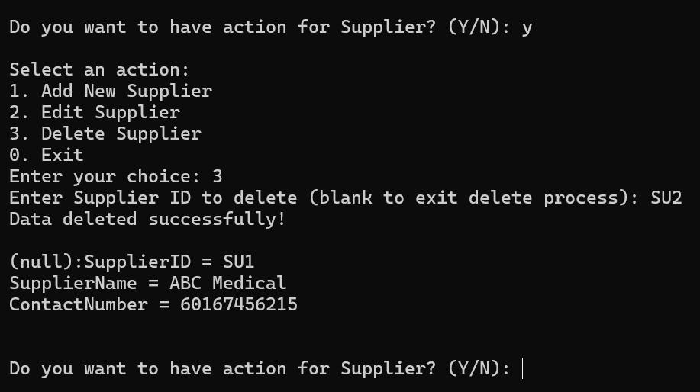

SQLite shows the supplier data is deleted.

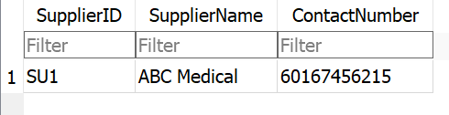

#### **6.6.8.3 Purchase Order**

The system displays details of purchase order records. After showing this information, it prompts whether you want to perform another action related to purchase order.

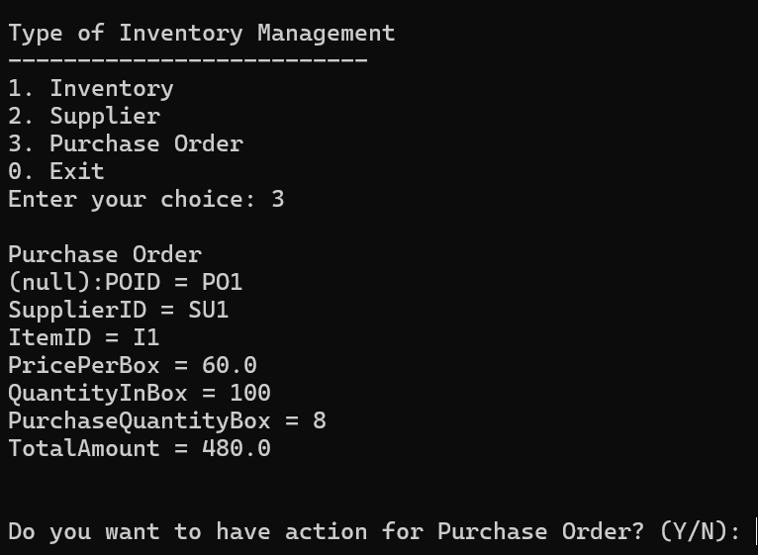

##### **6.6.8.3.1 Add Purchase Order**

If invalid `Supplier ID` `Supplier ID` are entered, error messages prompt the user to select valid options. Once the correct IDs are entered, the user provides the price per box, quantity in each box, and the number of boxes to be purchased. The system calculates the total amount and confirms the successful addition of the purchase order. Finally, it asks if the user wants to add another purchase order.

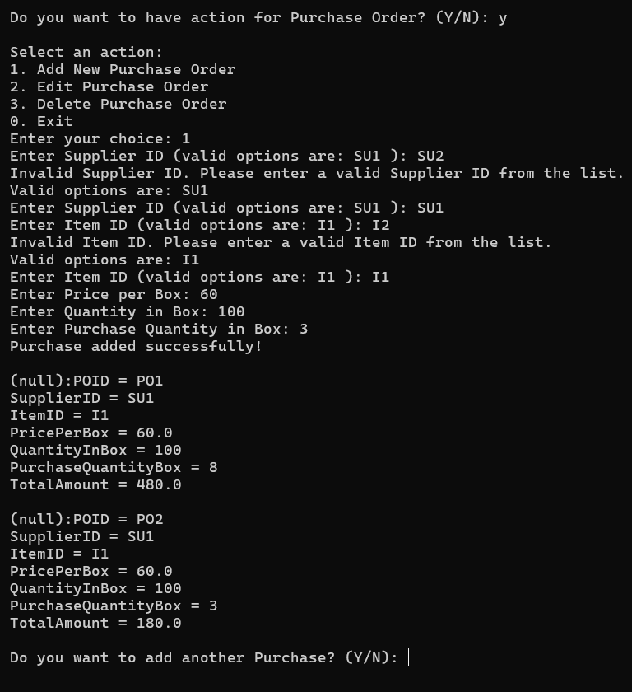

SQLite shows the new purchase order data successfully.

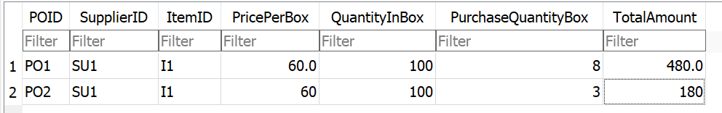

##### **6.6.8.3.2 Update Purchase Order**

The system prompts for the **Purchase ID**. If blank, the update process exits. If it doesn’t match any records, a **no relevant search results found** message is shown, and the update process exits.

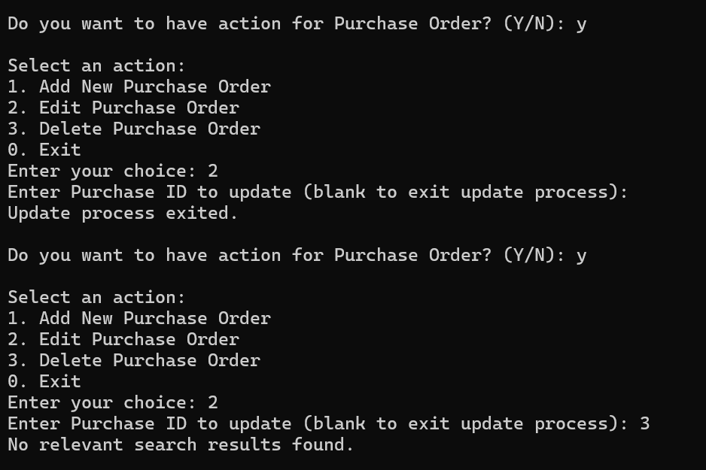

After entering a valid **Purchase ID**, the system lets you update fields, leaving blanks unchanged. It confirms successful updates and shows the updated information.

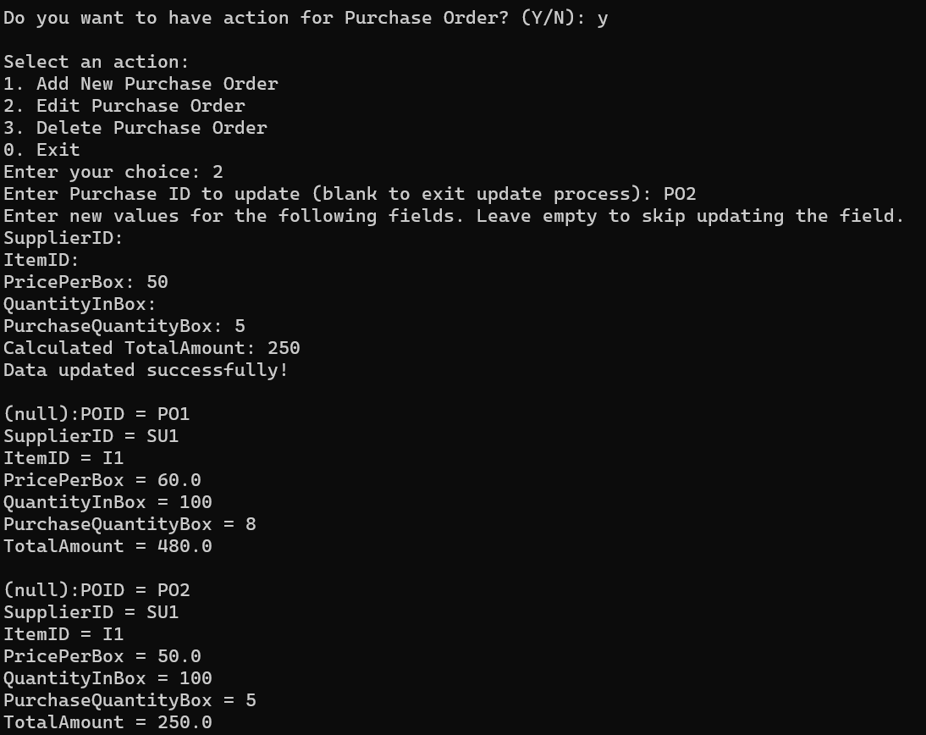

SQLite is showing the updated purchase order information.

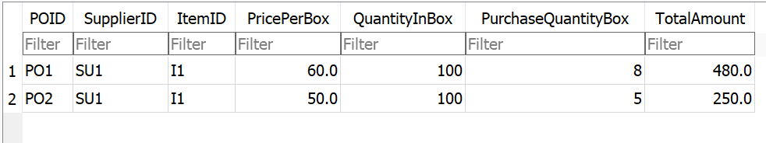

##### **6.6.8.3.3 Delete Purchase Order**

The system prompts for the **Purchase ID**. If blank, the deletion process exits. If it doesn't match any records, a **no relevant search results found** message is shown, and the deletion process exits.

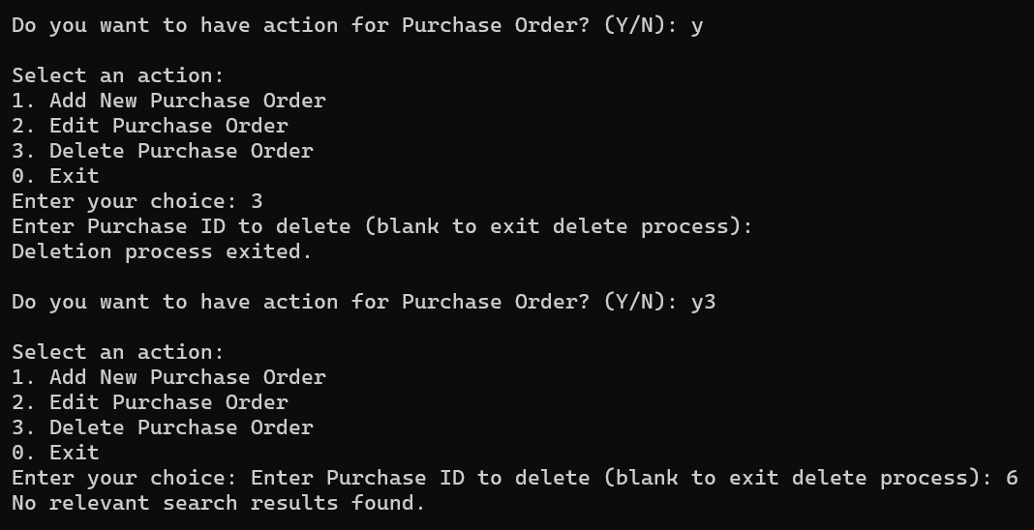

After entering a valid **Purchase ID**, the system successfully deletes the user and confirms the deletion. Then it displays the remaining users and asks if you want to perform another action.

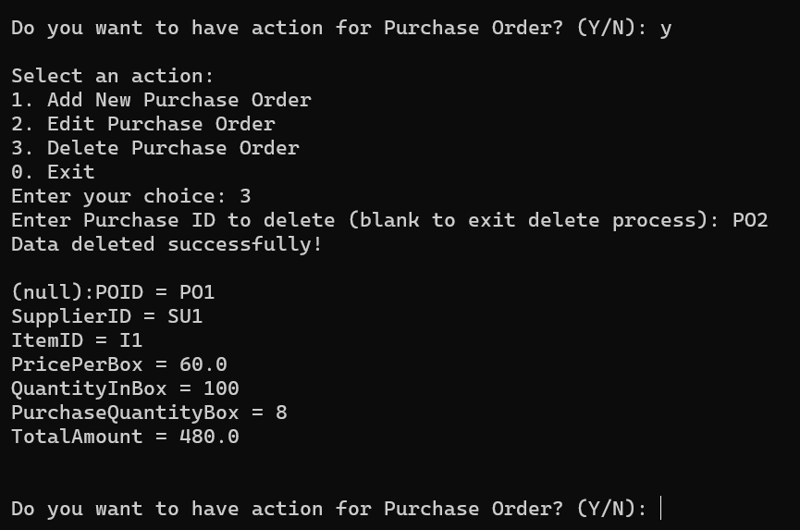

SQLite shows the purchase order data is deleted.

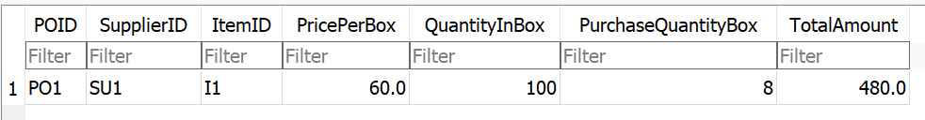

### **6.6.9 View and Publish Notices**

The system displays a list of notices with their IDs, descriptions, and the person who posted them. It then prompts the user to choose whether to take further action regarding notices.

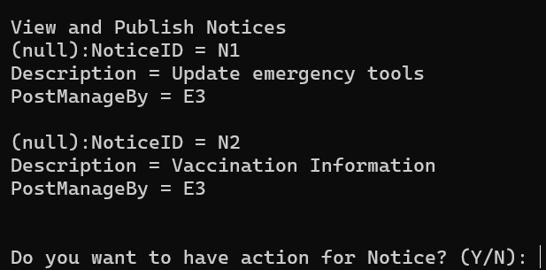

#### **6.6.9.1 Add Notices**

Ensuring the description and the User ID of the person managing the post are provided. If the User ID is invalid, the system prompts for a valid ID. After successfully adding the notice, it displays the updated list of notices and asks if the user wants to add another.

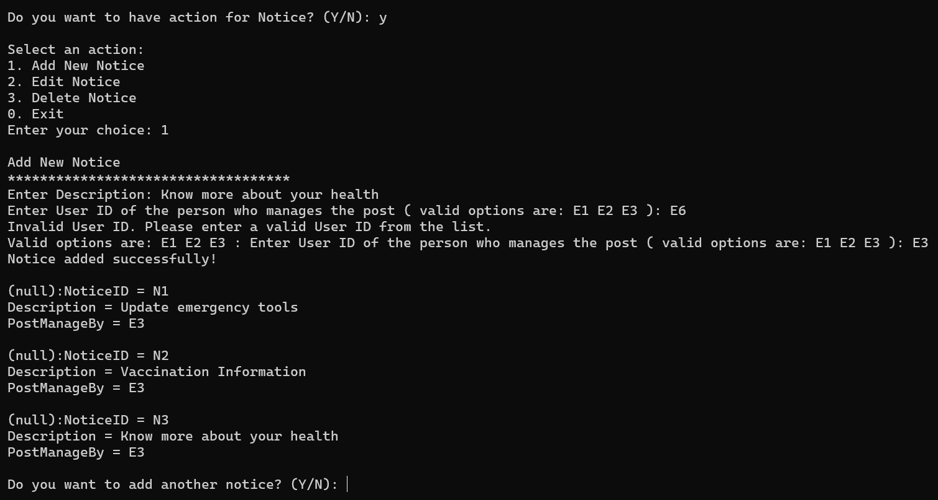

SQLite shows add the new notice data successfully.

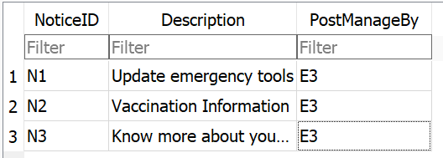

#### **6.6.9.2 Update Notices**

The system prompts for the **Notice ID**. If blank, the update process exits. If it doesn’t match any records, a **no relevant search results found** message is shown, and the update process exits.

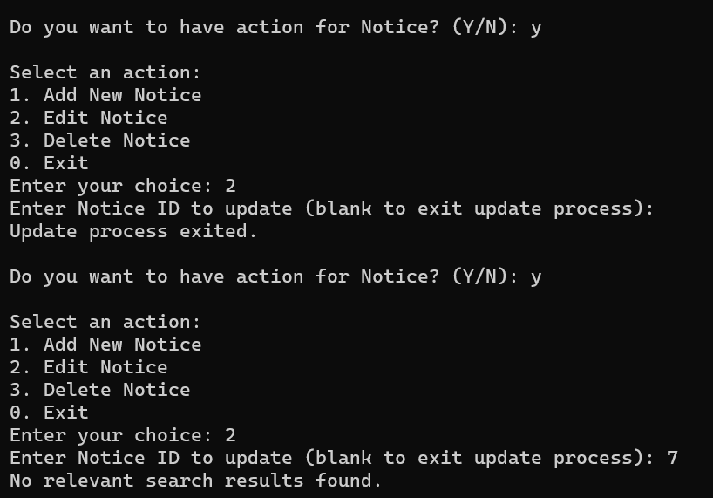

After entering a valid **Notice ID**, the system lets you update fields, leaving blanks unchanged. It confirms successful updates and shows the updated information.

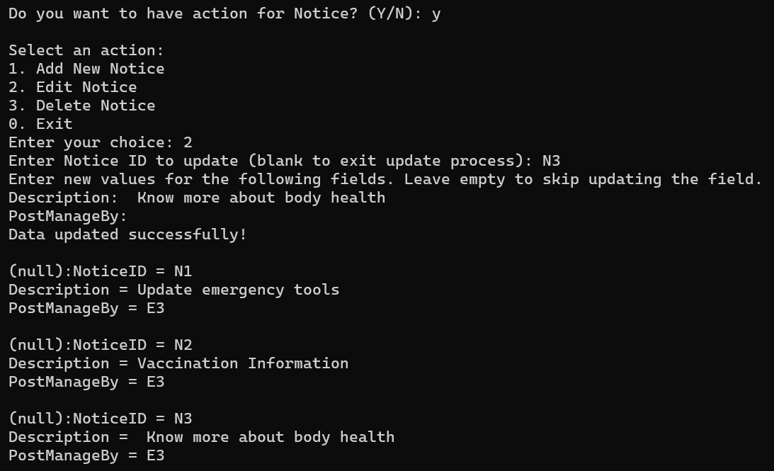

SQLite is showing the updated notice information.

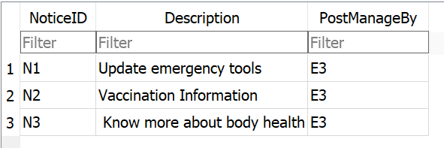

#### **6.6.9.3 Delete Notices**

The system prompts for the **Notice ID**. If blank, the deletion process exits. If it doesn't match any records, a **no relevant search results found** message is shown, and the deletion process exits.

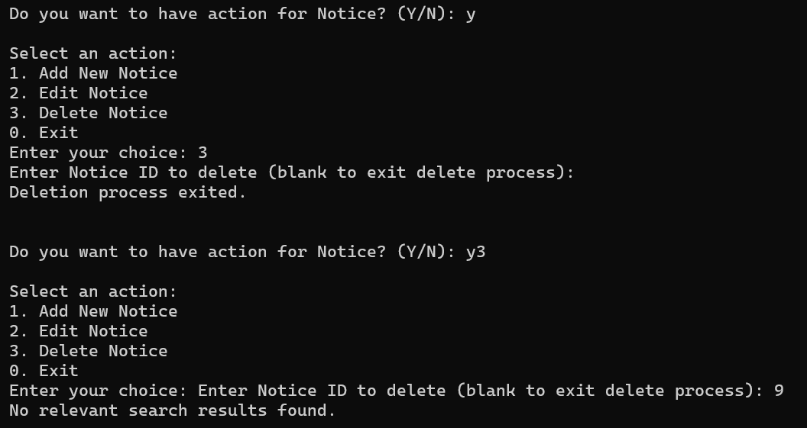

After entering a valid **Notice ID**, the system successfully deletes the user and confirms the deletion. Then it displays the remaining users and asks if you want to perform another action.

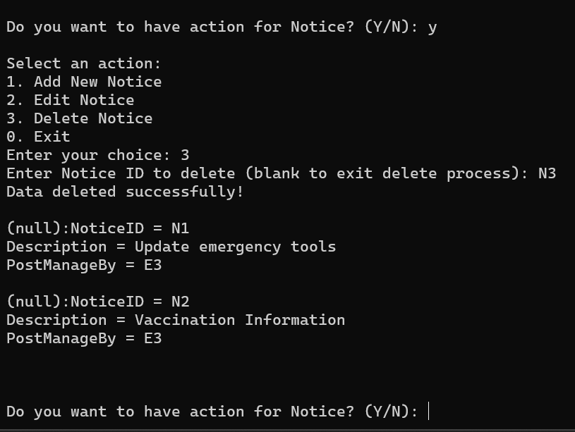

SQLite shows the notice data is deleted.

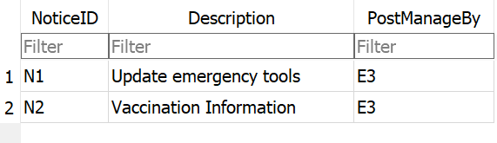

### **6.6.10 View and Publish Project**

The system displays the current project details and prompts whether the user wants to take further action on projects.

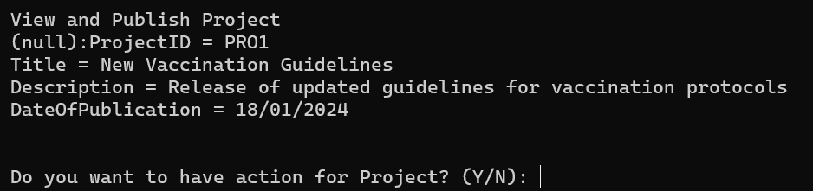

#### **6.6.10.1 Add Project**

The system allows adding a new project by entering the title, description, and publication date. It validates the date format and confirms successful addition of the project.

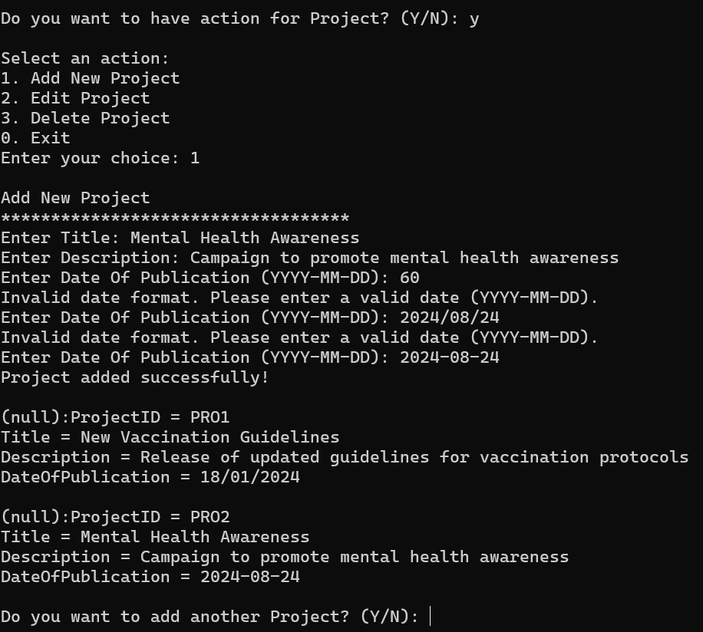

SQLite shows the new project data successfully.

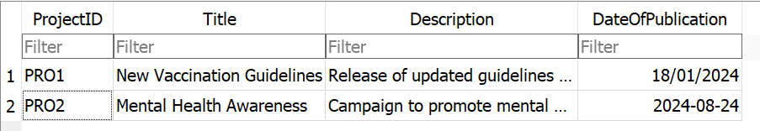

#### **6.6.10.2 Update Project**

The system prompts for the **Project ID**. If blank, the update process exits. If it doesn’t match any records, a **no relevant search results found** message is shown, and the update process exits.

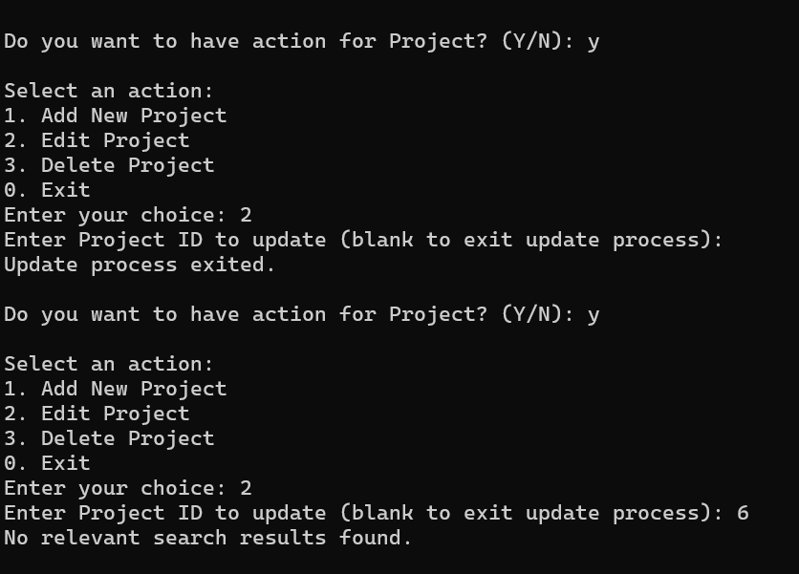

After entering a valid **Project ID**, the system lets you update fields, leaving blanks unchanged. It confirms successful updates and shows the updated information.

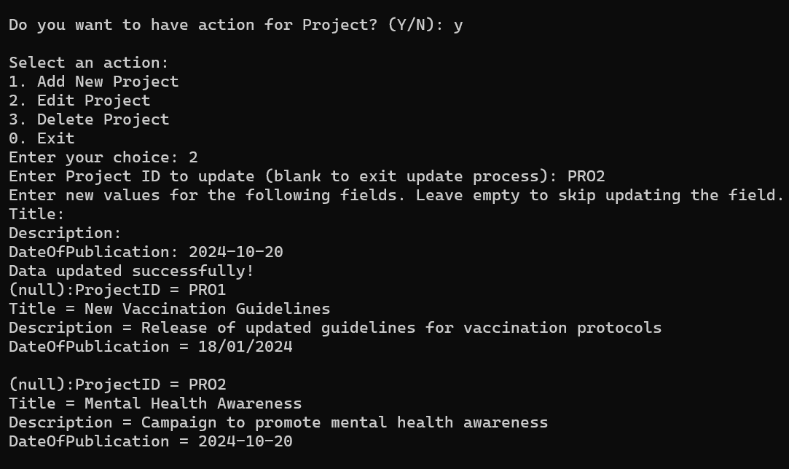

SQLite is showing the updated project information.

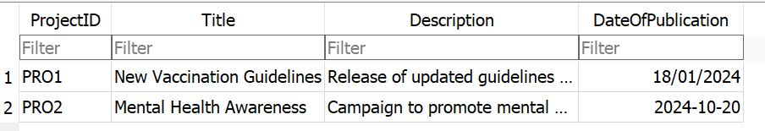

#### **6.6.10.3 Delete Project**

The system prompts for the **Project ID**. If blank, the deletion process exits. If it doesn't match any records, a **no relevant search results found** message is shown, and the deletion process exits.

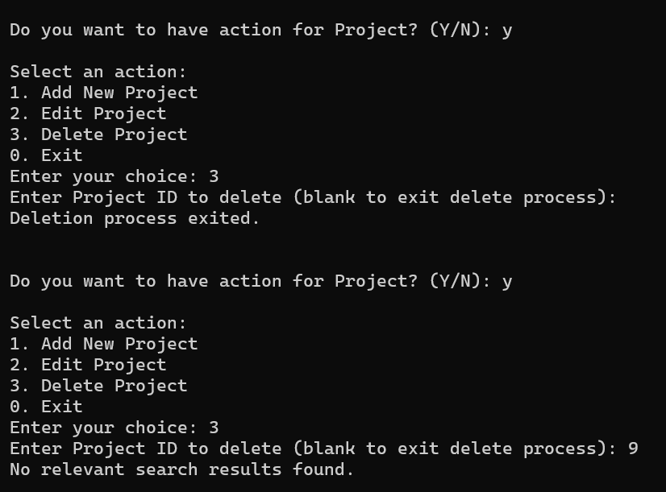

After entering a valid **Project ID**, the system successfully deletes the user and confirms the deletion. Then it displays the remaining users and asks if you want to perform another action.

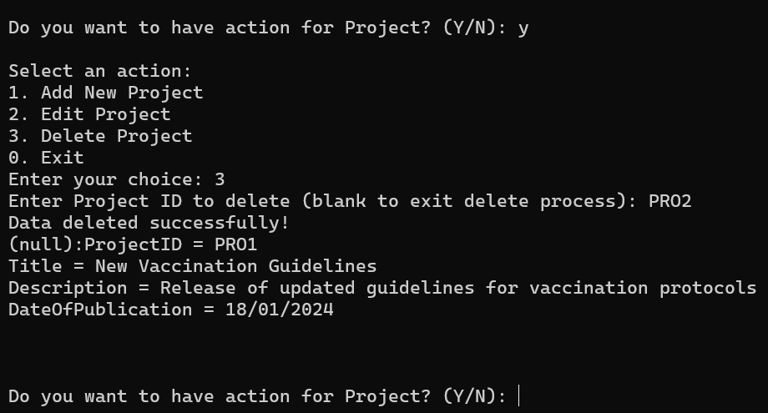

SQLite shows the project data is deleted.

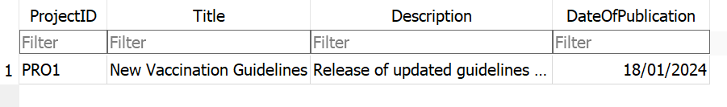

### **6.6.11 Discount**

The system displays existing discount information and prompts whether to proceed with actions related to discounts.

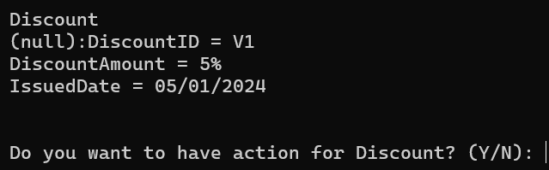

#### **6.6.11.1 Add Discount**

The system prompts for a discount amount and issued date. If invalid input is given, it requests valid information. After successful addition, it confirms the new discount and displays existing discounts.

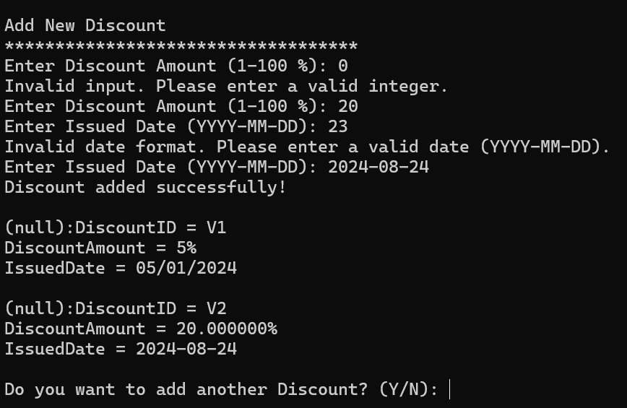

SQLite shows adding the new discount data successfully.

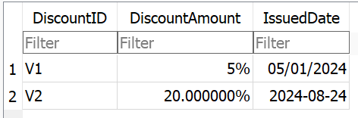

#### **6.6.11.2 Update Discount**

The system prompts for the **Discount ID**. If blank, the update process exits. If it doesn’t match any records, a **no relevant search results found** message is shown, and the update process exits.

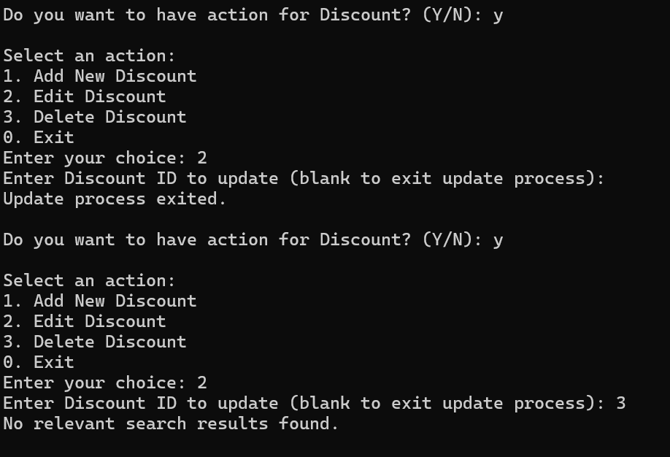

After entering a valid **Discount ID**, the system lets you update fields, leaving blanks unchanged. It confirms successful updates and shows the updated information.

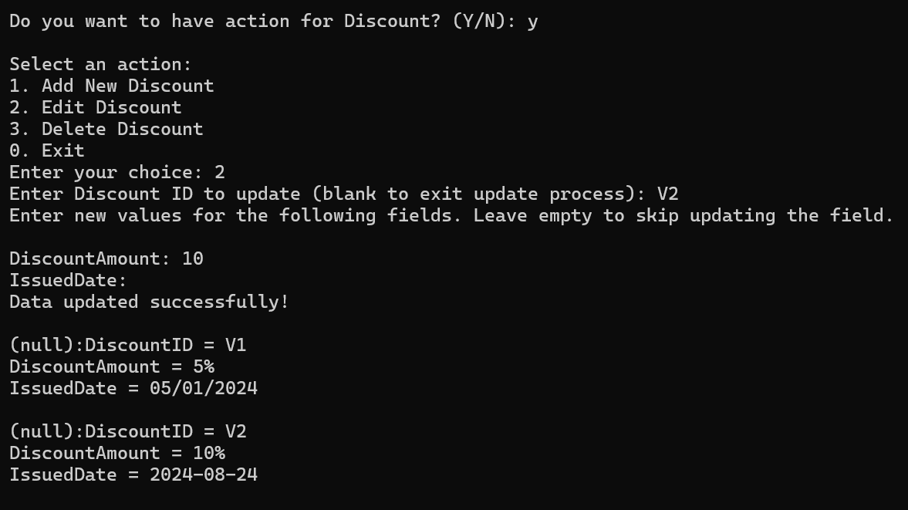

SQLite is showing the updated discount information.

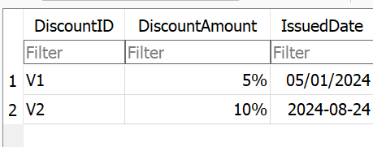

#### **6.6.11.3 Delete Discount**

The system prompts for the **Discount ID**. If blank, the deletion process exits. If it doesn't match any records, a **no relevant search results found** message is shown, and the deletion process exits.

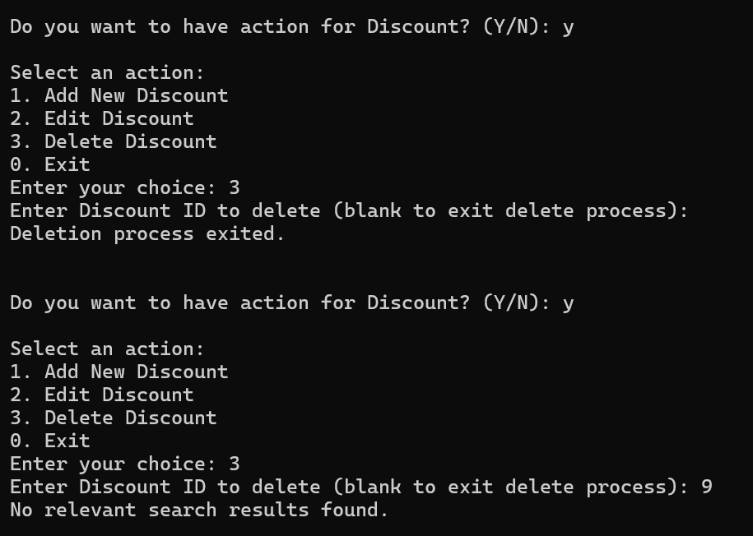

After entering a valid **Discount ID**, the system successfully deletes the user and confirms the deletion. Then it displays the remaining users and asks if you want to perform another action.

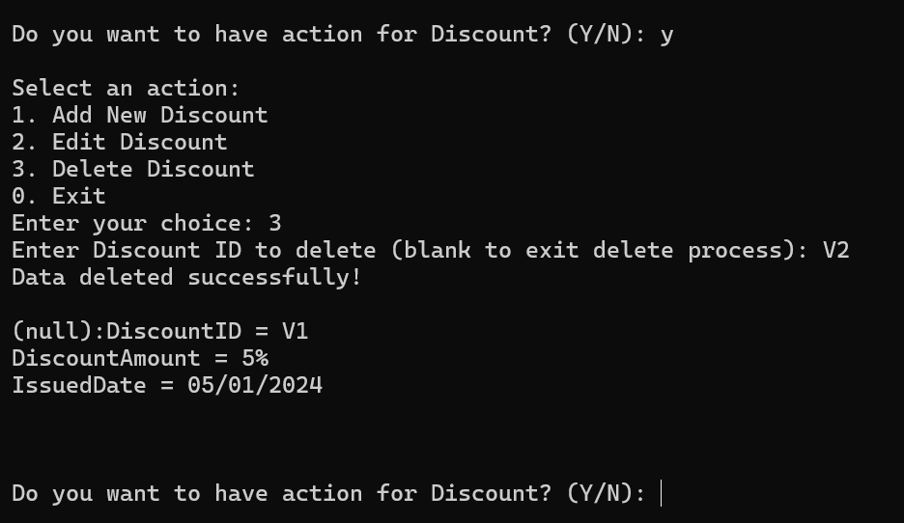

SQLite shows the discount data is deleted.

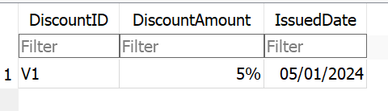

### **6.6.12 Patient Admission Transfer**

The system displays details of the patient’s admission transfer. Admin only has read rights.

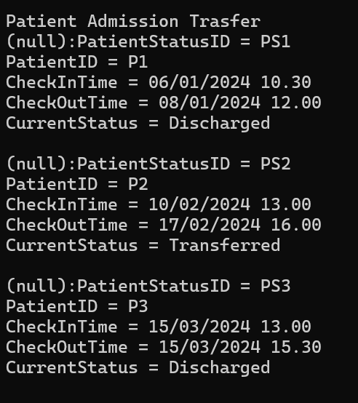

### **6.6.13 View Feedback**

The system displays details of the patient’s feedback for the clinic. Admin only has read rights.

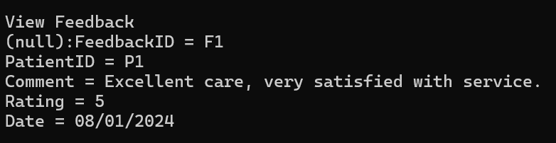

### **6.6.14 Patient Vaccination Records**

The system displays details of the patient’s vaccination records. Admin only has read rights.

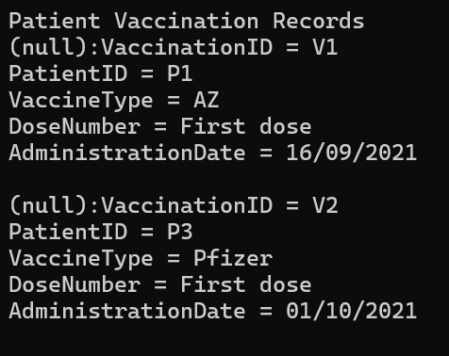

### **6.6.15 History of Patient Allergies**

The system displays details of the history of patient allergies. Admin only has read rights.

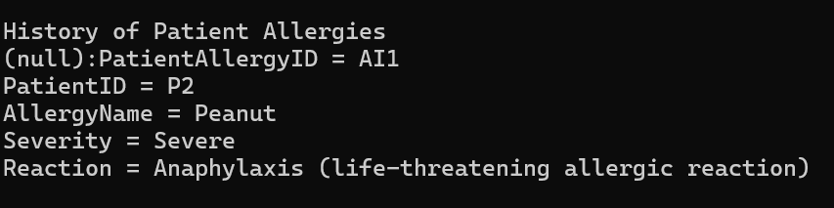

### **6.6.16 Latest Patient Status**

The system displays details of the patient’s admission transfer. Admin only has read rights.

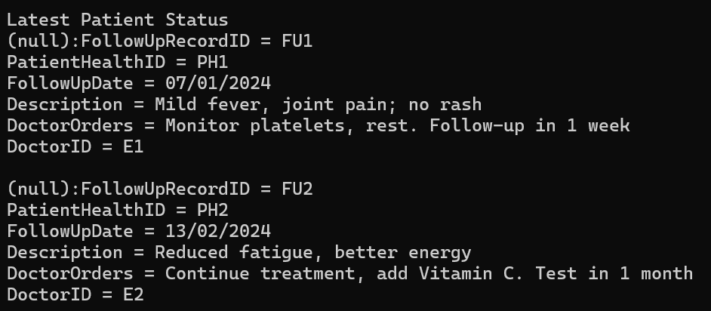

### **6.6.17 Emergency Tools**

The system displays existing emergency tools and asks if you want to perform actions related to them.

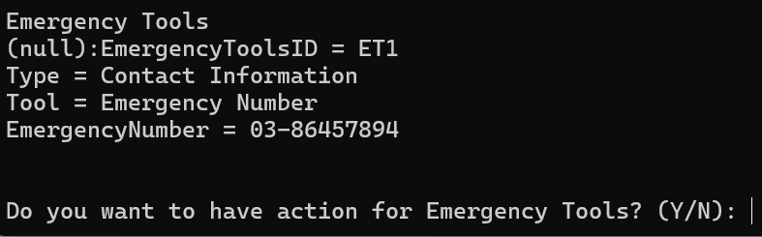

#### **6.6.17.1 Add Emergency Tools**

The system will verify the Contact Number, it needs at least 3 digits. After adding data successfully, it displays the updated list of emergency tools and asks if you want to add more.

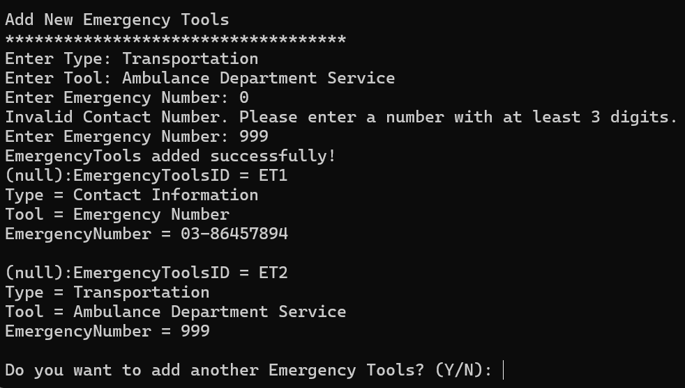

SQLite shows the new emergency tool data successfully.

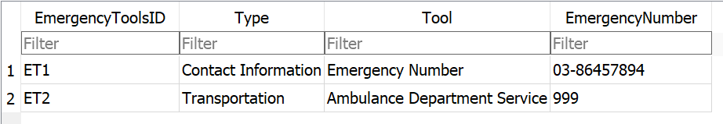

#### **6.6.17.2 Update Emergency Tools**

The system prompts for the **Emergency Tools ID**. If blank, the update process exits. If it doesn’t match any records, a **no relevant search results found** message is shown, and the update process exits.

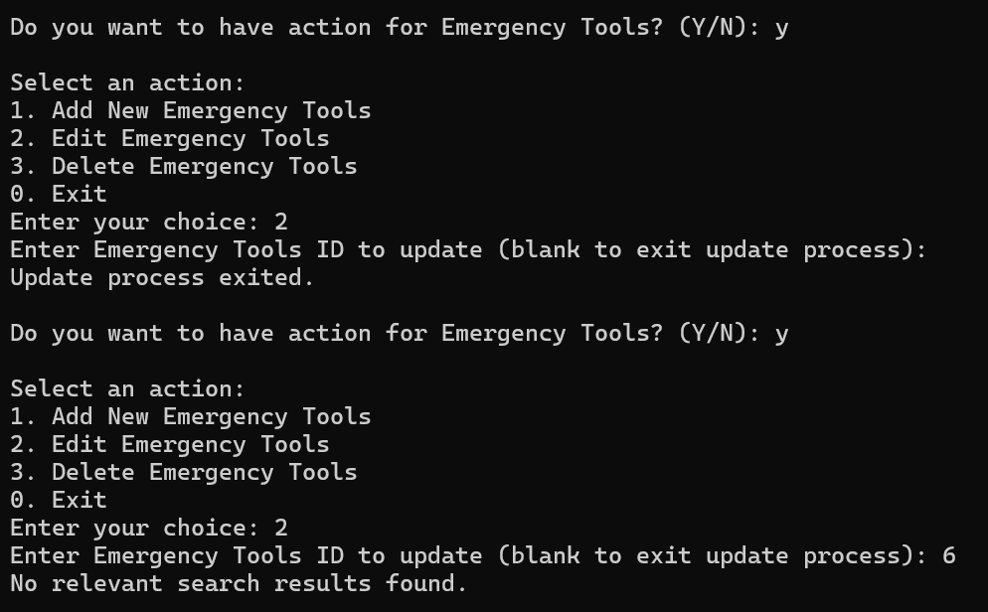

After entering a valid **Emergency Tools ID**, the system lets you update fields, leaving blanks unchanged. It confirms successful updates and shows the updated information.

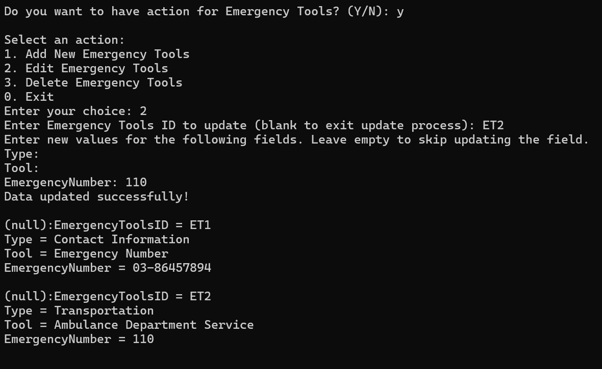

SQLite is showing the updated emergency tools information.

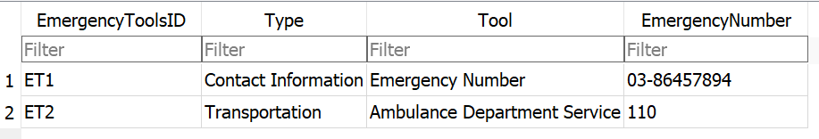

#### **6.6.17.3 Delete Emergency Tools**

The system prompts for the **Emergency Tools ID**. If blank, the deletion process exits. If it doesn't match any records, a **no relevant search results found** message is shown, and the deletion process exits.

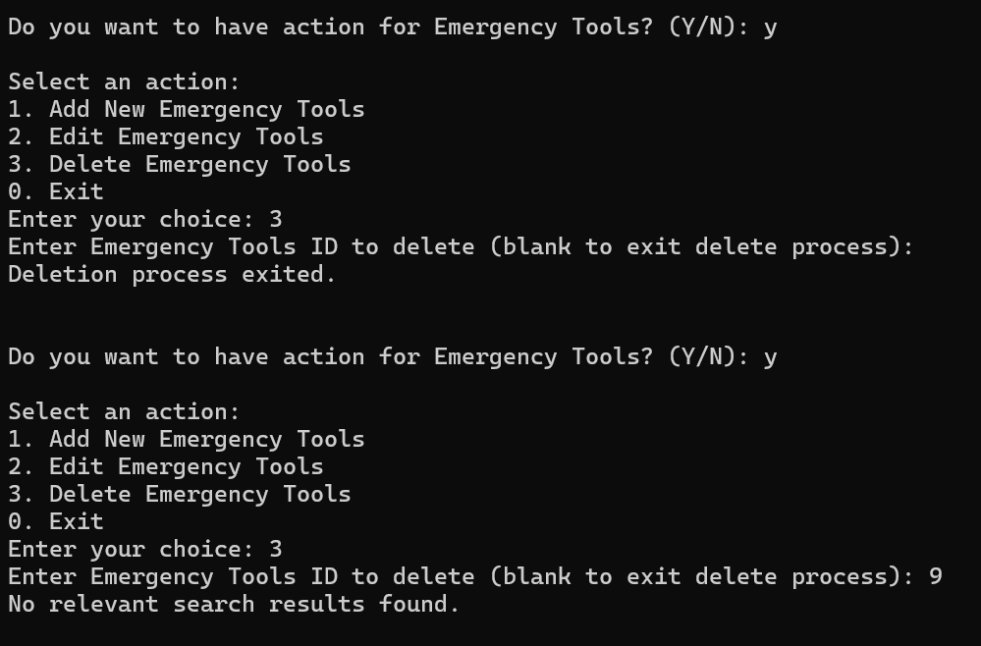

After entering a valid **Emergency Tools ID**, the system successfully deletes the user and confirms the deletion. Then it displays the remaining users and asks if you want to perform another action.

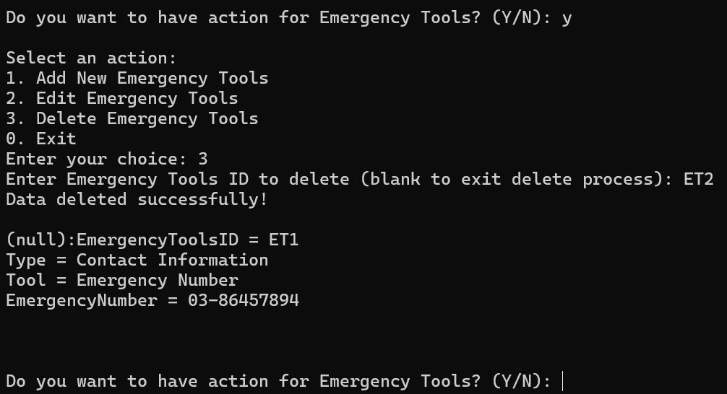

SQLite shows the emergency tools data is deleted.

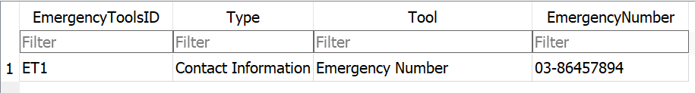

### **6.6.18 Billing**

The system displays details of the billing, also the invoices for patients. After showing this information, it prompts whether you want to perform another action related to billing.

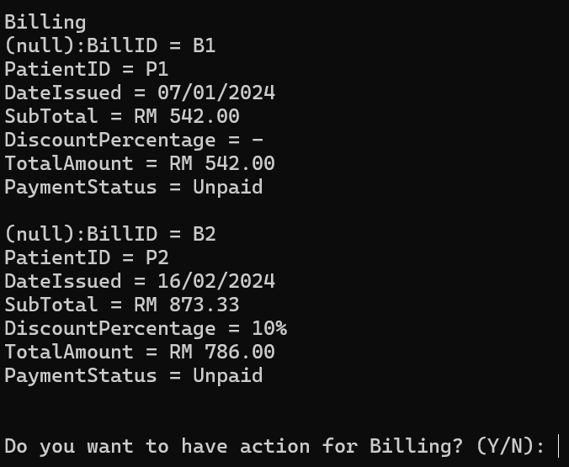

#### **6.6.18.1 Add Billing**

The system verifies the patient ID and date format, calculates the total amount considering any discount percentage, and records the payment status. Invalid inputs, such as incorrect patient IDs or date formats, are flagged for correction. For discounts, you can use '-' if there's no discount or specify a percentage (e.g., 10%). The system calculates the total amount by applying the discount to the subtotal.

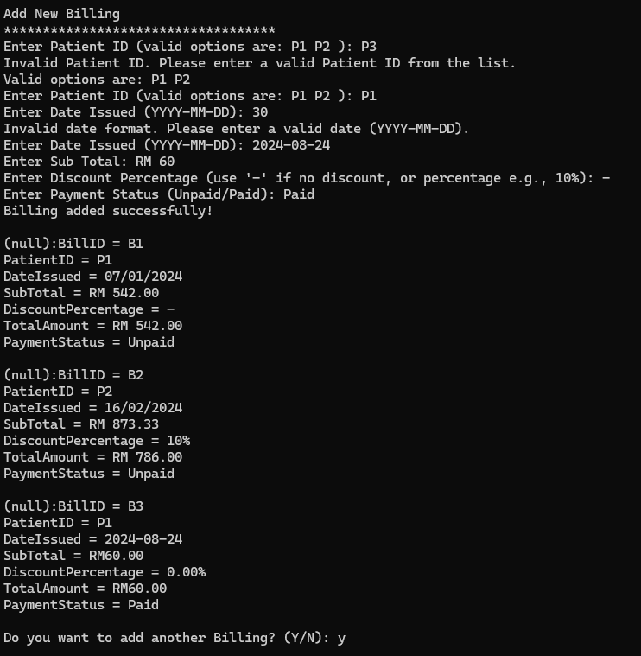

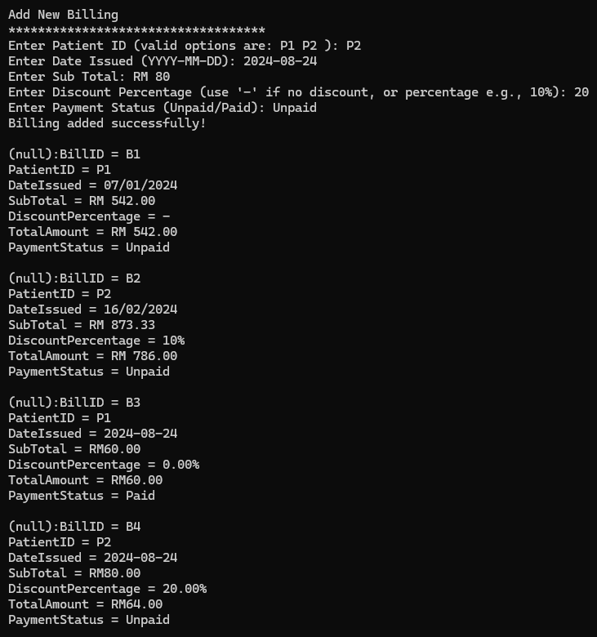

SQLite shows add the new cancel billing data successfully.

#### **6.6.18.2 Update Billing**

The system prompts for the **Bill ID**. If blank, the update process exits. If it doesn’t match any records, a **no relevant search results found** message is shown, and the update process exits.

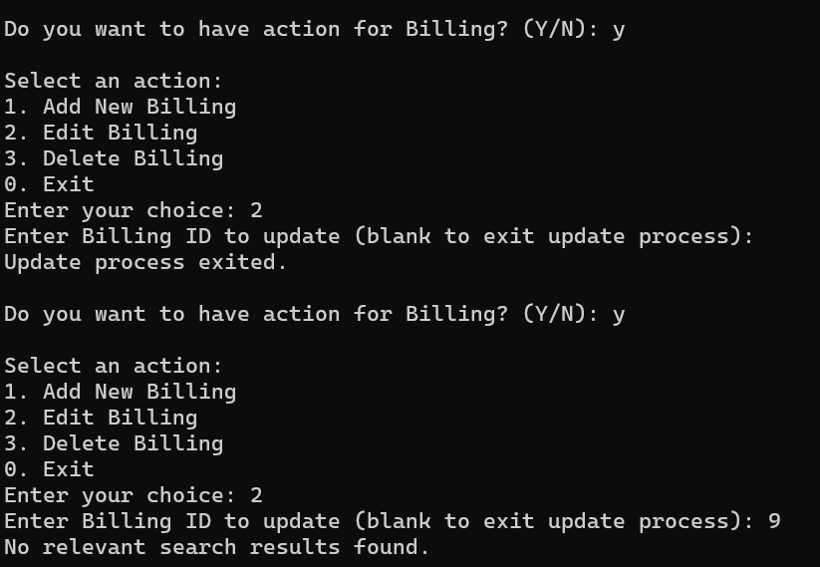

After entering a valid **Bill ID**, the system lets you update fields, leaving blanks unchanged. It confirms successful updates and shows the updated information.

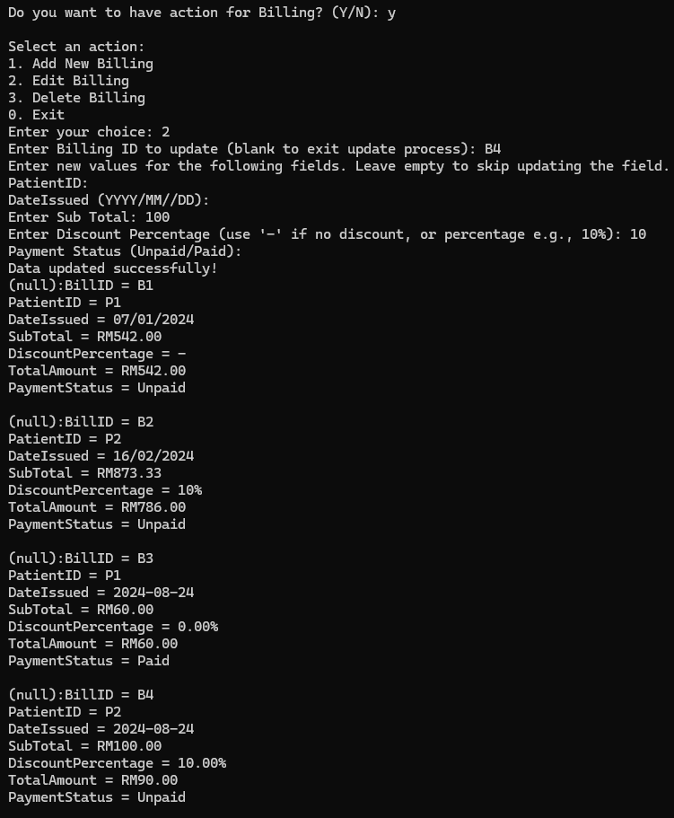

SQLite is showing the updated user information.

#### **6.6.18.3 Delete Billing**

The system prompts for the **Bill ID**. If blank, the deletion process exits. If it doesn't match any records, a **no relevant search results found** message is shown, and the deletion process exits.

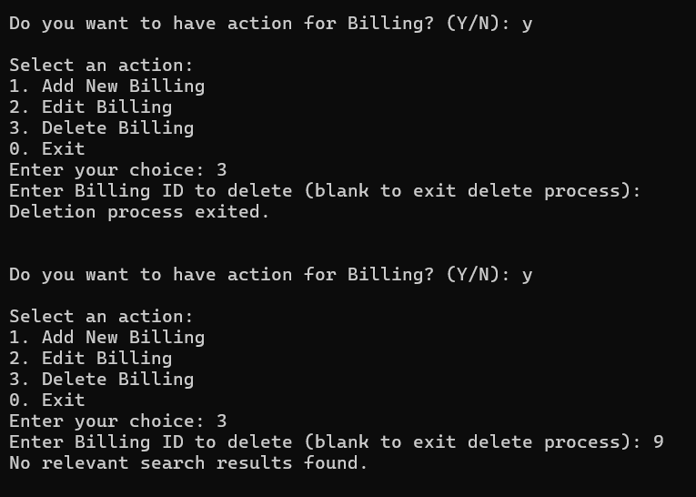

After entering a valid **Bill ID**, the system successfully deletes the user and confirms the deletion. Then it displays the remaining users and asks if you want to perform another action.

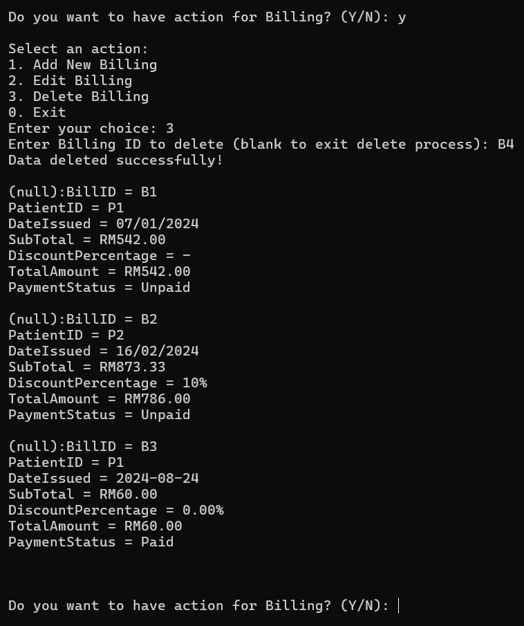

SQLite shows the billing data is deleted.

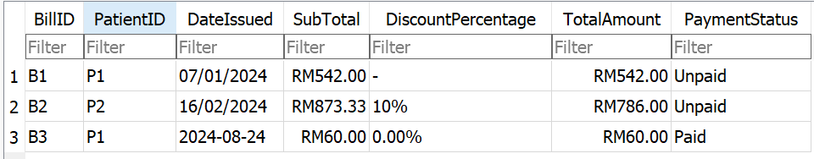

### **6.6.19 Exit**

Select Exit to exit the program.

# 

# **7. Example Coding**

## **7.1 Patient Menu**

### **7.1.1 Make appointments**

#### **7.1.1.1 Structure**

This structure defines a PatientAppointment node, containing details such as appointment ID, patient ID, service ID, date, time, status, and doctor ID. It also includes a pointer (next) that links to the next appointment in the list, facilitating the management of a series of patient appointments in a linked list format.

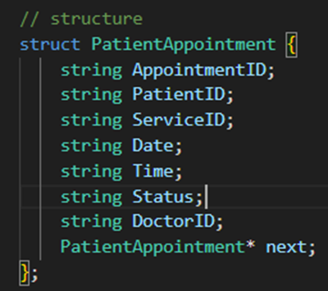

#### **7.1.1.2 Print**

This function printPatientAppointment prints a table of patient appointments. It first outputs a header with columns for Appointment ID, Patient ID, Service ID, Date, Time, Status, and Doctor ID. Then, it iterates through the linked list, printing each appointment's details in the corresponding columns.

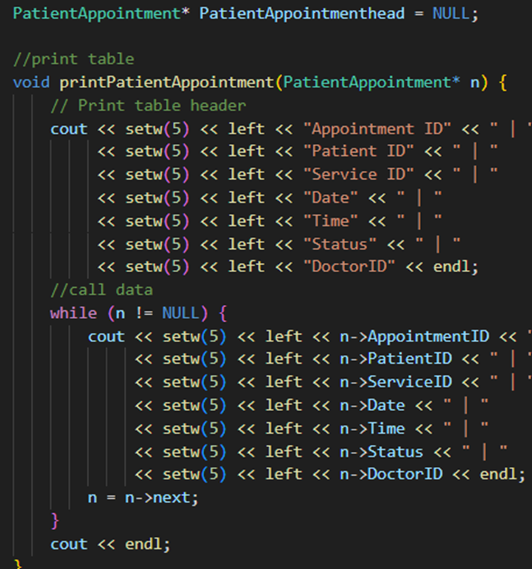

#### **7.1.1.3 Push back**

This function PushBackPatientAppointment adds a new PatientAppointment node to the end of a linked list. It first creates and initializes a new PatientAppointment node with the provided details and sets its next pointer to NULL. If the list (PatientAppointmenthead) is empty, it sets the head of the list to the new node. Otherwise, it traverses the list to find the last node and appends the new node to it.

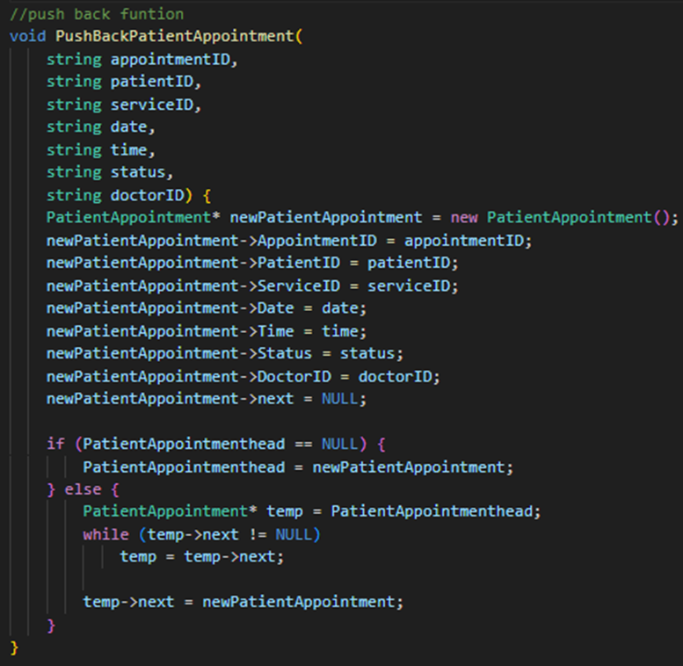

#### **7.1.1.4 Create**

The `patientCreatePatientsAppointment` function allows users to schedule a new appointment. It starts by generating a unique `AppointmentID` and then prompts the user to enter required details including Service ID, Date, Time, and Doctor ID. It verifies the validity of these inputs against predefined sets of valid IDs. Once all information is validated, it inserts the appointment into the database with the status set as "Accessed". The function continues to prompt the user if they wish to add more appointments until they choose to stop.

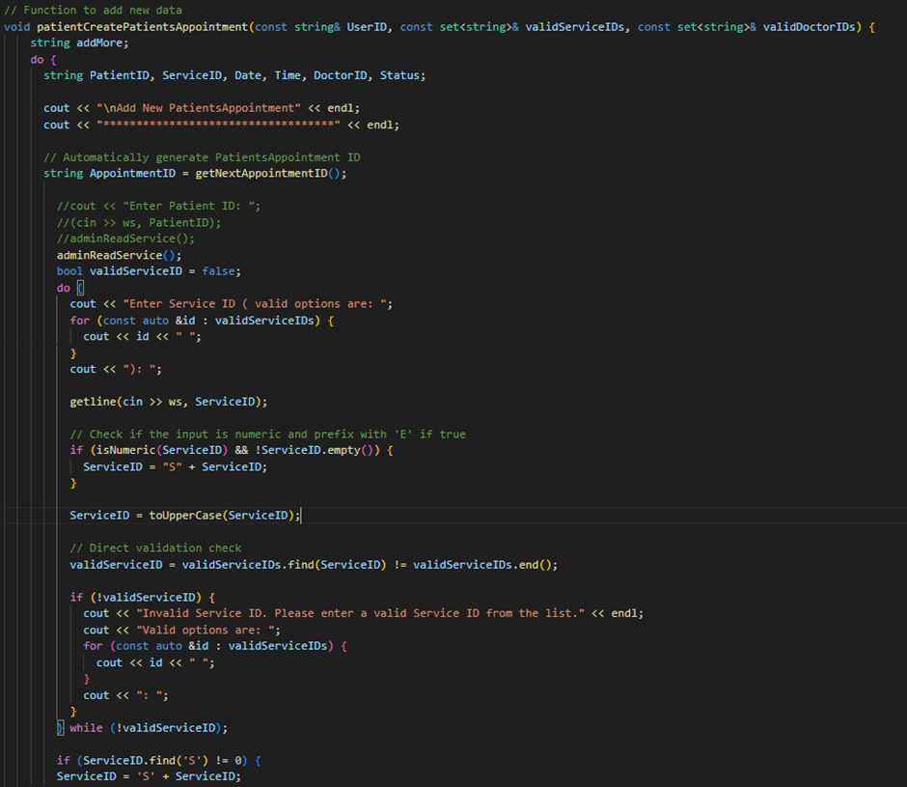

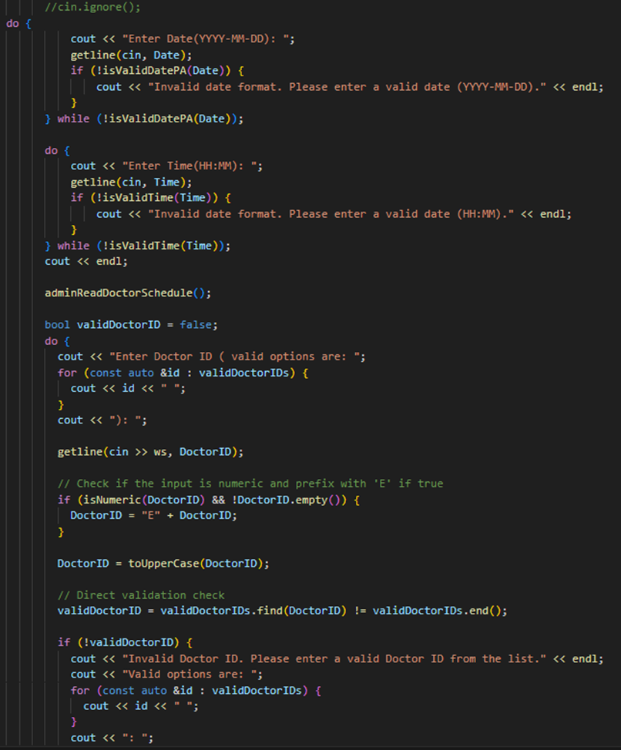

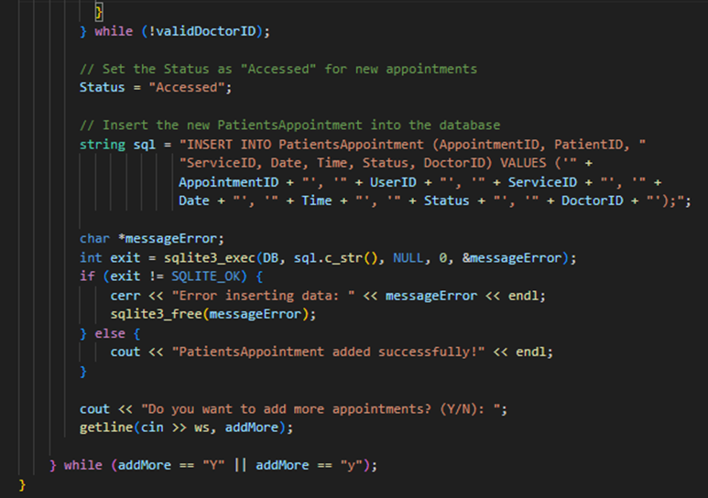

#### **7.1.1.5 Read**

The `patientReadAppointment` function retrieves and displays all appointments for a specified patient. It executes a SQL query to select all records from the `PatientsAppointment` table where the `PatientID` matches the provided parameter. If the query execution fails, it prints an error message. The `callback` function, defined elsewhere, processes and formats the results.

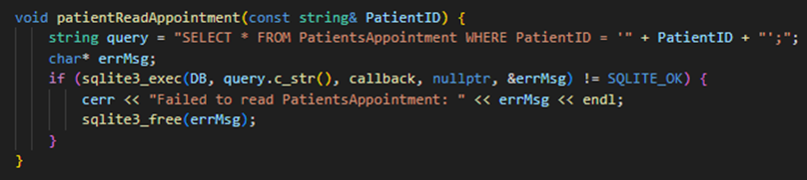

### **7.1.2 Cancel Appointment**

#### **7.1.2.1 Structure**

The `CancelAppointment` structure tracks cancelled appointments, storing details like `CancelAppointmentID`, `AppointmentID`, `DoctorID`, and `Reason`. It uses a `next` pointer to link each record in a dynamic list, enabling efficient management and retrieval of cancellation information.

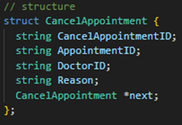

#### **7.1.2.2 Print**

The `printCancelAppointment` function displays the list of canceled appointments in a formatted table. It begins by printing the column headers, then iterates through the linked list of `CancelAppointment` records, outputting each record’s details. The `setw` function ensures that the columns are properly aligned for readability.

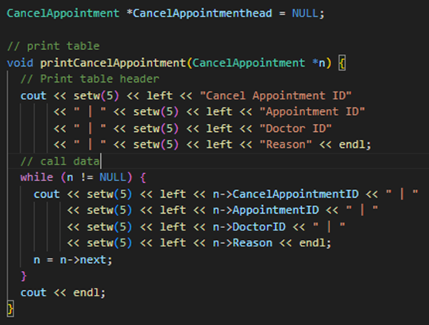

#### **7.1.2.3 Push back**

The `PushBackCancelAppointment` function adds a new `CancelAppointment` record to the end of the linked list. It creates a new `CancelAppointment` instance, initializes its fields with the provided values, and appends it to the list. If the list is empty, the new record becomes the head of the list; otherwise, it is added after the last existing record.

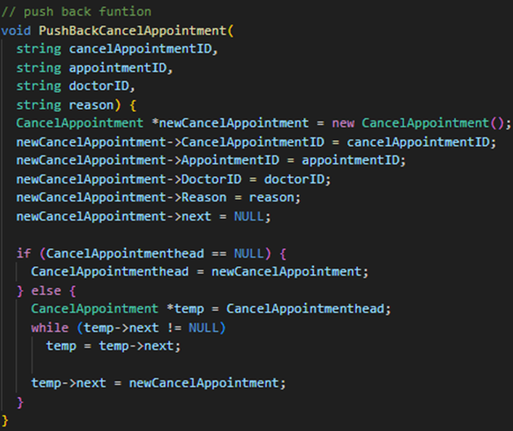

#### **7.1.2.4 Create**

The `patientCreateCancelAppointment` function allows adding a new cancellation appointment. It generates a unique `CancelAppointmentID` and validates the `AppointmentID` against a set of valid IDs. It ensures that the `AppointmentID` hasn't been previously canceled. The function retrieves the corresponding `DoctorID`, prompts for a cancellation reason, and inserts the new record into the `CancelAppointment` table. Additionally, it updates the status of the related appointment to "Cancelled" in the `PatientsAppointment` table, handling any errors encountered during database operations.

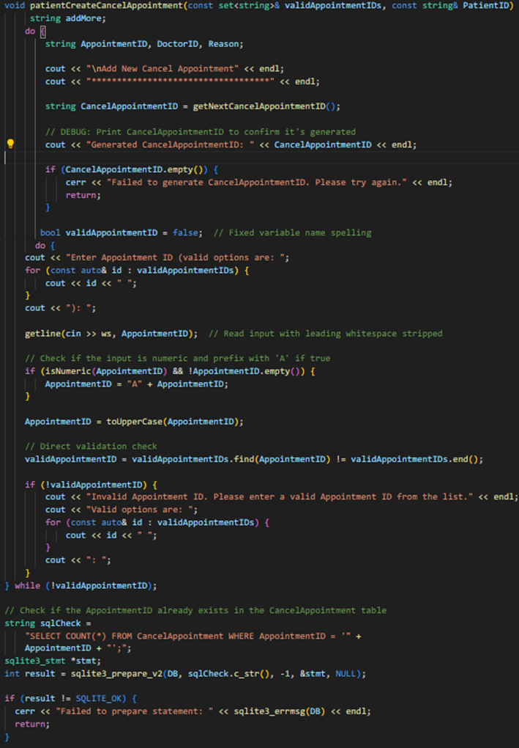

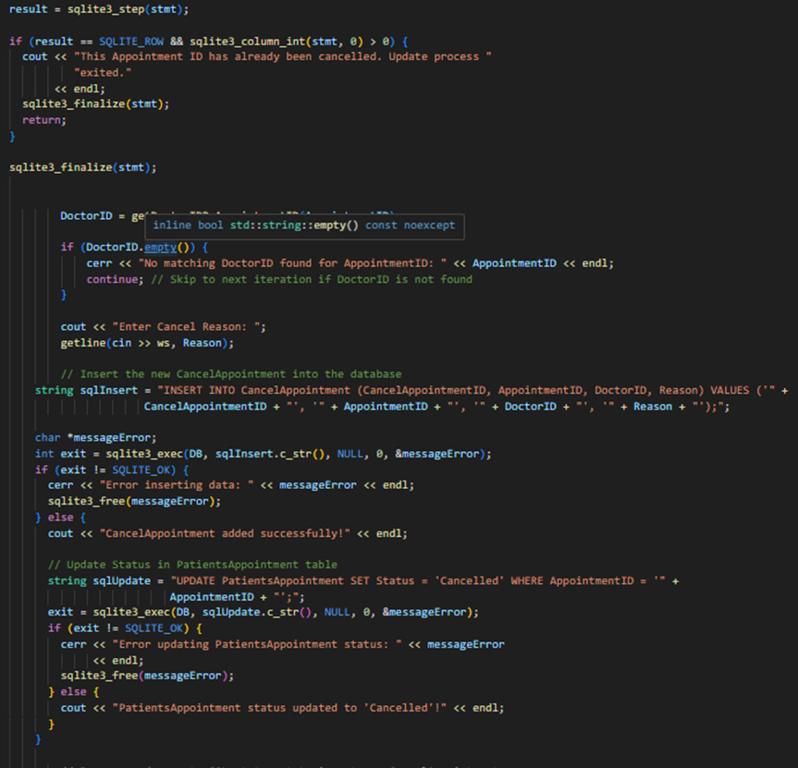

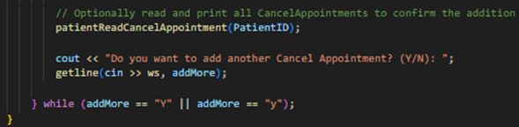

#### **7.1.2.5 Read**

The `patientReadCancelAppointment` function fetches and displays cancel appointment details for a given patient. It uses a parameterized SQL query to join `CancelAppointment` and `PatientsAppointment` tables, retrieves relevant records based on `PatientID`, and prints the cancel appointment ID, appointment ID, doctor ID, and reason. It handles errors and ensures resources are properly released.

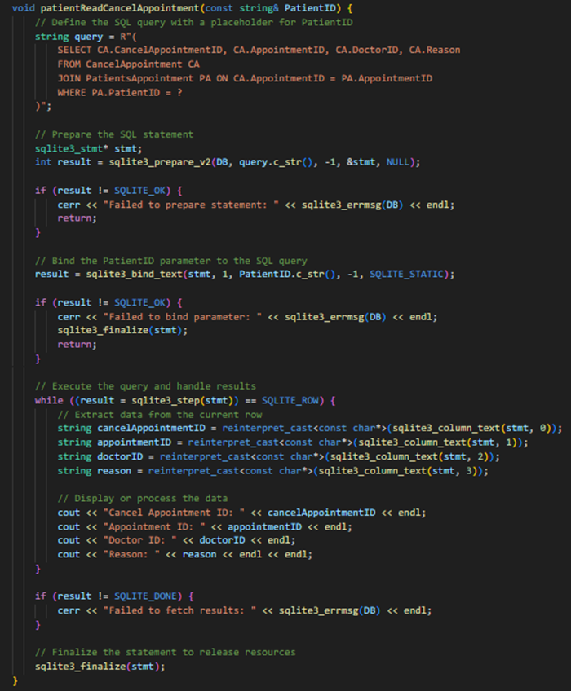

#### **7.1.2.6 Update**

The `patientUpdateCancelAppointment` function updates existing cancellation records by allowing the user to modify the `AppointmentID` and `Reason` fields. It first checks if the provided `CancelAppointmentID` exists in the database. If valid, it prompts the user to enter new values for the specified fields, leaving fields empty if they don't need updating. The function then constructs an SQL `UPDATE` statement based on the user's input and executes it to update the database. Finally, it displays the updated records to confirm the changes.

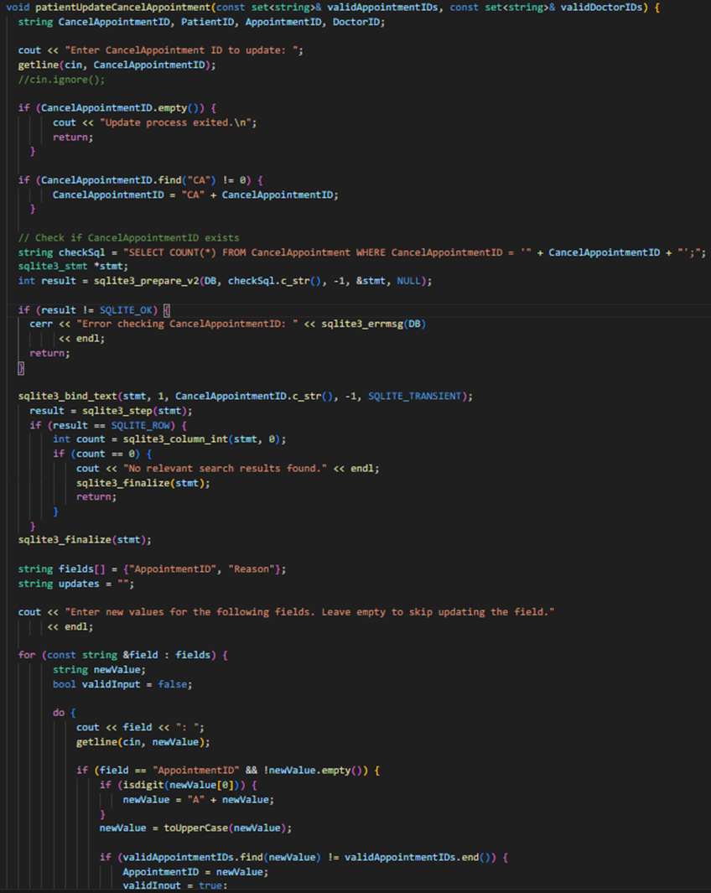

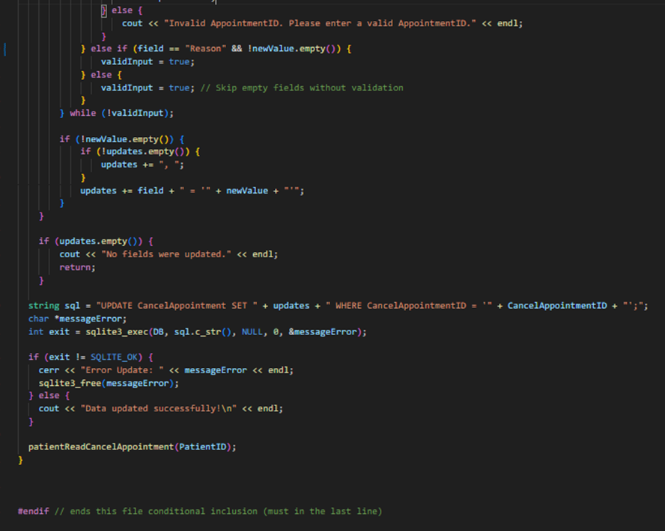

## **7.2 Doctor Menu**

### **7.2.1 Structure**

This structure defines a medicalDiagnosis node, containing details like patient ID, doctor ID, medical history, medications, diagnosis, last update, and a pointer (next) that links to the next diagnosis in the list.

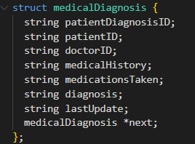

### **7.2.2 Node**

This function creates a new medicalDiagnosis node by allocating memory for it and initializing it with the provided diagnosis details.

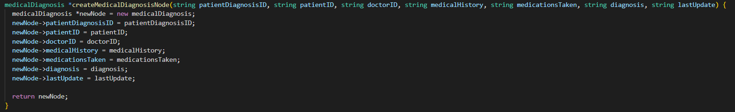

### **7.2.3 Push Back**

This function appends a newly created medicalDiagnosis node to the end of the linked list. If the list is empty, the new node becomes the head; otherwise, it’s added as the last node (tail).

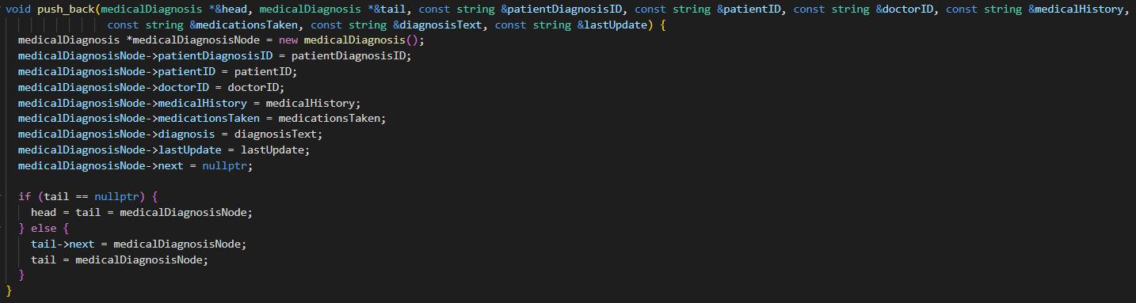

### **7.2.4 Generates Unique ID**

This function generates a unique PatientDiagnosisID by querying the database for the current highest ID and incrementing it. It ensures that each diagnosis has a distinct identifier.

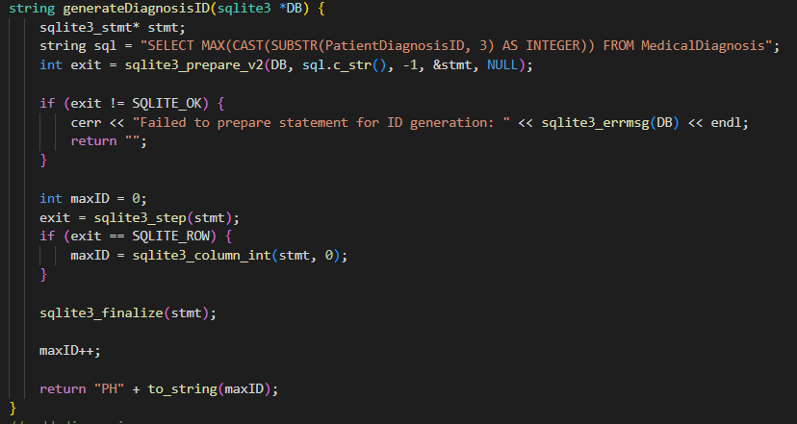

### **7.2.5 Create Medical Diagnosis**

This function inserts a new medical diagnosis into the database if the patient ID and doctor ID match an existing appointment in the PatientsAppointment table. It binds the diagnosis details to the SQL query parameters and executes the insertion.

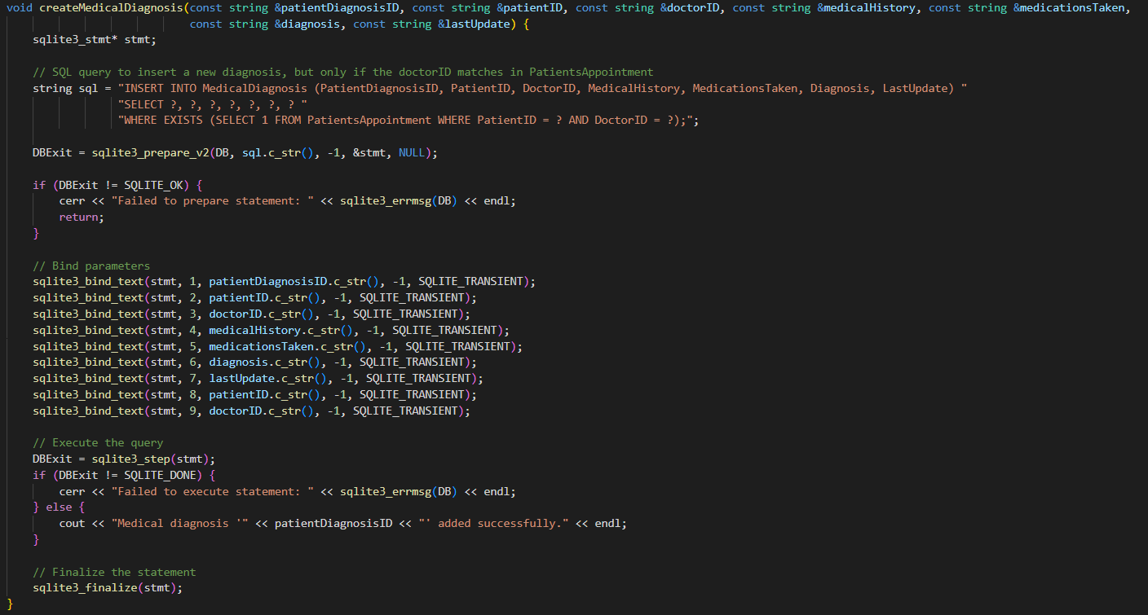

This function interacts with the user (doctor) to add a new diagnosis. It validates that the patient ID belongs to a patient assigned to the doctor, collects the diagnosis details, and then uses the push_back function to add the diagnosis to the linked list and the createMedicalDiagnosis function to store it in the database. The process is repeated if the doctor wants to add more diagnoses.

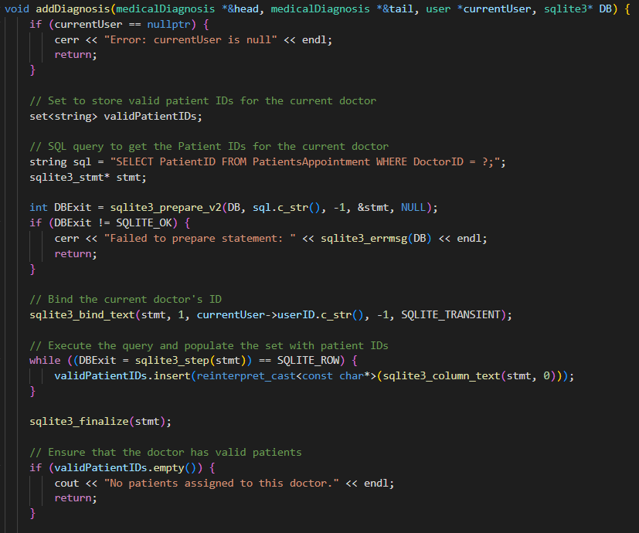

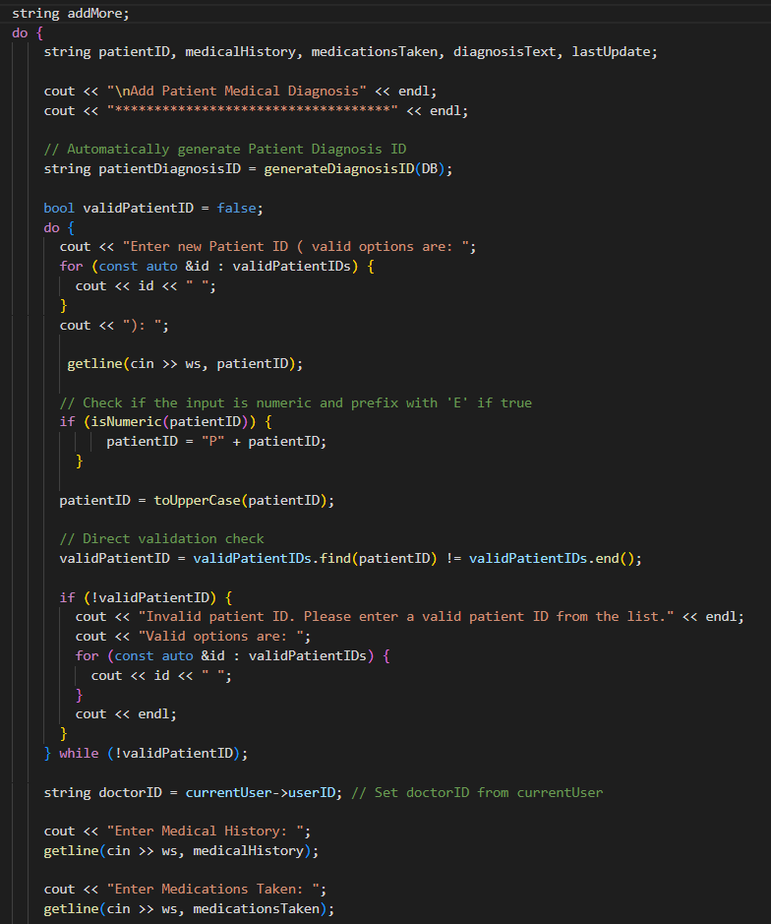

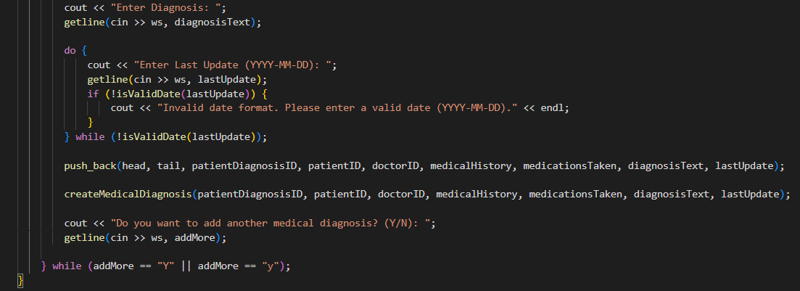

### **7.2.6 Read Medical Diagnosis**

The `readDiagnosis` function fetches and displays medical diagnosis records from the database for a specific patient. It executes a query to retrieve and format details such as diagnosis ID, patient ID, doctor ID, and medical history.

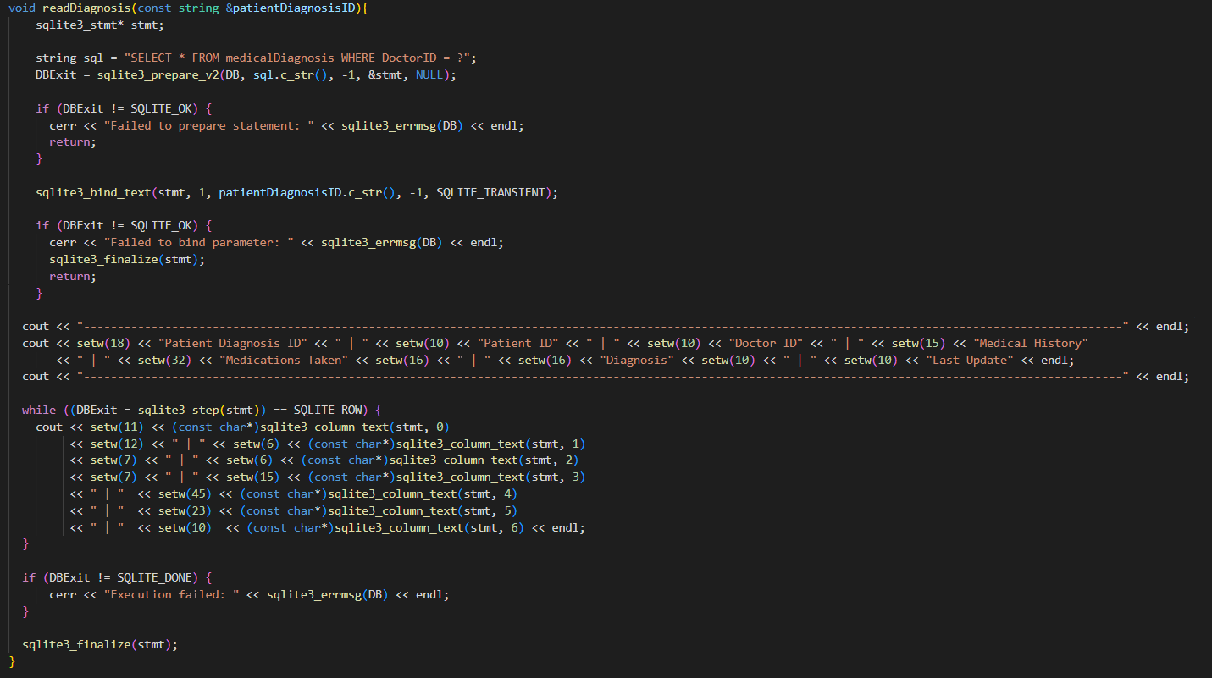

The `printMedicalDiagnoses` function calls `readDiagnosis` to display medical diagnoses based on the current user's ID. It passes the user's ID to `readDiagnosis` to fetch and print the relevant records.



### **7.2.7 Update Medical Diagnosis**

The `updateDiagnosis` function updates a medical diagnosis record in the SQLite database by preparing and executing an `UPDATE` SQL statement with new values for various fields. It binds the new values to the statement, executes it, and handles any errors. If successful, it confirms the update.

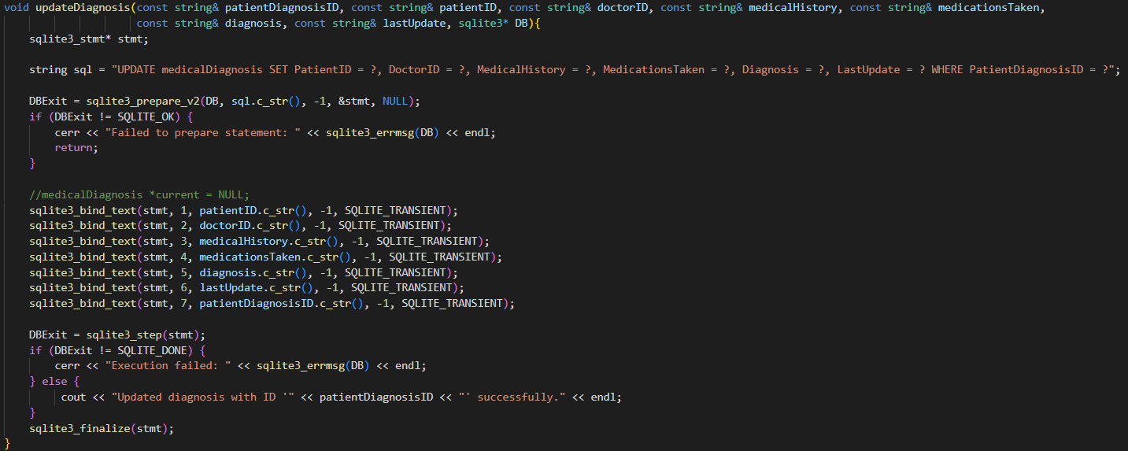

The `updateMedicalDiagnosis` function updates a diagnosis record for a logged-in doctor. It retrieves the list of patients assigned to the doctor, checks if the given diagnosis ID exists and belongs to those patients, and then prompts for new details. It validates these details before updating the record in the database. If the diagnosis ID is not found, it informs the user.

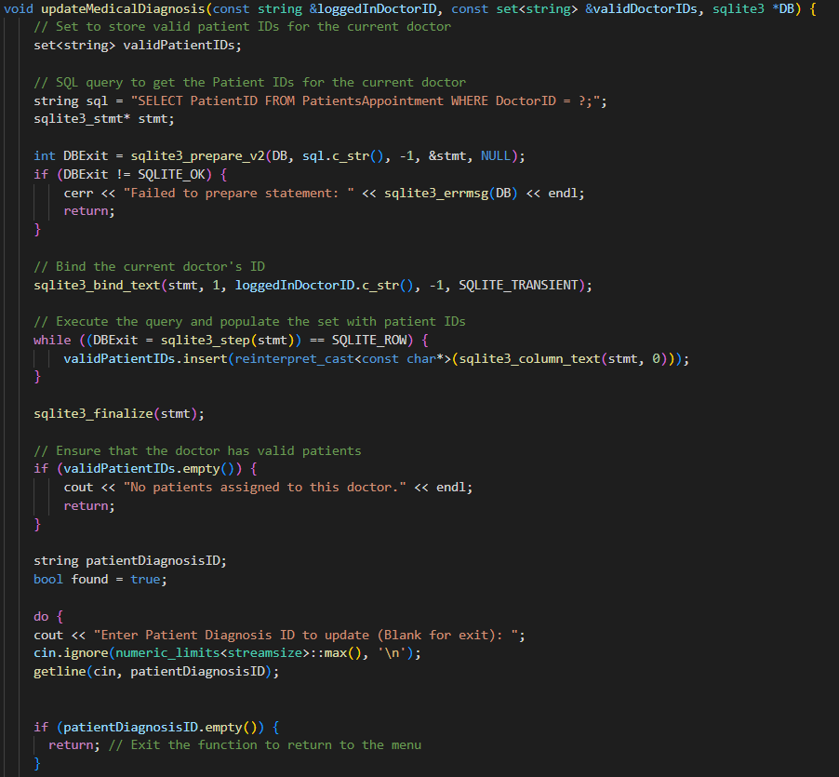

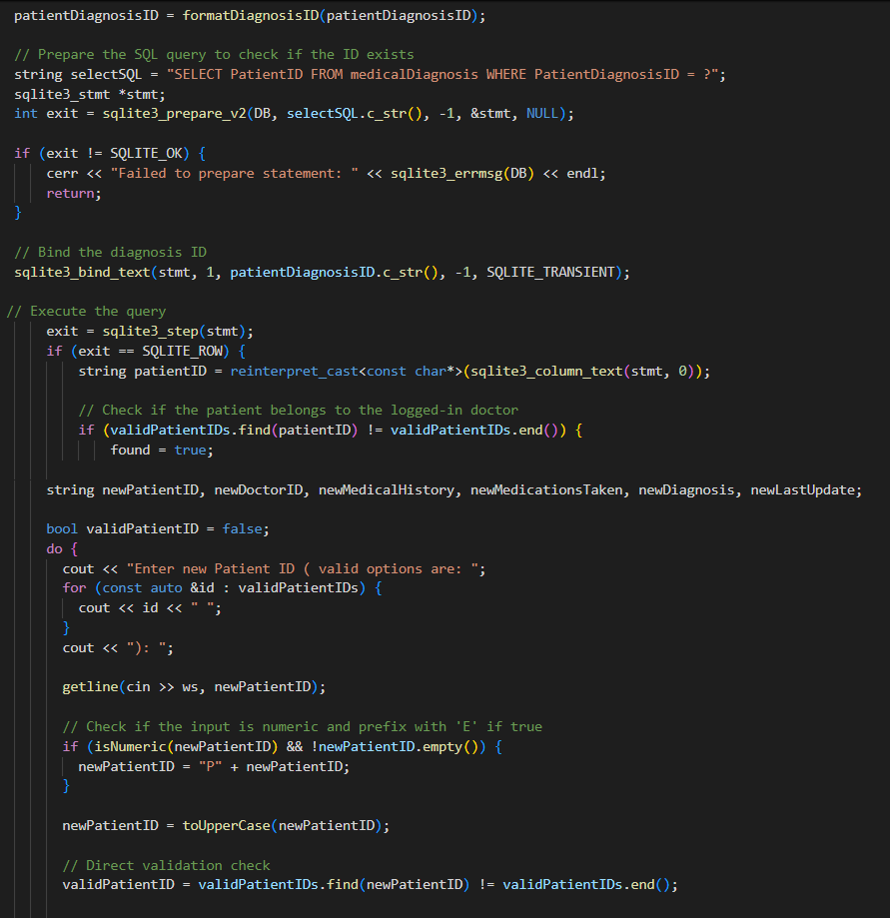

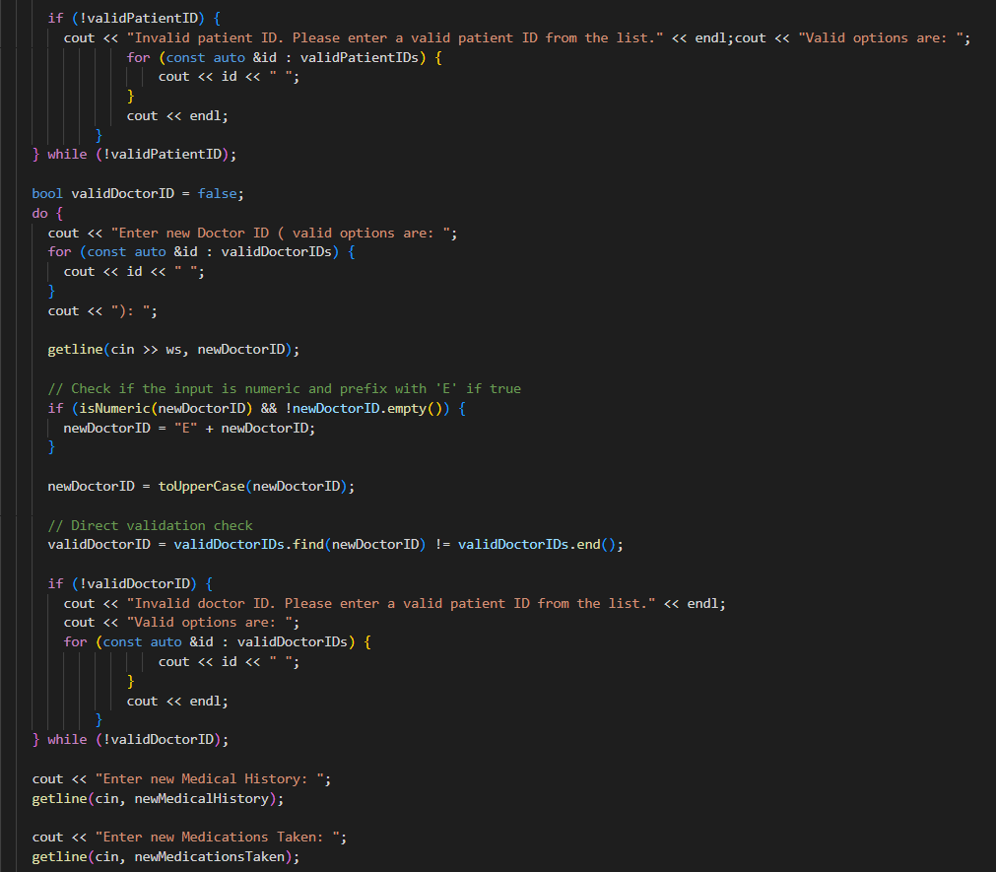

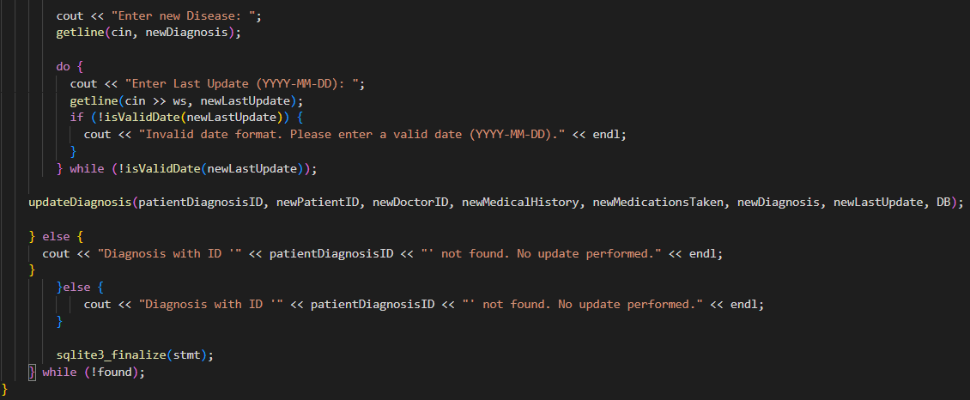

### **7.2.8 Delete Medical Diagnosis**

The `deleteDiagnosis` function removes a diagnosis record from the database if the logged-in doctor is authorized. It first checks if the diagnosis ID exists and retrieves the associated patient ID. It then verifies if the logged-in doctor is authorized to manage the patient’s diagnosis. If authorized, it deletes the diagnosis record. If the diagnosis is not found or the doctor is not authorized, it informs the user.

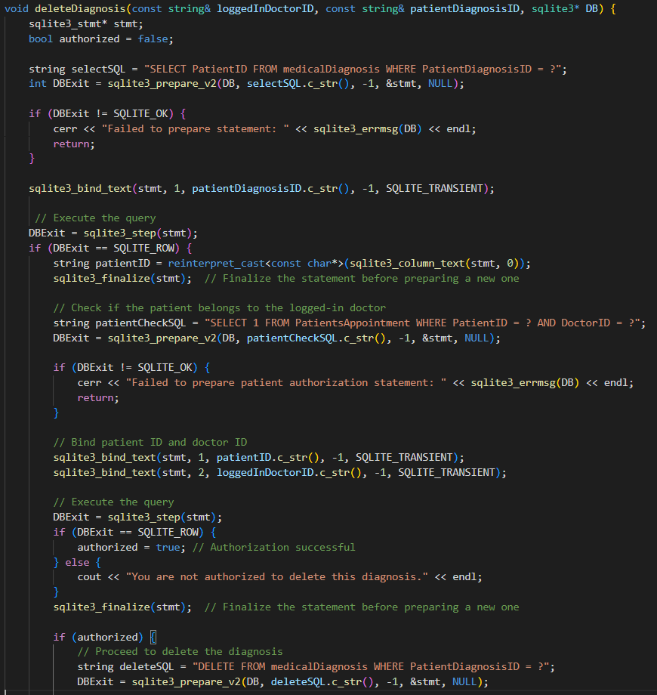

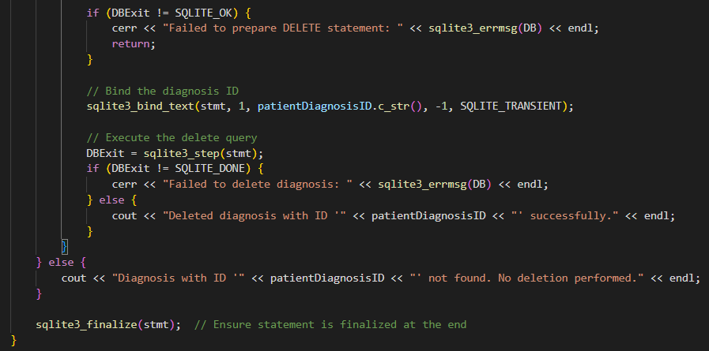

This function allows a doctor to delete a diagnosis if they are authorized. It checks if the diagnosis exists, retrieves the associated patient ID, verifies if the doctor is authorized for that patient, and then performs the deletion. If any conditions are not met, it provides appropriate feedback.

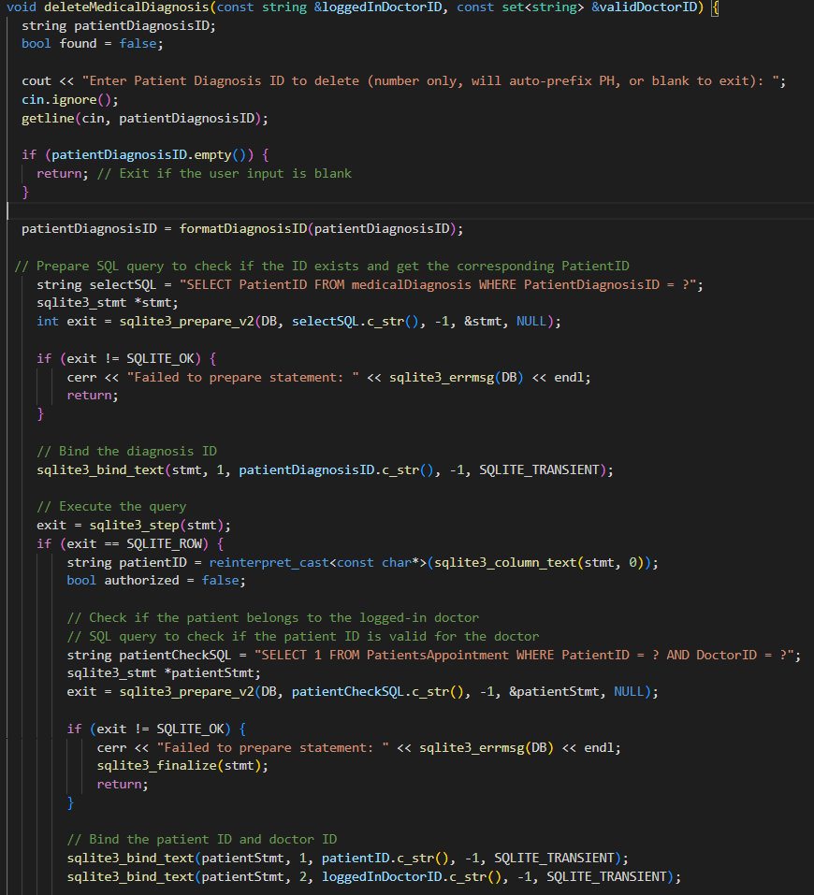

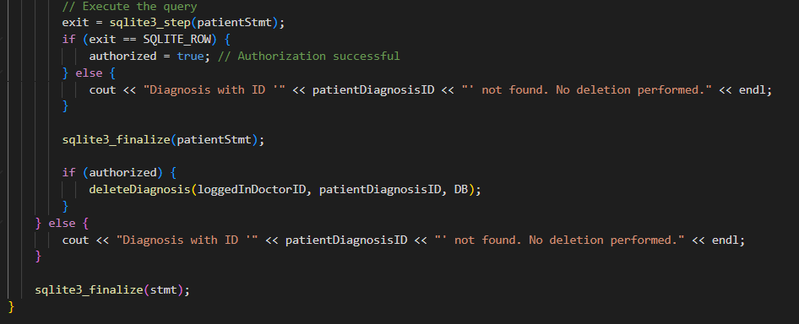

## **7.3 Admin Menu**

### **7.3.1 Inventory Structure**

This structure defines an inventory node, containing details like item ID, purchase item, quantity, person checking, and a pointer (next) that links to the next inventory item in the list.

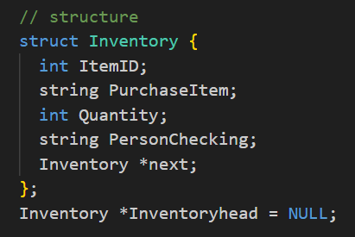

### **7.3.2 Inventory Node**

This function prints the inventory table by first displaying the table headers and then iterating through the linked list to print the details of each inventory item.

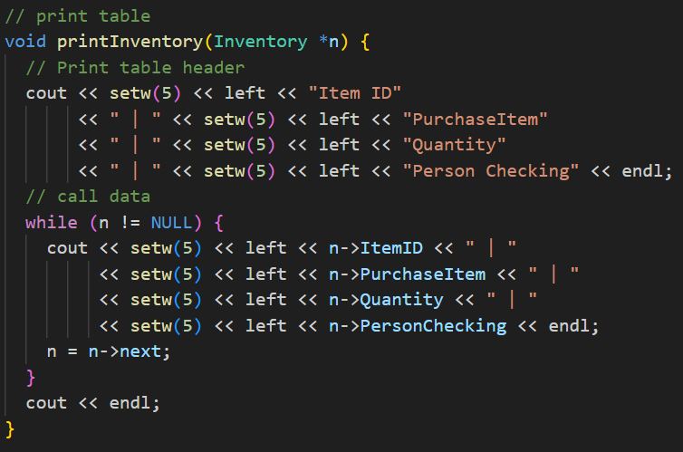

### **7.3.3 Inventory Push Back**

This function adds a new inventory item to the end of the inventory list by creating a new node with the provided details and linking it to the last node in the list.

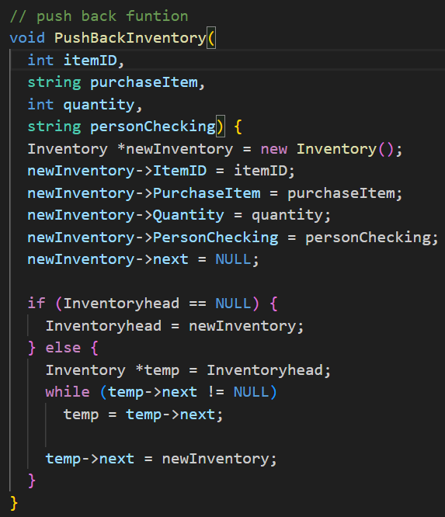

### **7.3.4 Generates Unique Inventory ID**

This function generates the next inventory ID by querying the maximum numeric part of the current IDs from the database, incrementing it, and returning the new ID with a prefix "I".

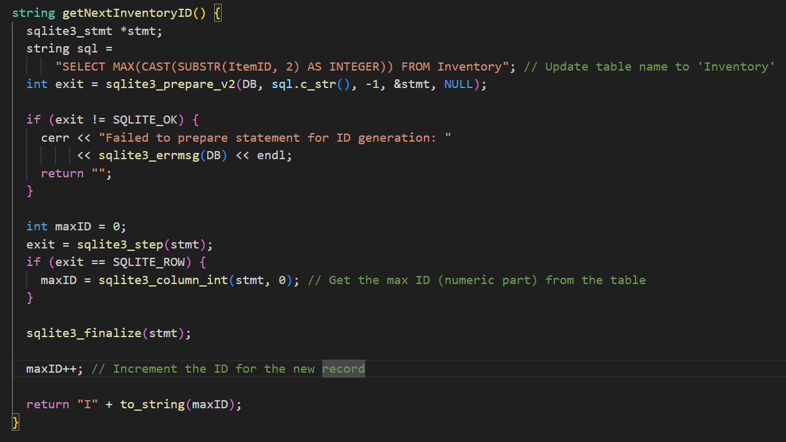

### **7.3.5 Read Inventory**

This function retrieves and displays all records from the `Inventory` table by executing a SQL `SELECT` query and using a callback function to process the results.

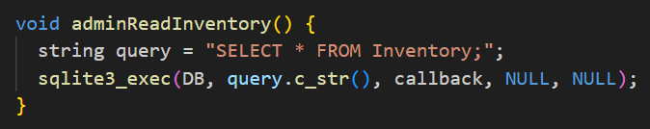

### **7.3.6 Create Inventory**

This function adds new inventory data to the database by prompting the user for details such as `PurchaseItem`, `Quantity`, and `PersonChecking`, validating the user ID, and then inserting the record into the `Inventory` table. It repeats the process if the user chooses to add more entries and displays the updated inventory list after each addition.

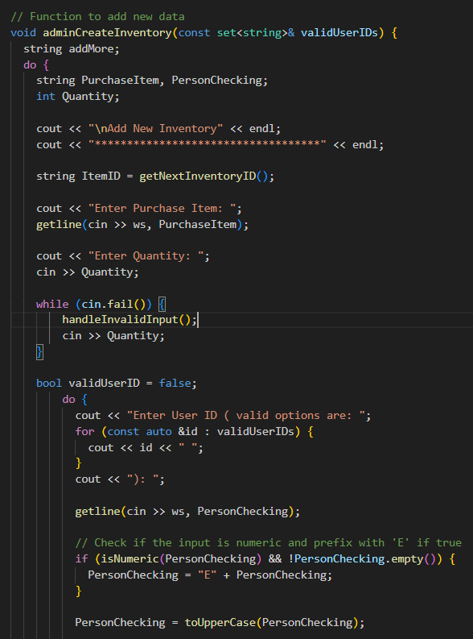

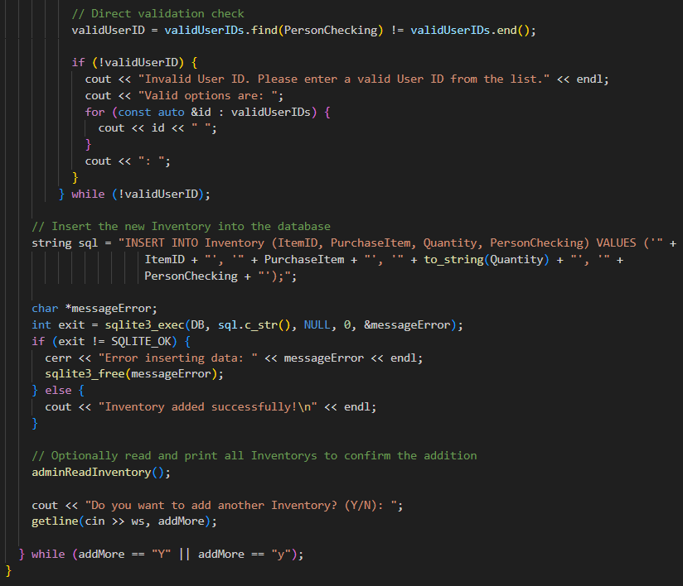

### **7.3.7 Update Inventory**

This function updates an inventory record in the database by prompting the user for an `ItemID`, verifying its existence, and allowing updates to fields such as `PurchaseItem`, `Quantity`, and `PersonChecking`. The function constructs the SQL update query based on user input, executes it, and displays the updated inventory list.

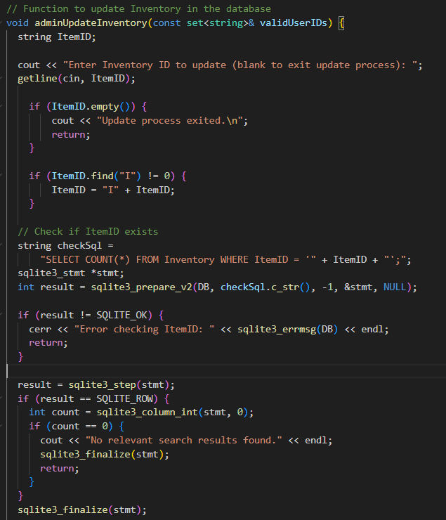

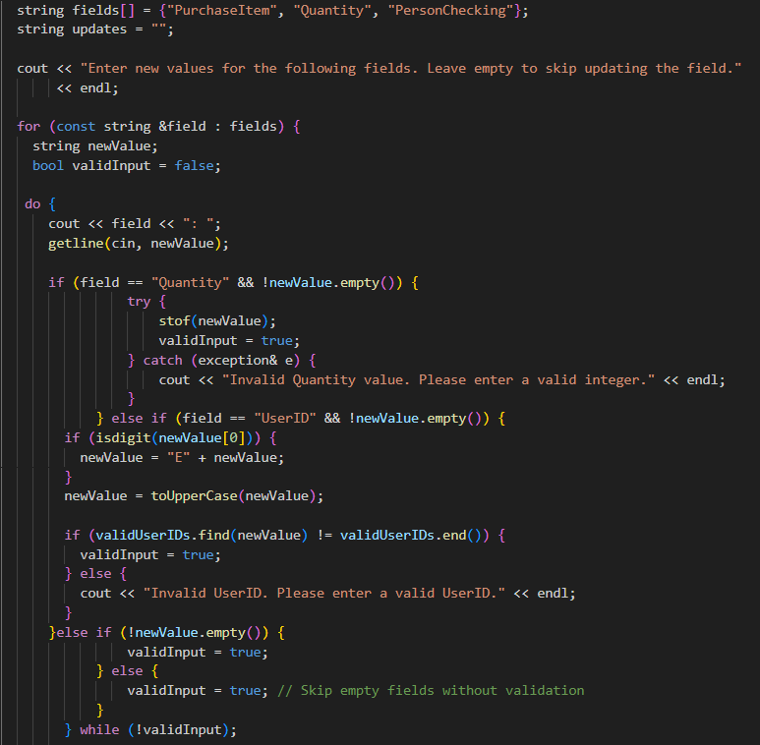

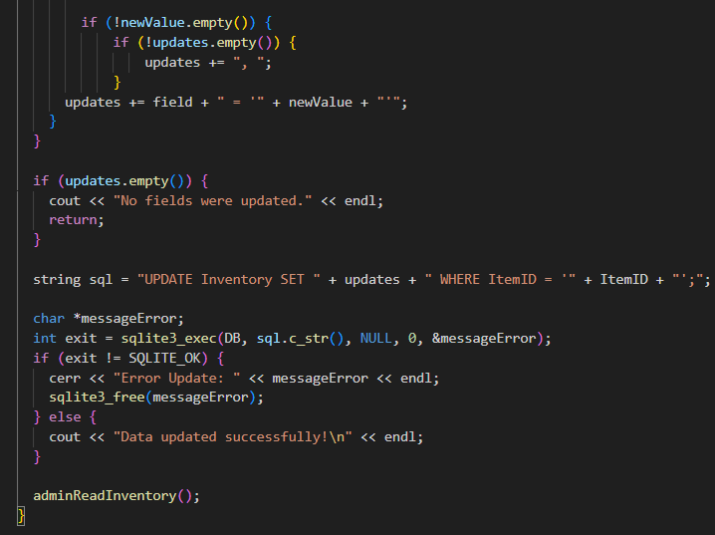

### **7.3.8 Delete Inventory**

This function deletes an inventory record from the database by prompting the user for an `ItemID`, checking if the ID exists, and executing a SQL `DELETE` statement. It then displays the updated inventory list.

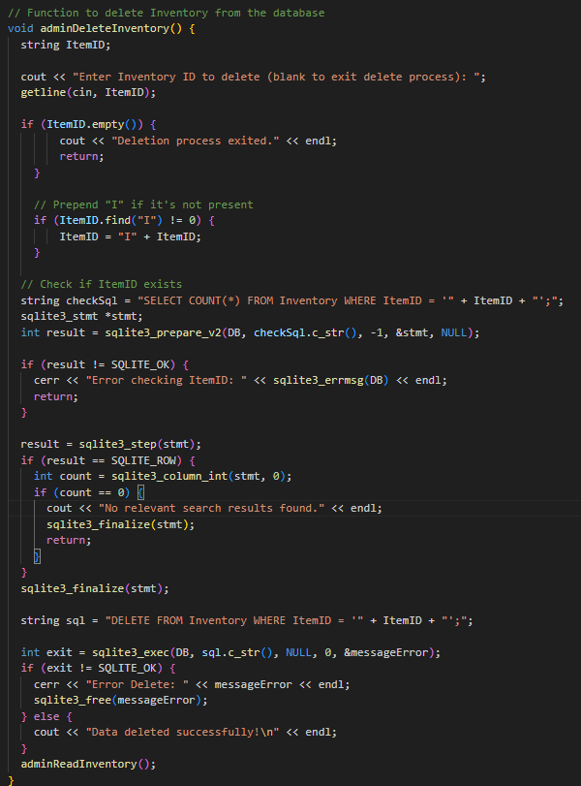

# **8. Database Sqlite3**

## **8.1 Billing Table**

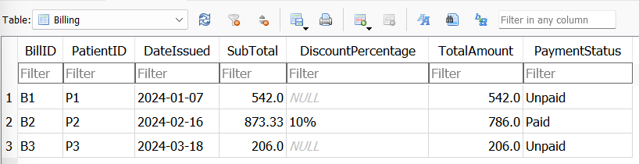

## **8.2 Cancel Appointment Table**

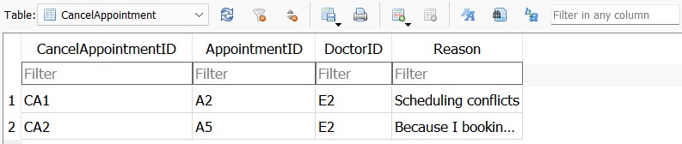

## **8.3 Discount Table**

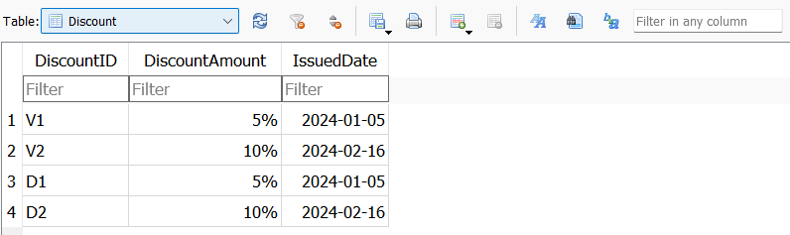

## **8.4 Doctor Schedule Table**

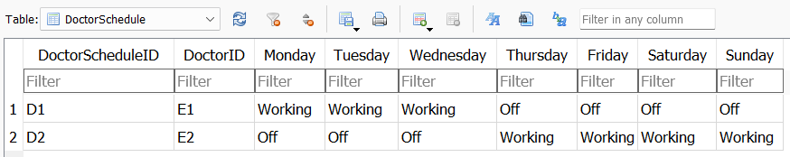

## **8.5 Emergency Table**

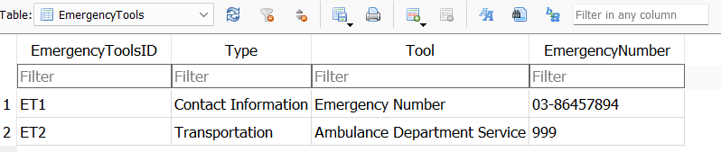

## **8.6 Feedback Table**

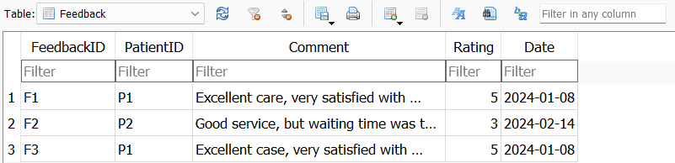

## **8.7 Inventory Table**

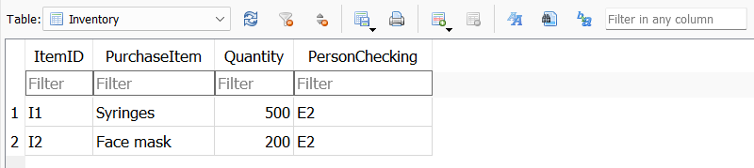

## **8.8 medical Diagnosis Table**

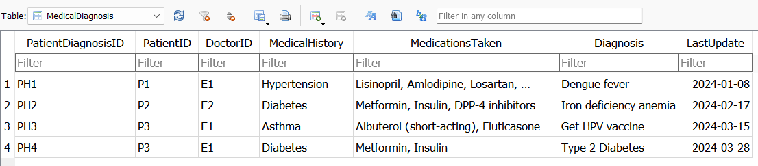

## **8.9 Medical Insurance Table**

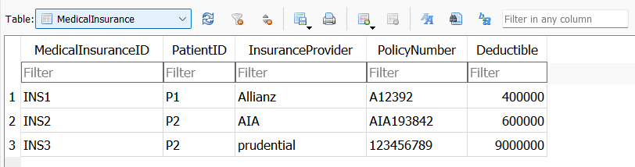

## **8.10 Notice Table**

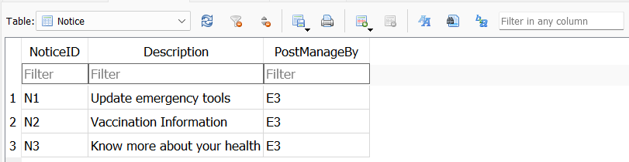

## **8.11 Patient Admission Transfer Table**

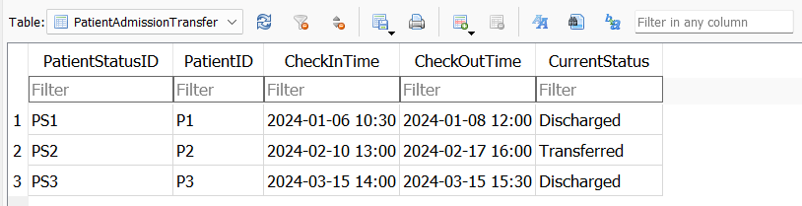

## **8.12 Patient Allergy Table**

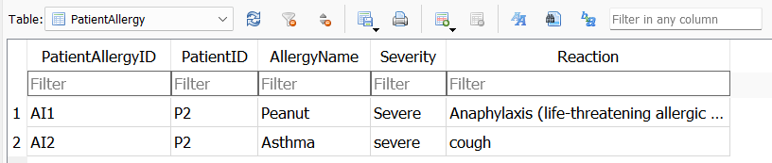

## **8.13 Patient Follow Up Table**

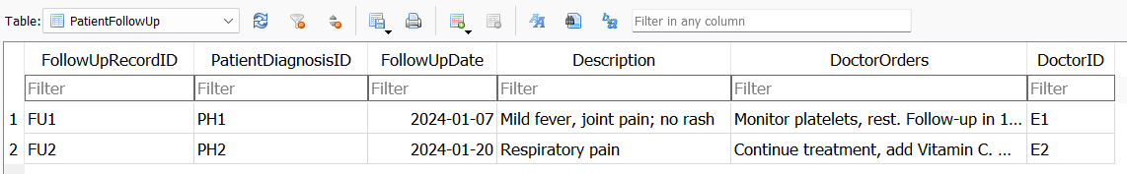

## **8.14 Patient Appointment Table**

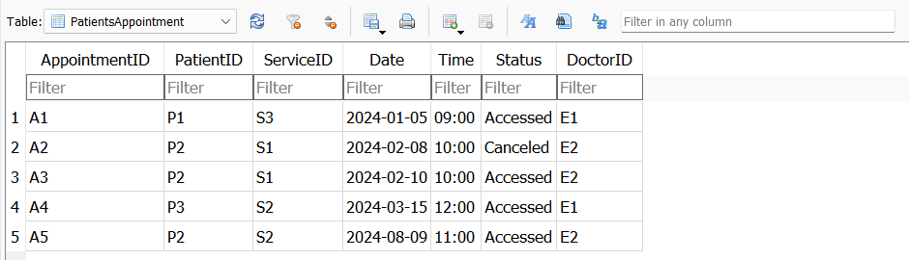

## **8.15 Project Table**

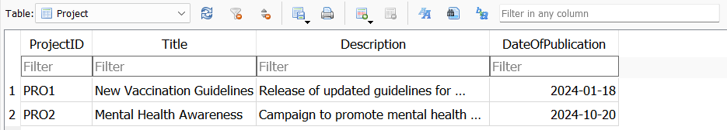

## **8.16 Purchase Table**

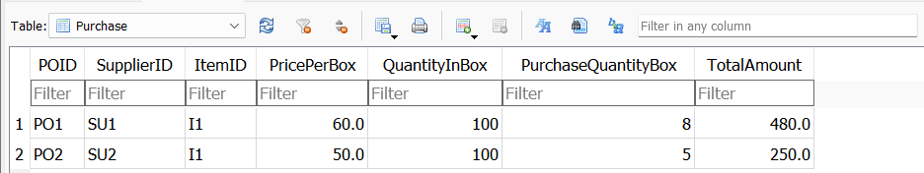**8.17 Supplier Table**

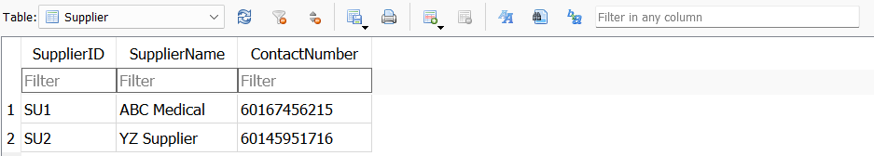

## **8.18 Type of Service Table**

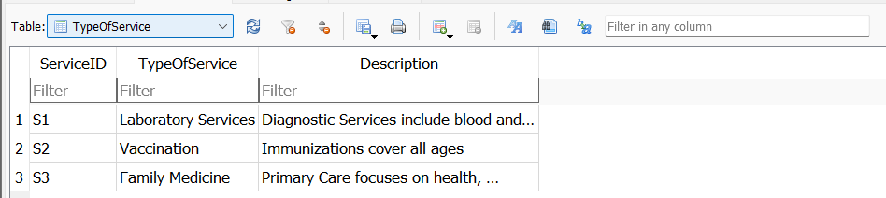

## **8.19 User Table**

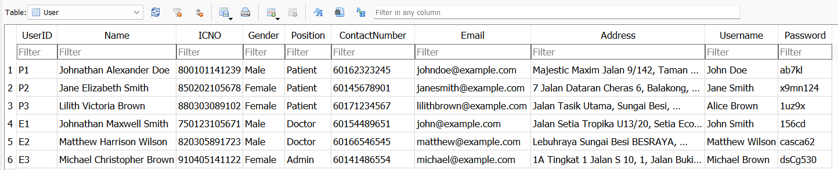

## **8.20 Vaccination Records Table**

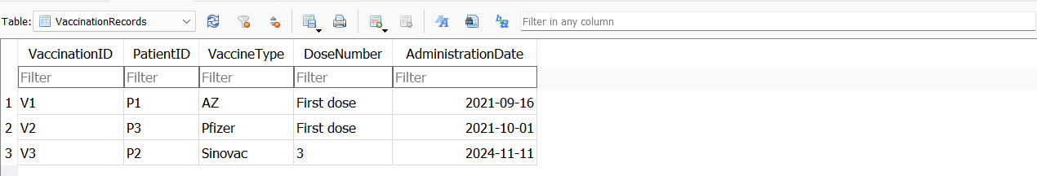

# **9.0 Conclusion**

Creating a clinic scheduling system that efficiently manages appointments for patients, doctors, and administrators is a complex task that involves several advanced programming techniques and tools. The use of linked lists, hash functions, pointers, references, and an SQLite3 database for CRUD (Create, Read, Update, Delete) operations is a sophisticated approach that ensures both flexibility and performance.

Linked lists are a fundamental data structure in computer science that allows for dynamic memory allocation. In the context of a clinic scheduling system, linked lists are particularly useful for managing a potentially large and dynamic set of appointments. Each appointment can be represented as a node in the linked list, with pointers connecting each node to the next. This structure allows for efficient insertion and deletion of appointments, which is crucial in a medical environment where schedules are constantly changing. For instance, if a patient cancels an appointment, the corresponding node can be quickly removed from the list without needing to shift other elements, as would be the case with an array.

Hash functions play a critical role in optimizing the retrieval of records, such as patient or doctor information. In a scheduling system, the need to quickly access a patient’s record or a doctor’s schedule is paramount. By applying a hash function, you can convert data (like patient ID or doctor ID) into a fixed-size integer, which acts as an index in a hash table. This enables near-instantaneous access to the required data, reducing the time complexity of search operations from O(n) in a linked list to O(1) in the best-case scenario. This speed is crucial in a medical setting where time is of the essence.

Pointers and references are essential in managing memory efficiently, especially in a system that uses linked lists. Pointers allow the program to dynamically allocate memory for new appointments and manage the connections between nodes in the linked list. By using references, the system can pass large data structures without the overhead of copying them, which enhances performance. In a scheduling system, where many operations involve manipulating complex data structures like appointment records or patient data, pointers and references help in maintaining the integrity of the data while minimizing memory usage.

An SQLite3 database provides a robust backend for storing and managing the clinic's data. SQLite is a lightweight, file-based database that is well-suited for applications where simplicity and efficiency are key. In the clinic scheduling system, the database is used to store persistent information such as patient records, doctor schedules, and appointment histories. The CRUD operations (Create, Read, Update, Delete) are implemented to manage this data. For example, when a new appointment is created, a corresponding entry is added to the database. If an appointment is rescheduled or canceled, the database is updated accordingly.

By integrating SQLite3 with linked lists and hash functions, the scheduling system benefits from both the speed of in-memory operations and the reliability of persistent storage. The database serves as a backup for the linked list, ensuring that no data is lost even if the system is restarted.

In summary, the combination of linked lists, hash functions, pointers, references, and SQLite3 creates a highly efficient and flexible clinic scheduling system. Linked lists provide the dynamic structure needed for managing appointments, while hash functions optimize data retrieval. Pointers and references ensure efficient memory management, and the SQLite3 database offers a reliable backend for persistent storage. Together, these elements form a robust system capable of handling the complex and dynamic environment of a medical clinic, ensuring that patients receive timely care, doctors manage their schedules effectively, and administrators can oversee the system with ease. This integration of advanced programming techniques makes the system both powerful and reliable, ensuring its effectiveness in a real-world medical setting.

Thank you, teacher, for your unwavering dedication and the profound impact you’ve had on my learning journey. Your guidance, patience, and deep understanding have not only helped me grasp complex concepts but also inspired me to push beyond my limits. The time and effort you invest in each lesson, the care with which you address our questions, and the encouragement you provide have all contributed to my growth, both academically and personally. I am deeply grateful for your commitment to our education and for the positive influence you’ve had on my life. Your support and wisdom are truly appreciated, and I feel fortunate to have had the opportunity to learn from you.

# **10.0 Distribution**

|  |  |  |  |
| --- | --- | --- | --- |
| **No** | **Name** | **ID** | **Description** |
| 1 | Lim Feng Yao | 2350102-DCS | **1.** **Introduction**  **2.** **Data Structure System**  - Data Structure: Linked List  - Data Flow Diagram (DFD)  **3.** **Hash Function**  **4.** **Program Output**  - Register, login, and forgot password  - Doctor Menu  · CRUD  **5.** **Database Sqlite3**  **6.** **Example Coding**  - Doctor Menu  · CRUD |
| 2 | Yap Hui Jun | 2320020-DCS | **1.** **Data Structure System**  - Data Flow Diagram (DFD)  - Data Table  - Data Type  **2.** **Pointers and References**  **3.** **Program Output**  - Patient Menu  · CRUD  **4.** **Example Coding**  - Patient Menu  · CRUD |
| 3 | Wong Jie Ying | 2350080-DCS | **1.** **Flow of System (Flow Chart Diagram)**  **2.** **Database Table**  **3.** **Program Output**  - Admin Menu  · CRUD  **4.** **Example Coding**  - Admin Menu  · CRUD |